**Report of the**

**2018 Joint Mars Rover Mission**

**Joint Science Working Group (JSWG)**

*Final Version*

*26 March 2012*

Recommended bibliographic citation:

MEPAG JSWG (2012) Report of the 2018 Joint Mars Rover Mission Joint Science Working Group (JWSG), 93 pp., posted March, 2012, by the Mars Exploration Program Analysis Group (MEPAG) at http://mepag.jpl.nasa.gov/reports/.

Or:

Beaty, D.W., Kminek, G., Allwood, A.C., Arvidson, R., Borg, L.E., Farmer, J. D., Goesmann, F., Grant, J. A.,

Hauber, E., Murchie, S.L., Ori, G.G., Ruff, S. W., Rull, F., Sephton, M. A., Sherwood Lollar, B., Smith, C. L., Westall, F., Pacros, A.E., Wilson, M.G., Meyer, M.A., Vago, J.L., Bass, D.S., Joudrier, L., Laubach, S., Feldman, S., Trautner, R., Milkovich, S.M. (2012) Report of the 2018 Joint Mars Rover Mission Joint Science Working Group (JSWG), 93 pp., posted March, 2012, by the Mars Exploration Analysis Group (MEPAG) at http://mepag.jpl.nasa.gov/reports/.

Inquiries regarding this report should be directed to David Beaty ([David.Beaty@jpl.nasa.gov](mailto:David.Beaty@jpl.nasa.gov), +1 714 818-354-7968) or Gerhard Kminek ([Gerhard.Kminek@esa.int](mailto:Gerhard.Kminek@esa.int), +31 71 565 6096) (JSWG co-chairs).

Contents

Executive Summary 4

List of Acronyms 6

1. Background, assumptions, and deliverables 8

1.1. Assumptions 8

1.2. Deliverables 8

1.3. Notes Regarding this Report 8

2. Methods and Schedule 9

3. Scientific Objectives 11

3.1. Introduction 11

3.2. Discussion of proposed scientific objectives 13

3.2.1. Precursor statement 13

3.2.2. Objective 1 13

3.2.3. Objective 2 14

3.2.4. Objective 3 15

3.2.5. Objective 4: 16

4. Implementation Strategies to Achieve Objectives 17

5. Achieving a Scientifically Compelling Landing Site 20

5.1. Landing site elevation 20

5.2. Landing site latitude 22

5.2.1. Importance of Northern vs. Southern Latitude Terrain for Candidate Landing Sites 23

5.3. The importance of “go-to” landing sites 24

5.4. Landing Site Selection Process 26

6. Scientific Instruments 26

6.1. Introduction 26

6.2. Summary of Pasteur Payload (PPL) Instruments 27

6.2.1. Externally-mounted instruments 27

6.2.2. Instruments in the Analytical Laboratory Drawer (ALD) 28

6.3. New instruments to be competed 30

6.3.1. Mast-mounted imaging instrument 32

6.3.2. Competed mast-mounted instrument 33

6.3.3. Competed close-up instruments 33

6.3.4. Candidate instruments options (“example instrument payload”) 34

6.4. Scientific Instruments infographics 35

7. Science Support Hardware 36

7.1. Mast 37

7.2. The ExoMars Drill 38

7.3. Robotic Arm 39

7.4. Sample Acquisition and Caching System 40

7.5. Surface Preparation Tool 43

7.6. Analytical Laboratory Drawer (ALD) and Sample Preparation and Distribution System (SPDS) 44

7.7. Science Support Environment 45

7.7.1. Contamination control 45

7.7.2. Blanks 46

7.7.3. Cross-contamination 47

8. Quantitative aspects of the mission implementation—how many? 47

9. The scientific importance of using organic geochemistry information in selecting samples for the sample cache 49

10. The scientific importance of including a sample from the deep subsurface in the sample cache 50

11. Reference Surface Mission Operations Scenario, and Implications for Minimum Mission Lifetime 52

11.1. Maximizing science return within 1 Martian year (669 sols) 52

11.2. Two Operational Centers 53

11.3. Looking at a Three-season rover 54

12. Conclusions and Recommendations 57

12.1. Conclusions 57

12.2. Recommendations 58

13. Acknowledgements 58

14. References Cited 60

Appendices 63

Appendix 1: Charter 64

Appendix 2: Candidate Landing Sites 66

Appendix 3: Additional Detail Regarding Entry, Descent, and Landing (EDL) 69

Appendix 4: Pasteur Payload Summary Table 73

Appendix 5: Description of the Pasteur PanCam Instrument 74

Appendix 6: Competed Instruments Level 2 Requirements and Justifications 76

Appendix 7: Candidate Instrument Options 84

Appendix 8: Baseline Operations Scenario—Analysis notes 86

Executive Summary

The Joint Science Working Group (JSWG) was established by the NASA-ESA Joint Mars Exploration Board (JMEB) to support the definition of a proposed joint rover mission in the frame of the Joint Mars Exploration Program (JMEP). This document presents the proposed science objectives for the joint rover mission, and develops recommendations for mission strategies and requirements to achieve the mission science objectives.

The mission concept put forward in this study integrates elements of the ExoMars Program of ESA, the stated NASA interest to cache samples for a subsequent sample return mission, and findings from previous relevant mission studies (e.g. MAX-C), MEPAG reports, and the most recent NASA Decadal Survey.

The proposed scientific objectives reflect a strong overlap between *in-situ* investigations and sample return science, with a strong focus on understanding the martian surface and subsurface environments with respect to habitability, organic chemistry, and life.

Performing *in-situ* investigations constitutes a valid objective in its own right. It is also considered a prerequisite for identifying suitable samples to cache, with the added benefit of providing an early science result, in anticipation of the cached samples’ return. The main benefit of returning samples to Earth lies in the ability to study them using much more sophisticated sample preparation and analysis tools than could be implemented on robotic missions. This aspect is of great importance to address questions related to martian organic chemistry and life, but also to better understand the evolution of Mars as a planet.

Performing *in-situ* investigations to study the surface and subsurface environment on Mars requires a number of scientific instruments working in concert. In addition to the Pasteur Payload provided by the ExoMars Program of ESA, there is a need to include additional instrumentation to support the *in situ* surface exploration and sample return objectives of the mission. The JSWG has identified and documented the capabilities required for the additional instrumentation, in preparation for a potential future AO. The proposed, combined instrument suite would be able to provide unprecedented visual, chemical, mineralogical, and organic analysis capabilities to explore Mars and guide the selection of valuable samples for caching. The proposed rover system, including the scientific payload under consideration, would be the most sophisticated robotic spacecraft sent to the surface of another planet since the dawn of the space age.

The JSWG has concluded that a rover surface mission lifetime of one Mars year (almost two Earth years) is necessary to adequately pursue the mission objectives. When considering the present engineering capabilities for rovers, the mission objectives, and the available time, the JSWG considers that two operations centres, separated by several time zones, are necessary. Reducing the duration of surface operations would either require additional investments to improve landing accuracy, traverse speed and rover autonomous performance, or would excessively compromise the scientific objectives.

The characteristics of the landing site are of fundamental importance for meeting the stated scientific objectives. The JSWG recommends that an open, comprehensive landing site selection process, involving the scientific community at large, be put in place.

|  |  |  |  |
| --- | --- | --- | --- |
| **Proposed 2018 Joint Mars Rover Mission Traceability Matrix** | | | |
| **Science Objectives** | **Measurement Requirements** | **Instrument Requirements**  **(Pasteur Payload in *Italics*)** | **Overarching Mission Requirements** |
| 1. Analyze the local geology over kilometer to sub-millimeter scales and to a depth of ~2 meters, with emphasis on supporting the objectives 2-4 | • Mast-based color and stereo imaging system to determine terrain morphology, color, and topography.  • Mast-based determination of mineralogy for terrains mapped with the imaging system  • Remote determination of shallow (1 to 3m) subsurface structure  • Close-up color imaging, elemental analysis and mineralogical determination of rock surfaces  • On-board mineralogical and elemental analysis of samples acquired from surface rocks  • On-board mineralogical and elemental analysis of samples acquired from subsurface rocks, and down-borehole measurements of wall rock mineralogy | Mast-based instruments:  • Panoramic Camera System (*Pancam*)  • Mineralogy Instrument (TBD)  Rover body instruments:  • Ground penetrating radar (*WISDOM*)  • Microscopic color imager (*CLUPI*)  Arm-based instruments:  • Rock brush and grinder  • Close-up Elemental Chemistry Instrument (TBD)  • Close-up Microscopic Imaging Instrument (TBD)  • Close-up Mineralogy Instrument (TBD)  Drill capable of 2 meter depth (*ExoMars Drill*) with in-hole IR spectrometer (*Ma_MISS*) and capability of delivery of core material to *ALD*  Analytical Laboratory Drawer *(ALD)*:  • VISIR microscopy imaging spectrometer (*MicrOMEGA*)  • Raman Laser Spectrometer (*Raman*)  • XRD and XRF (*Mars XRD)* | • Land on scientifically interesting terrain within project-defined limits of ≤ -1 km relative to MOLA areoid between 25°N and 15°S at a geologically relevant site  • Traverse capability ≥ 20 km to ensure access capability to key landing site possibilities  • Complete the mission in ≤669 sols  • Core six samples from surface targets and perform analysis of cored material.  • Drill six 1.5 m holes with acquisition of a sample and in-situ analysis of cored material.  • Drill two 2.0 m holes with acquisition of a sample every 50 cm and in-situ analysis of cored material.  * Have the capability to select any 31 of the 38 encapsulated samples for subsequent caching on the surface of Mars.  • Maintain integrity of 31 cached samples >3350 sols |
| 2. Investigate geological settings indicative of past habitability and favorable for preserving physical or chemical signs of life and organic matter | • Measurement requirements as defined above | Measurement capabilities as defined above |
| 3. Search for evidence of abiotic carbon chemistry and for physical and chemical signs of life | *•* Measurement requirements as defined above plus on board organic analysis of samples from surface and subsurface. | Measurement capabilities as defined above plus:  • Mars Organic Molecule Analyzer (*MOMA*) with laser desorption mass spectrometry and gas-chromatography Mass-Spectrometry capabilities  • Life Marker Chip (*LMD*) |
| 4. Select, establish context for, collect, and cache samples that could be returned to Earth for definitive analysis addressing broad science goals | • Use of all the above measurements to help guide selection of rock targets for acquiring and caching rock cores that have high probability of meeting science objectives associated with MSR objectives. | Measurement capabilities as defined above plus a  sample acquisition and caching system to acquire and encapsulate 38 scientifically relevant rock cores and/or soil samples. This includes three cache blanks/standards, with each sample tube capable of holding approximately 15-16 grams of material. Provide interface capability for subsequent mobile system to retrieve sample cache. |

List of Acronyms

Acronym Definition

ALD Analytical Laboratory Drawer, a component of the ExoMars mission concept including the Sample Preparation and Distributions System (SPDS) and Pasteur analytical instruments

AO Announcement of Opportunity

CAPTEM Curation and Analysis Planning Team for Extraterrestrial Materials, a part of the NASA advisory system

CLUPI Close-Up Imager, an instrument of the ExoMars mission concept accommodated on the subsurface drill box and included in the proposed 2018 joint rover mission concept

CRISM Compact Reconnaissance Imaging Spectrometers for Mars, an instrument on the 2005 MRO mission

CSTM Core Sample Transport System, would receive samples from the ExoMars drill and deliver them to the ALD for processing and analysis, a subsystem for the proposed 2018 joint rover mission

DEM Digital Elevation Model

DM Deep Measurement, acquire a sample at depth with the Pasteur drill and analyze it

E2E-iSAG End-to-End International Science Analysis Group, a 2011 MEPAG study team

EDL Entry, Descent and Landing

ESA GNC European Space Agency Ground Navigation Control

ExoMars Currently, the name of an ESA program. Previously a rover mission concept.

FOV field-of-view

FTIR Fourier Transformed Infrared

HDA Hazard Detection and Avoidance, see detailed explanation in Appendix 3 of this report.

HiRISE High Resolution Imaging Science Experiment, an instrument on the 2005 MRO mission

HRC High Resolution Camera

HRSC High-Resolution Stereo Camera, an instrument on the 2003 Mars Express mission

IFOV Instantaneous Field of View

IR Infrared

JEWG Joint Engineering Working Group

JMEB Joint Mars Executive Board

JPL Jet Propulsion Laboratory

JSWG Joint Science Working Group

LIBS Laser-induced breakdown spectroscopy

LIDAR Light Detection and Ranging

LMC Life Marker Chip, an instrument of the ExoMars mission concept and included in the proposed 2018 joint rover mission concept

MAHLI An instrument on the 2011 Mars Science Laboratory Mission

Ma_MISS Mars Multispectral Imager for Subsurface Studies, an instrument of the ExoMars mission concept and included in the proposed 2018 joint rover mission concept

MARS-XRD Mars X-Ray Diffractometer, an instrument of the ExoMars mission concept and included in the proposed 2018 joint rover mission concept

MAX-C Mars Astrobiology Explorer-Cacher, name for a sample collection mission concept proposed by 2009 MRR-SAG.

MER Mars Exploration Rover, a Mars mission launched in 2003

MEX Mars Express, a Mars mission launched in 2003

MOLA Mars Orbiter Laser Altimeter, an instrument on the 1996 MGS mission

MOMA Mars Organic Molecule Analyzer, an instrument of the ExoMars mission concept and included in the proposed 2018 joint rover mission concept

MOMA-GCMS Mars Organic Molecule Analyzer Gas-Chromatograph Mass-Spectrometry

MOMA-LDMS Mars Organic Molecule Analyzer Laser Desorption Mass Spectrometry

MPI Max Planck Institute

MRO Mars Reconnaissance Orbiter, a Mars mission launched in 2005

MRR-SAG Mid-Range Rover Science Analysis Group, a 2009 MEPAG study team

MSL Mars Science Laboratory, a Mars mission launched in 2011

MSR Mars Sample Return. For the purpose of this report, a campaign of missions intended to return martian samples to Earth. The proposed 2018 joint rover mission would be the first mission of the proposed MSR Campaign.

NASA National Aeronautics and Space Administration

ND-SAG Next Decade Science Analysis Group, a 2008 MEPAG study team

PanCam Panoramic Camera System, an instrument of the ExoMars mission concept and included in the proposed 2018 joint rover mission concept

PI Principal Investigator

PPL Pasteur Payload

RAT Rock Abrasion Tool, a device on the 2003 MER mission

REE Rare earth element

RLS Raman Laser Spectrometer, an instrument of the ExoMars mission concept and included in the proposed 2018 joint rover mission concept

ROI Region of Interest

RPB Red, Panchromatic, Blue

SAM Sample Analysis at Mars, an instrument on the 2011 MSL mission

SAT Sample Acquisition Tool; a specific example of an implementation concept for an arm-mounted corer subsystem for the proposed 2018 joint rover mission

SHEC Sample Handling, Encapsulation, and Containerization; a specific example of an implementation concept for a rover body-mounted sample handling, encapsulation and sealing subsystem for the proposed 2018 joint rover mission

SM Surface Measurement, acquire a sample from a surface target with the Pasteur drill and analyze it

SPDS Sample Preparation and Distribution System

TBR To be reviewed

TC Team Coordinator

TES Thermal Emission Spectrometer, an instrument on the 1996 MGS mission

TGO Trace Gas Orbiter, a Mars mission concept proposed for launch in 2016

TRN Terrain-Relative Navigation, see detailed explanation in Appendix 3 of this report.

UCZ Ultra-Clean Zone, a component of the ALD

UHF Ultra High Frequency

UV Ultraviolet

Vis-Near-IR Visible-Near-Infrared

VS Vertical Survey, obtain samples at 50 cm increments from 0 to 2-m depth with the Pasteur drill and analyze them

VS/DM Vertical Surveys and Deep Measurements

WAC Wide Angle Cameras

WISDOM Water Ice and Subsurface Deposit Observations on Mars, a ground-penetrating radar instrument of the ExoMars mission concept and included in the proposed 2018 joint rover mission concept

**Definitions of Key Terms**

Term Definition

Corer Specific term used to refer to the arm-mounted shallow drill capable of obtaining small cores from an outcrop or large rock.

ExoMars Drill Specific term used to refer to the ExoMars 2-meter deep drilling system.

Cuttings The broken rock or regolith transported to the surface as part of the operation of the corer or the ExoMars drill as part of the drilling process.

Geological context Geological features that can collectively constrain the nature of past geologic environments and processes at a site and how they have changed over geologic time. Context information may include such things as the nature and range of lithotypes present at a site; contact relationships between geological units and relative ages of geologic units (e.g. based on cross-cutting relationships and superposition); lateral and vertical changes in bedding geometries and sedimentary structure associations; tectonic features (e.g. faults and folds); surface topography and geomorphology; spatial distribution of bedrock in relationship to soil/regolith; processes of weathering (e.g. mechanical and chemical breakdown of rocks) and erosion (e.g. transport by wind, water, gravity).

Granular material Term denoting unconsolidated material; including regolith, the material produced as a result of crushing a sample in the ALD crushing station, and drill cuttings.

Regolith The entire layer of fragmental and loose, incoherent, or unconsolidated rock material of any origin that mantles more coherent bedrock (Gary et al. 1972).

1. Background, assumptions, and deliverables

In 2011, inspired by the release of the NRC’s Decadal Survey in the United States, NASA and ESA began concentrated evaluation/discussion of a joint program for Mars exploration, having as a long-term goal the return to Earth of carefully selected samples from a well-characterized site on Mars. The proposed 2016 ExoMars Trace Gas Orbiter, with its ability to detect atmospheric trace gases of geological or biological origin, and its telecommunications relay capability, would be the first mission in the Joint Mars Exploration Program (JMEP). The next step in the JMEP would be the launch of a single, joint rover to Mars in the 2018 launch opportunity. The joint rover would pursue *in-situ* science objectives and would also cache samples, constituting the first element of a proposed international Mars Sample Return (MSR) campaign. The proposed combined ExoMars-MAX-C mission would significantly advance Mars science by delivering the next generation *in situ* life detection experiments to the surface of Mars, the first since Viking. In addition, the highest priority samples from the surface and near subsurface would be cached for return to labs on Earth for more in depth analysis. These two mission objectives mark long anticipated breakthroughs in Mars science and are the next logical steps in exploration. Planning for this joint NASA and ESA mission has heightened excitement across the Mars community, and fostered a new spirit of international cooperation in Mars exploration.

To support definition of the 2018 mission concept, a Joint Science Working Group (JSWG) was chartered by the Joint Mars Exploration Executive Board (JMEB) to serve the role of a science definition team. This document is the final report of JSWG.

## Assumptions

JSWG has been asked to base its analysis on the following programmatic assumptions:

* The joint rover is tightly cost-constrained
* The joint rover needs to incorporate the scientific objectives and requirements from the ESA ExoMars rover
* The joint rover needs to incorporate scientific objectives and priorities related to preparing for the eventual return of samples from Mars from the NRC’s Decadal Survey (NRC, 2011) and from the Mars Exploration Program Analysis Group’s (MEPAG) End-to-End international Science Analysis Group (E2E-iSAG, 2011)
* The joint rover needs to incorporate the ExoMars rover’s Pasteur Payload, including the 2-meter ExoMars drill.

## Deliverables

The deliverables to be provided by the JSWG to support the definition of the proposed 2018 joint rover mission include:

* Statement of proposed scientific objectives
* Input to a list of proposed mission-level requirements
* Evaluation of the need for, and proposed science requirements of, instruments to be acquired through a future competitive joint Announcement of Opportunity (AO), to support the proposed scientific objectives of the mission
* A Reference Surface Mission operations scenario, consistent with the engineering requirements, supporting the scientific objectives proposed

## Notes Regarding this Report

Some notes regarding this report:

* We have proposed ~30 science-related requirements that seem to us to be fundamental to definition of the mission concept. However, these requirements clearly would fit into different levels of a requirements hierarchy. We have made preliminary separation of these draft requirements into Level 1 and Level 2 or lower, but JSWG recognizes that the process for writing requirements for a mission would involve many future iterations, and lots of other inputs, and there is no assumption that what we have proposed is final.
* Aspects of the mission that are inherited from the former ExoMars rover mission are included as L1 requirements, such as the inclusion of the Pasteur Payload instruments and the number of measurements to be performed using those instruments.
* For some of the requirements, we were able to propose both baseline and threshold requirement values. However, more work on the threshold levels is needed, and the absence of a threshold value in this report for some proposed requirements does not mean that one is not needed.

1. Methods and Schedule

The Joint Science Working Group (JSWG) for the proposed 2018 joint rover mission (a placeholder name, pending the selection of a mission name) was organized in June 2011. The JSWG was chartered (see Appendix 1 for the statement of charter) by the NASA/ESA Joint Mars Executive Board (JMEB), having membership drawn in equal parts from submissions by NASA and ESA. The JSWG was asked to work in parallel with the 2018 Joint Engineering Working Group (JEWG), a joint engineering team developing the implementation concept for the proposed 2018 joint rover.

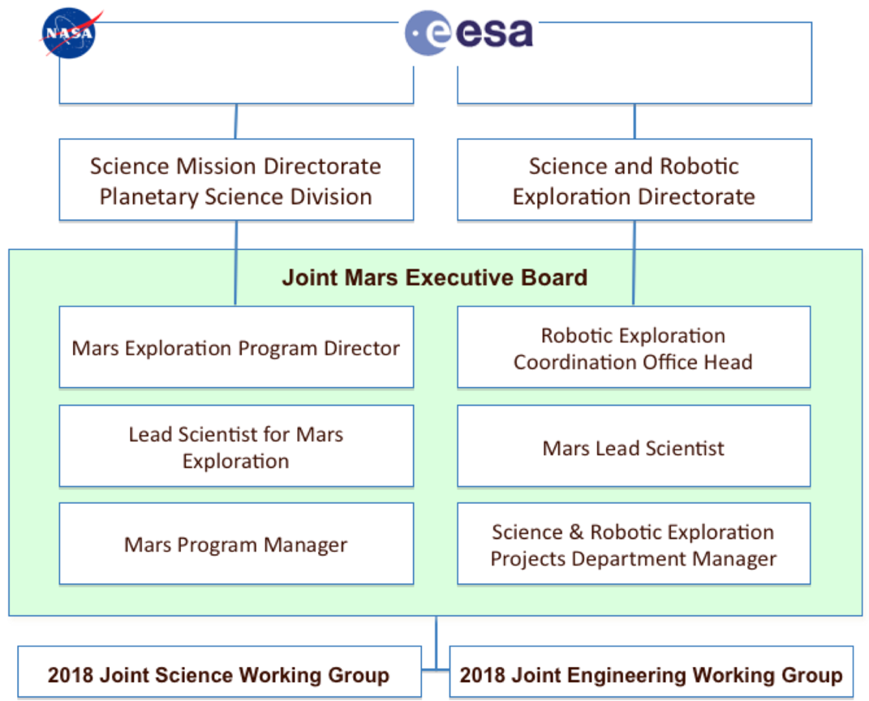

***Figure 1.*** *The relationship of the 2018 Joint Science Working Group, the 6-member Joint Mars Executive Board, and the 2018 Joint Engineering Working Group to their sponsoring organizations, NASA and ESA.*

The JSWG was composed of two co-chairs, fifteen internationally distributed members of the Mars science community, two engineering representatives, two ex-officio members of JMEB, and several

supporting experts (especially in the areas of surface operations, instruments, sampling systems, and science system engineering). All personnel are listed in Table 1. The JSWG conducted its work via weekly teleconferences (from July 6, 2011 to Jan. 25, 2012), e-mail exchanges, and intermittent sub-group activity. No face-to-face meetings were held. Several videoconference reports, and one face-to-face report, were provided to JMEB to report on interim results. Connections between JSWG and JEWG were maintained through periodic telephone tag-ups by the co-chairs of both groups, and through participation in each other’s meetings.

|  |  |  |
| --- | --- | --- |
| Name | Professional Affiliation | Interest/Experience |
| *Co-Chair* | | |
| Beaty, Dave | NASA-JPL/Caltech |  |
| Kminek, Gerhard | ESA-ESTEC |  |
| *Science Members* | | |
| Allwood, Abby | NASA-JPL/Caltech | Field astrobiology, early life on Earth |
| Arvidson, Ray | Washington Univ. | Mars surface geology, mission operations |
| Borg, Lars | Lawrence Livermore | REE, geochronology, member of CAPTEM |
| Farmer, Jack | Ariz. State Univ. | Astrobiology, field instruments |
| Goesmann, Fred | MPI for Solar Sys. Res., Lindau (D) | TC (PI) for MOMA in ALD |
| Grant, John | Smithsonian, DC | Geophysics, landing site selection, MER, MRO (HiRISE), MSL |
| Hauber, Ernst | DLR | Geology, ExoMars PanCam team, MEX, landing sites |
| Murchie, Scott | JHU-APL | IR spectroscopy, stratigraphy, MRO (CRISM) |
| Ori, Gian | IRSPS, Pescara, Italy | Sedimentology, planetary geology, MEX (HRSC) |
| Ruff, Steve | Ariz. State Univ. | MER operations, spectral geology. MGS (TES), MER |
| Rull, Fernando | Universidad de Valladolid | TC (PI) for raman instrument in ALD |
| Sephton, Mark | Imperial College | Organics extraction and analysis, ExoMars |
| Sherwood Lollar, Barb | Univ. Toronto Canada | Astrobiology, light stable isotopes |
| Smith, Caroline | Natural History Museum (UK) | Sample curation, contamination issues |
| Westall, Frances | CNRS, Orléans (F) | Field geology, paleobiosignatures |
| *Engineering representatives* | | |
| Pacros, Anne | ESA-ESTEC | ExoMars Instruments System Engineer |
| Wilson, Michael | NASA-JPL/Caltech | Advanced Studies and Program Architecture; Mars 2018 |
| *Ex-officio* | | |
| Meyer, Michael | NASA-HQ | Mars Lead Scientist |
| Vago, Jorge | ESA-ESTEC | ExoMars Project Scientist |
|  |  |  |
| Bass, Deborah | NASA-JPL/Caltech | Joint Operations Science Working Group |
| Joudrier, Luc | ESA-ESTEC | Joint Operations Science Working Group |
| Laubach, Sharon | NASA-JPL/Caltech | Joint Engineering Working Group |
| Feldman, Sabrina | NASA-JPL/Caltech | Joint Instrument Working Group |
| Trautner, Roland | ESA-ESTEC | Joint Instrument Working Group |
| Milkovich, Sarah | NASA-JPL/Caltech | Science system engineering support |

***Table 1.*** *Participants in the 2018 Joint Science Working Group. Additional technical experts contacted as a part of this study are listed in the acknowledgements.*

1. Scientific Objectives

## Introduction

Numerous discoveries from orbiting and landed spacecraft provide evidence of the past existence of aqueous environments on Mars, supporting the conclusion that ancient Mars was wetter (including the presence of liquid water), and possibly warmer, than it is today (NRC 2011 and references therein). In at least some parts of Mars’ geologic history, there are thought to have been environments that could have been inhabited by life as we know it here on Earth. NASA’s 2011 Mars Science Laboratory (MSL) mission will study surface geology and search for organic matter in surface materials, with the goal of evaluating the habitability of past environments and the potential for preservation of biosignatures. The proposed 2018 joint rover mission constitutes the next logical step in Mars exploration, with the primary scientific purpose to investigate whether life ever arose on the red planet.

The science objectives for the proposed Joint Rover Mission are derived from a combination of the science objectives of the ExoMars rover mission concept (see ExoMars Science Management Plan, 2010), the MAX-C mission concept (MRR-SAG 2009, Wilson et al 2010, and NRC, 2011) and the proposed MSR Campaign (E2E-iSAG, 2011) (of which MAX-C was envisioned as the first flight component). The MAX-C and ExoMars mission concepts, and the proposed MSR Campaign, all have a strong focus on evaluating past habitability, the potential for preservation of biosignatures and searching for evidence of life. The approach to addressing these objectives differs in each of the concepts: MAX-C would investigate surface geological materials *in-situ*, investigations of returned samples would build on the *in-situ* investigations of MAX-C, and ExoMars would carry out *in-situ* investigations with a strong focus on shallow subsurface exploration. The approaches of MAX-C, ExoMars and returned sample study do strongly overlap regarding landing site science criteria. They also require a good understanding of the local geology in order to assess past habitability and the potential for preservation of biosignatures, and to locate promising analytical targets in the search for evidence of life. The proposed 2018 joint rover mission would combine the three approaches and take advantage of the overlaps existing between them.

The simultaneous pursuit of *in-situ* and returned sample science objectives would be an important characteristic of the proposed Joint Rover Mission. These two pursuits are complementary because sample return science requires a solid foundation of *in-situ* science in order to select the best samples, and to interpret and document the geologic context of the samples so that sample analyses on Earth could be more confidently interpreted. The outcome of the mission’s *in-situ* investigations constitute an invaluable science result in their own right, and would provide a more immediate science return (i.e. cached samples could only be analyzed once they are brought to Earth).

**PREVIOUS MISSION/CAMPAIGN OBJECTIVES FROM WHICH JOINT ROVER MISSION SCIENCE OBJECTIVES ARE DERIVED**

**Proposed 2018 MAX-C mission science objectives (MRR-SAG, 2009)**

1. Primary Scientific Objectives: At a site interpreted to represent high habitability potential, and with high preservation potential for physical and chemical biosignatures:
   * Evaluate paleoenvironmental conditions
   * Characterize the potential for the preservation of biotic or prebiotic signatures
   * Access multiple sequences of geological units in a search for possible evidence of ancient life and/or prebiotic chemistry
2. Samples necessary to achieve the proposed scientific objectives of the potential future sample return mission would be collected, documented, and packaged in a manner suitable for potential return to Earth.
3. Secondary Scientific Objective: Address the need for long-term atmospheric pressure data from the martian surface.

**ExoMars rover mission science objectives (ExoMars Science Management Plan, 2010)**

1. To search for signs of past and present life on Mars
2. To characterize the water/geochemical environment as a function of depth in the shallow subsurface.

**Proposed Mars Sample Return Campaign Objectives (E2E-iSAG, 2011)**

1. Critically assess any evidence for past life or its chemical precursors, and place detailed constraints on the past habitability and the potential for preservation of the signs of life
2. Quantitatively constrain the age, context and processes of accretion, early differentiation and magmatic and magnetic history of Mars.
3. Reconstruct the history of surface and near-surface processes involving water.
4. Constrain the magnitude, nature, timing, and origin of past planet-wide climate change.
5. Assess potential environmental hazards to future human exploration.
6. Assess the history and significance of surface modifying processes, including, but not limited to: impact, photochemical, volcanic, and aeolian.
7. Constrain the origin and evolution of the martian atmosphere, accounting for its elemental and isotopic composition with all inert species.
8. Evaluate potential critical resources for future human explorers.

***Table 2.*** *Statements of previously proposed scientific objectives of the 2018 precursor mission concepts.*

|  |
| --- |
| **SCIENCE OBJECTIVES OF THE PROPOSED JOINT ROVER MISSION**  At a geologically diverse site interpreted to have strong potential for past habitability and for preserving the physical and chemical signs of life and organic matter:   1. Analyze the local geology over kilometer to sub-millimeter scales and to a depth of ~2 meters, with emphasis on supporting the objectives 2–4; 2. Investigate geological settings indicative of past habitability and favorable for preserving physical or chemical signs of life and organic matter; 3. Search for evidence of abiotic carbon chemistry, and for physical and chemical signs of life; 4. Select, establish context for, collect, and cache samples that could be returned to Earth for definitive analysis, addressing the following broad science goals in order of priority:    1. Critically assess evidence for life, pre-biotic chemistry, or abiotic organic matter in samples and determine their preservation potential;    2. Determine the magmatic, magnetic and atmospheric history in samples to constrain the mechanisms and ages for the accretion, early differentiation and thermal evolution of Mars;    3. Reconstruct the history of surface and near surface processes and climate change using detailed geochemical and mineralogical analyses;    4. Assess potential hazards and resources for future human explorers. |

***Table 3.*** *Proposed statement of scientific objectives for the proposed 2018 joint rover mission.*

## Discussion of proposed scientific objectives

### Precursor statement

There are four numbered science objectives for the proposed Joint Rover Mission and a critical precursor statement. The precursor statement describes the need to pursue the science objectives at a site that has suitable geological characteristics, as interpreted from orbital remote sensing data. Undertaking the science investigations at the kinds of locations described in the precursor statement would allow much greater opportunities to answer the science questions behind objectives 1–4. To maximize the likelihood of being able to access such a site, when one is identified, it would be important to retain the capability to land on a wide array of potential locations. These locations would be progressively whittled down as the landing site analysis and selection process proceed. For associated landing site requirements see Section 5.

### Objective 1: Analyze the local geology over kilometer to sub-millimeter scales and to a depth of ~2 meters, with emphasis on supporting the objectives 2-4

Objective 1 describes the fundamental task of investigating the geology of a site, on the surface and at depth, in order to understand the local geologic history. This kind of investigation could be carried out in many different ways, from simply identifying different geologic units to establishing detailed basin-wide sequence stratigraphic models or conducting millimeter-scale sedimentological mapping. However, planning a field campaign on another planet constrained by limited mission time and data return capabilities requires focusing on the specific science questions or goals to be addressed. For this reason, objective 1 states that the geological analysis should be performed with a view toward supporting the remaining objectives. One important aspect covered in objective 1 is the need to coordinate and integrate multiple data obtained from orbiting instruments, at large scale, with those collected by surface instruments, at local and microscopic (mineral grain) scale. Terrestrial studies show that multi-scale observations, on the surface and in depth, are essential for arriving at confident interpretations of scientific data.

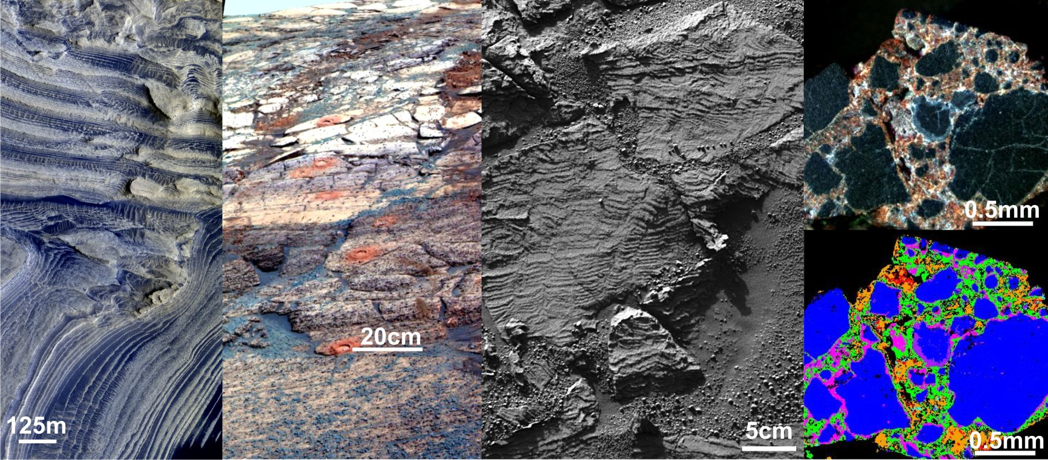

***Figure 2.*** *The proposed 2018 rover would perform a range of measurements at multiple scales, from kilometer scale (as measured across the landing site from multiple rover positions) to meter-scale (e.g. features contained in an outcrop) down to sub-millimeter-scale investigations (e.g. as measured in an abraded patch by instruments on the arm). Left: HiRISE image of layers within Becquerel Crater, courtesy NASA/JPL/University of Arizona. Left center: MER Pancam image of the Burns Formation, Endurance Crater wall. Rock Abrasion Tool (RAT) holes are 3 cm across. Courtesy NASA/JPL. Right center: MER microscopic image of festoon cross bedding at Overgaard (Meridian Planum, Mars), courtesy NASA/JPL. Upper right: Natural color image (obtained with 463, 522, 667 nm bands) of a terrestrial, hydrothermally altered volcanic breccia (Iceland) taken with an early prototype of the MMI instrument (from Sellar et al, 2011 and Nunez et al., in prep).  The data resolution is 62.5 μm/pixel. Lower right: Spectral End Member map of the above image, prepared using ENVI.*

### Objective 2: Investigate geological settings indicative of past habitability and favorable for preserving physical or chemical signs of life and organic matter

Objective 2 addresses the issues of: (1) whether the past environments, as recorded in the local geologic record, could have been inhabited by living organisms (based on what is known about habitats of life on Earth); and (2), whether the physico-chemical conditions, present at the time any organisms were alive and thereafter, were conducive to the preservation of chemical or morphological traces of those organisms (biosignatures) (Southam et al., 2007; Hoehler and Westall, 2010; Summons et al., 2011).

An important part of this assessment involves the evaluation of possible evidence for water, as recorded in such features as sedimentary structures, aqueous mineral assemblages, stratigraphy, and basin architecture. Another important part of assessing habitability would be establishing whether there were potential energy sources for life to use. It would also be valuable to understand the presence of bioessential elements (C, H, N, O, P, S, transition metals), and their possible preservation under the form of particular organic molecular structures. The latter would depend on physicochemical environmental factors (temperature, pH, salinity, radiation) affecting the stability of biomolecular bonds. These environmental factors play an important role in the preservation of potential organic geochemical biosignatures through diagenesis, together with oxidative degradation and the physical destruction of the biosignatures by impact shock, fragmentation, abrasion, and dissolution (NRC, 2007; Westall and Cavalazzi, 2011).

Scientifically interesting sites with past (or present) habitability potential would be identified from remote sensing data. These data would also provide some clues about the likelihood for biosignature preservation. However, only a limited amount of information about the parameters describing habitability or preservation could be obtained from orbit, and just at a regional scale. Only *in-situ* investigations could provide the level of detail and resolution necessary to really evaluate the habitability and the potential for preserving biosignatures at a site.

***Figure 3.*** *A key aspect of the strategy to search for the signs of life would be to concentrate the search in paleoenvironments with high potential for both habitability and preservation of the evidence. Based on experience on Earth, the habitability and preservation potential could vary at a local level, and would need to be evaluated at every paleoenvironment considered.*

### Objective 3: Search for evidence of abiotic carbon chemistry and for physical and chemical signs of life

Objective 3is primarily about searching for evidence of life, particularly past life. The types of signatures that would be sought include chemical signatures detectable *in-situ*, principally organic molecules of biological origin (biomarkers), as well as physical signatures detectable *in-situ*, such as macroscopic morphological features (reefs, stromatolites, thrombolites, microbially induced sedimentary textures and structures, organic deposits with physical character indicative of biological processing, etc.). Some types of biosignatures are unlikely to be recognized *in-situ*, such as fossilized microbial cells, as they typically require sample preparation steps that are not practical to carry out *in-situ*: these biosignatures are less relevant to objective 3, but would be relevant to objective 4.

In addition to searching for organic matter of biological origin, a high priority is also placed on the search for organic matter of any origin; that is, including potentially abiotic organic matter, such as compounds delivered to the surface of Mars by meteorite influx. Understanding where and why organic matter of abiotic or biotic origin could be preserved on Mars would be a critical and extremely useful piece of information to guide the search for signs of life. A key strategy for pursuing this objective would be to test the hypothesis that organic molecules are more likely to be preserved in the subsurface. This hypothesis predicts that the best chance for detecting organic material on Mars is in subsurface samples obtained from suitable buried deposits (that may be identified on the basis of surface outcrop analysis) where any organic deposits would have remained protected from surface conditions, preferably since their formation, by the overlying rock/regolith. An alternative hypothesis, which will be tested by MSL beginning in August 2012, is that organic molecules could be preserved in shallow rock cores that could be collected from surface rocks/outcrops (MSL’s drill will be able to penetrate and sample rocks to a depth of 5.5 cm; Anderson et al., in press).

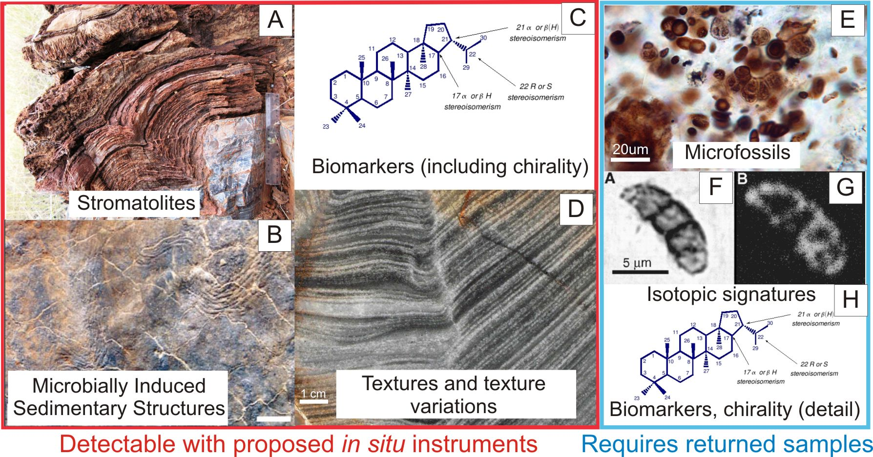

***Figure 4.*** *Types of biosignatures that may be detected in situ using the proposed 2018 rover payload (Objective 3) at left, with biosignatures that may only be detected in returned samples for comparison at right. (a) stromatolite from the 3.45 Ga Strelley Pool Formation, 15cm ruler for scale (Allwood et al., 2007). (b) “wrinkle structure” on fine-grained sandstone bedding plane surface, caused by wrinkling of microbial mats. Scale = 10cm (from Noffke et al., 2006). (c) and (h) Hopanoid molecule (http://www-eaps.mit.edu/geobiology/biomarkers/hopanoids.html) (d) Polished slab showing internal fabric of a conical stromatolite, with adjacent flat laminae, from Strelley Pool Formation. (e) microfossils from the 700Ma Draken Formation, sample courtesy A. Knoll. (see Knoll, 1982 for further reading) (f) Microfossil from the 850 Ma Bitter Springs Formation: Thin section photomicrograph (left) and 12C– scanning ion image (right) (from House et al., 2000).*

### Objective 4: Select, establish context for, collect, and cache samples that could be returned to Earth for definitive analysis addressing broad science goals

Objectives 4a to 4c derive directly from the proposed MSR Campaign objectives (E2E-iSAG, 2011) (see table 2). E2E-iSAG identified eight high priority science objectives that could be achieved through the analysis of returned samples, and ranked them in order of relative priority. These objectives are grouped under four general headings or Science Aims. Here, the eight objectives are re-grouped and presented as summary statements of the objectives pertaining to each Aim.

Objective 4 of the proposed 2018 joint rover mission is fundamentally about selecting the samples that would enable the proposed returned sample science objectives to be met in the future. Selection of the samples would be based on careful characterization of the local geology and identification of samples from within the geologic context interpreted to enable returned sample science questions to be answered. The proposed 2018 joint rover mission would need to establish the geologic context for the samples in such a way that the necessary information would be available to future researchers who are analyzing the samples, so that they may use the geologic context to constrain their interpretations. The additional payload inherited from ExoMars may provide information about the local geology, which could be useful for selecting samples. This is undoubtedly true of the PanCam data. In addition, if unequivocal evidence of indigenous martian organic material were detected, this would be a strong argument for caching.

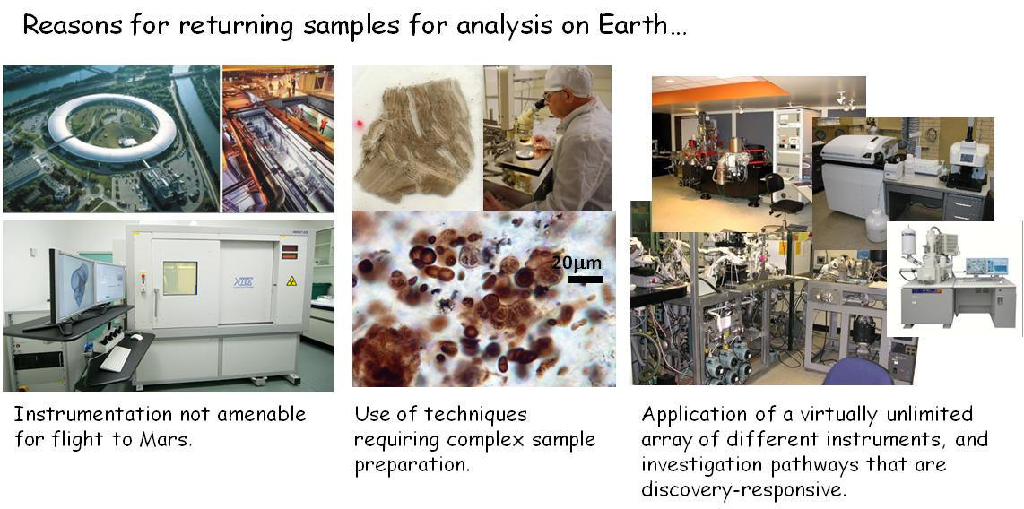

***Figure 5.*** *Some of the primary reasons for returning martian samples to Earth. Adapted from iMARS (2008) and E2E-iSAG (2011).*

1. Implementation Strategies to Achieve Objectives

The JSWG envisions a mission that uses five primary implementation strategies to achieve its scientific objectives.

SCIENCE STRATEGY (JSWG REF #S1): Land and operate a rover safely at a landing site of compelling scientific interest.

This strategy would be the foundation for achieving the science objectives of the mission, and has implications regarding the importance of landing site elevation, landing site latitude, and the significance of “go-to” landing sites (see discussion in Section 5). Technical developments that would have a major positive impact on scientific return include terrain relative navigation and hazard detection and avoidance (See Appendix 3). If implemented, these capabilities would allow targeting sites including comparatively more topographic hazards (desirable since scientific targets are commonly associated with topographic relief), thereby increasing the range of site options that could be considered, and perhaps more importantly, reducing the amount of driving needed to access the science targets.

SCIENCE STRATEGY (JSWG REF #S2): Equip the rover with a set of instruments capable of investigating the surface outcrops, rocks and soils at multiple scales across the landing site.

Detailed field-based investigations of surface outcrops, rocks and soils are a crucial strategy for meeting the proposed science objectives of the Joint Rover mission (Figure 2). Measurements of geological relationships and variations as seen in rock outcrops are the single most essential piece of any science investigation that seeks to understand the geology of an area, the potential habitability of past environments in that area, the potential for preservation of biosignatures in that area, and the nature, context and distribution of any potential signs of life that occur in the area. The surface-based investigations would provide critical evidence that addresses these science objectives, but would also lay critical foundations for subsurface investigations as well as investigations of returned samples.

This strategy implies that the system would have sufficient mobility range and lifetime, as well as adequate instruments and support equipment, to enable the rover to detect geologic variation at small and large scales across the landing site, recognizing the different kinds of rocks, minerals and soils present, and collecting the data needed to interpret how they formed and were subsequently modified. This information would be used to seek and investigate geological settings indicative of past habitability that are favorable for preserving physical or chemical signs of life.

SCIENCE STRATEGY (JSWG REF #S3): Have subsurface exploration capabilities on the mission, including a deep drill and sample acquisition system to support the characterization of the local geology and the search for martian organic chemistry and life.

The search for martian organic chemistry and life is the primary science objective of the ExoMars program of ESA and reflected in the stated objectives of the joint rover mission. A key hypothesis to be tested in this context is that complex molecules, whether related to abiotic-, prebiotic- or biochemistry, are better preserved in the sub-surface.

Mars has no magnetosphere and its atmosphere is more tenuous than Earth’s. As a consequence: 1) The ultraviolet (UV) radiation dose at the Martian surface is higher than that on Earth, and could rapidly damage exposed organisms or biomolecules that may have been present at any particular site; 2) UV-induced photochemistry can produce reactive oxidant species capable of destroying biomarkers; the diffusion of oxidants into the subsurface is not well characterized and constitutes an important measurement objective of the mission; 3) Ionizing radiation from Galactic Cosmic Radiation (GCR) and Solar Particle Events (SPE) can penetrate into the uppermost meters of the planet’s subsurface. This can cause a slow degradation process that, over many millions of years, can alter organic molecules beyond the detection sensitivity of *in-situ* analytical instruments. Complex molecules in buried deposits would be better protected from all these damaging factors and also from frequent diurnal and annual temperature variation.

The ExoMars Pasteur Payload, in combination with the ExoMars drill, was specifically selected to test this hypothesis via *in-situ* measurements.

E2E-iSAG (2011) also presented in their Section 4.1.3 scientific arguments for caching samples from the subsurface. See Section 10 in this report for relevant discussions, requirements and findings.

SCIENCE STRATEGY (JSWG REF #S4): Achieve a scientifically compelling cache of samples using several linked strategies, including careful establishment of geologic context, high selectivity from a wide range of possibilities, and sample encapsulation to preserve scientific value.

A key objective for the proposed 2018 joint rover mission would be to assemble a cache of samples that could be returned to Earth by a future mission (objective 4). E2E-iSAG (2011) concluded that certain scientific objectives relating to Mars are best addressed through the analysis of a carefully-selected set of samples returned to Earth. The scientific selection and caching of samples needed to meet those sample return science objectives would take part during proposed 2018 exploration operations.

An essential strategy needed to achieve objective 4 would be to combine and integrate field observations to provide a solid contextual foundation for analyses of samples on Earth. Significant effort would need to go into understanding geologic context, and the inter-relationships between samples. The processes of sample selection and context documentation would both involve geological field work (as described in Strategy #S2), comprising a large number of reconnaissance level measurements that would lead to selection of targets for fewer detailed, up-close measurements. This in turn would lead to selection of a small number of targets for sampling and caching (Fig. 6). This hierarchy of observations was established based on consideration of terrestrial field studies and MER surface operations (E2E-iSAG, 2011), and is reflected in the operations strategy, presented in Section 11.

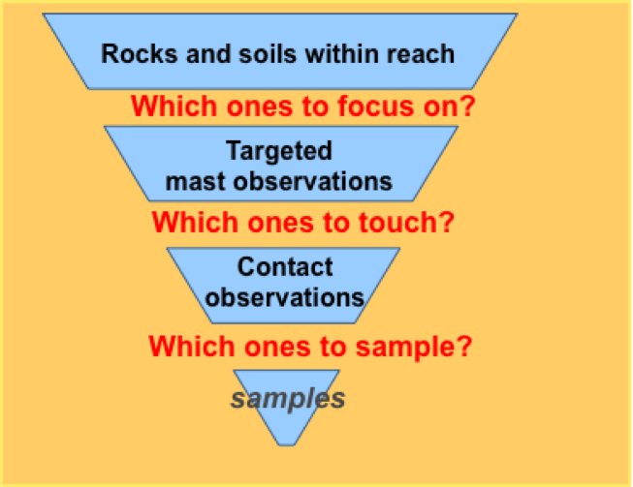

***Figure 6.*** *Many more rocks would need to be imaged than interrogated closely, and more rocks would be examined in detail than are actually cached (adapted from E2E-ISAG, 2011).*

Note that to meet the science objectives does not require a strategy of finding "the perfect sample". Obtaining a well-selected set of materials that sample a diverse range of promising targets within a sensibly selected field site would be sufficient. Given an appropriate field site, there would be multiple ways to assemble an “outstanding” set of samples.

Another aspect of strategy #4 is driven by reasons of operational efficiency. The samples would need to be acquired as the geologic picture is progressively uncovered (field geologists on Earth typically sample this way), as opposed to attempting to fully interpret the geology before commencing sample selection. Of course, it would be ideal to fully understand the geology before selecting samples, but mission resources would not permit the enormous amount of back-tracking that would entail. Even in terrestrial field geology expeditions it is typically impractical to collect all of the field data first, to select and acquire samples later. A consequence of this is that later sample collection benefits from substantially improved understanding of contextual information while the early sample collection would not.

A further aspect of the strategy relates to the encapsulation and of samples and preparation of the cache to be left on the surface of Mars for a potentially long period of time. The date at which it may be possible to return the sample cache is not yet known, so the samples would need to be packaged in a way that preserves their scientific value for many years.

SCIENCE STRATEGY (JSWG REF #S5): Pursue the search for martian organic chemistry and life using three complementary investigation strategies: observation of field relationships, in-situ analysis on Mars, and analysis of returned samples.

There are many different types of observations that may provide evidence of life, including morphological, mineralogical, organic geochemical, isotopic, and other observations. Which of these types of evidence might be preserved in the geologic record on Mars is dependent on the character of hypothetical martian life forms, the nature of the environment in which the organism lived, and most importantly the integrated effect of all of the geological processes that have affected the rocks since the organisms existed. Because of these uncertainties, it is crucial to have a search strategy that includes multiple approaches. The observation of field relationships would be important not just for establishing the geologic context of the landing site, but also many potential lines of evidence for life could be detected in this way. A primary importance of the on-board laboratory, and its associated deep sampling system, would be that it would test the hypothesis that organic molecules are better preserved in the shallow subsurface than at the surface (see Science Strategy S#3 in this section). For life as we know it on Earth, organic molecules are a common sign of life. The capability for organic measurements on the surface of Mars is an essential part to guide the selection of samples for caching (see Section 9). Finally, the return of samples to Earth would allow investigation by a full range of laboratory techniques, and with detection limits, accuracy, and precision far better than could be achieved at Mars.

1. Achieving a Scientifically Compelling Landing Site

Fundamental to meeting the scientific objectives of the proposed 2018 joint rover mission as a stand-alone mission, and meeting the scientific objectives of the associated proposed MSR Campaign, would be the selection and safe landing at a site on Mars that hosts the desired materials for in-situ and Earth return sampling needs, and development of a joint rover that could access and sample these desired materials. Engineering capabilities of the entry, descent and landing (EDL) system, and the operational characteristics and constraints of the rover itself, could significantly influence the pool of landing sites available for a proposed 2018 joint rover mission landing site selection process (see Appendix 3). Subsequent JSWG findings take these engineering factors into consideration and are discussed below.

## Landing site elevation

The functional requirements related to the landing site for the proposed 2018 joint rover mission are derived from those identified by E2E-iSAG (2011), which are endorsed by the JSWG. The engineering considerations that lead to elevation limitations are described in Appendix 3. The E2E-iSAG reviewed previously considered and new sites against four threshold criteria to establish requirements for elevation and latitude that would enable a reasonable number of candidate sites to be considered for meeting the science objectives of the proposed MSR Campaign. These criteria define priorities for the types of science targets that should be available at the landing location. They include: 1) the presence of subaqueous sediments or hydrothermal sediments (equal 1st priority), or of hydrothermally altered rocks or low-temperature fluid-altered rocks (equal 2nd priority); 2) the presence of outcrops containing aqueous mineral phases (e.g., phyllosilicates, carbonates, sulfates); 3) sites of Noachian/Hesperian age, based on stratigraphic relations and/or crater counts; and 4) the presence of igneous rocks with known stratigraphic relations, of any age, as identified by primary minerals.

E2E-iSAG (2011) identified candidate landing sites satisfying these threshold scientific criteria, primarily for the purpose of framing the engineering requirements for landing capabilities. These sites, referred to as “reference landing sites”, were derived from a review of the ~60 landing sites proposed for the MSL mission (Grant et al. 2011), and of ~25 additional community-proposed landing sites identified for possible future missions (originating through a 2010 Future Landing Sites call). These sites are not intended to be favored over any others that may eventually be proposed. A recommendation for the actual site selection process for the proposed 2018 joint rover mission is proposed in Section 5.5 of this report.

Many of the sites considered for MSL, and/or proposed for possible future missions, overlap in science objectives with the proposed MSR Campaign and have been partially, to nearly completely, characterized by high resolution spatial and spectral mapping (e.g., from MRO, MEX, and Odyssey orbiter missions). The E2E-iSAG team chose sites expected to provide a range of science and engineering characteristics that could be used to help define landing and roving requirements. Sites with substantial existing image coverage were favored because such data enable meaningful engineering studies of the proposed MSR Campaign EDL system requirements.



***Table 4.*** *The reference landing site set proposed by E2E-iSAG (2011). Note that a mission that could land at these reference sites would also be able to land at Gale Crater (latitude = 4.6 S; elevation = –4.5 km), the landing site for MSL.*

The seven reference landing sites identified by the E2E-iSAG are described in Table 4 and range in latitude from approximately 14˚S to just over 33˚N. Elevations range from –0.6 km to approximately –3.0 km (relative to the MOLA aeroid). Ideally, the functional requirements of the proposed 2018 mission’s landing system would encompass the E2E-iSAG (2011) reference landing sites. Additional limitations in either latitude or elevation accessibility would likely reduce the number of candidate sites that could be considered for the proposed 2018 joint rover mission. For example, setting the baseline landing elevation at –1 km, 10 out of the 60 or so sites considered for MSL (Grant et al., 2011) would need to be ruled out (including the Nili Fossae Trough reference site). Dropping the baseline elevation to –1.5 km would further eliminate another 16 sites from consideration, including one more E2E-iSAG reference site, as well as other sites that were highly rated during the MSL selection campaign. Reducing the maximum altitude landing capability to –2 km would eliminate yet an additional 9 candidate MSL sites from consideration, including 3 more E2E-iSAG reference sites (and would put a 4th, NE Syrtis at –2.1 km, at risk). While a maximum landing site altitude of –1 km has some impact on potential landing sites, a majority of the sites proposed for MSL, and those considered as reference sites by the E2E-iSAG, could remain under consideration. This provides a sound scientific basis for establishing –1 km as the site’s maximum baseline for the proposed 2018 joint rover mission. A –2 km landing baseline would mean that a majority of sites proposed for MSL and considered as reference sites by the E2E team, would be eliminated from consideration. Hence, a –2 km or lower landing elevation is established as the threshold elevation recommendation for the mission.

DRAFT REQUIREMENT (L1; JSWG REF #R1): The project system shall be able to land at altitudes of up to [–1.0] km relative to the MOLA aeroid. Threshold requirement: The project system shall be able to land at altitudes of up to [–2.0] km relative to the MOLA aeroid.

## Landing site latitude

The engineering considerations related to latitude limitations are described in Appendix 3. The adoption of a baseline of 25°N for the northern limit would eliminate just one E2E-iSAG reference site from consideration. However, a reduction to 13°N would eliminate up to five of the seven reference sites. In particular, such a limitation would rule out all of the high interest sites west-northwest of Isidis (e.g., NE Syrtis, Nili Carbonate, Jezero, Nili Trough).

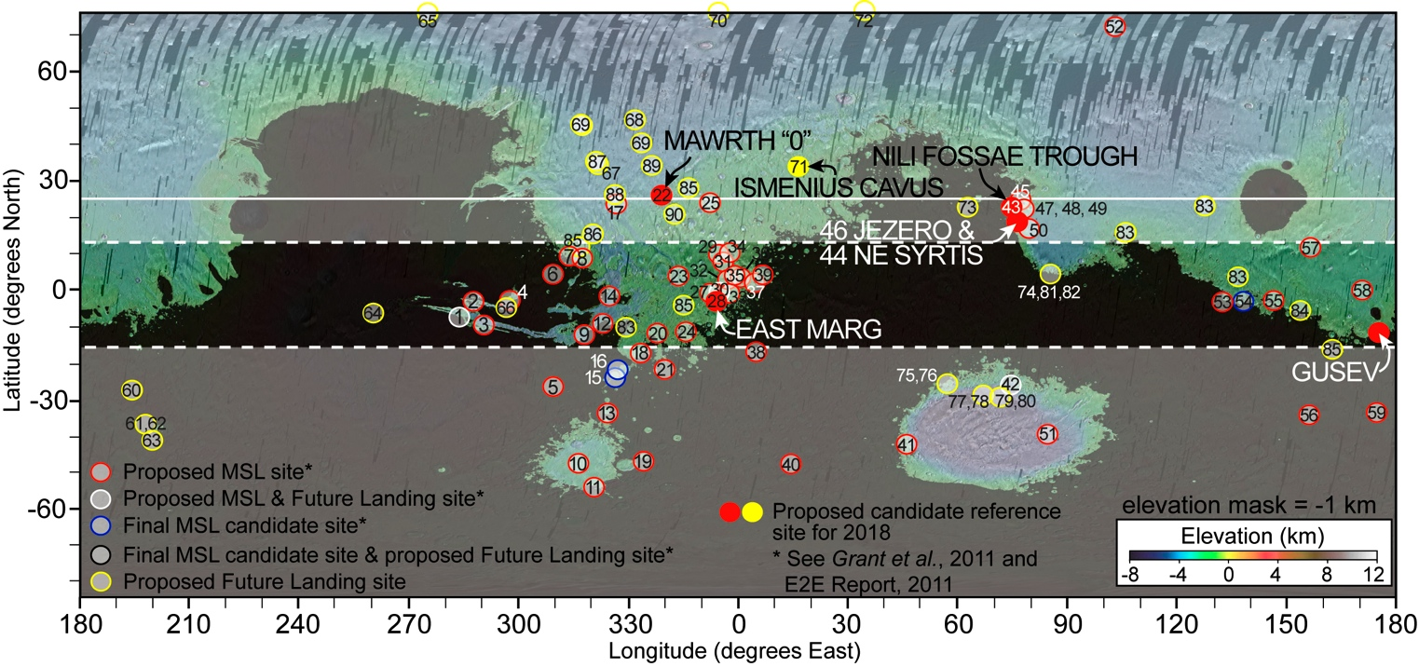

***Figure 7.*** *Map of the candidate landing sites proposed for MSL (red, blue, and black outlined dots), sites proposed for future missions (yellow and black outlined dots), and reference sites for the proposed 2018 joint rover mission as proposed by E2E-iSAG (2011). Areas shaded in black lie above –1 km (MOLA datum) and hence above the nominal requirement recommendation for maximum landing elevation. Areas shaded in white and bounded by the solid and dashed white lines indicate latitude bands exceeding the recommended nominal and threshold requirements for the landing site, respectively. Based on the distribution of the sites considered for MSL and proposed for future missions, stronger constraints on the elevation and latitude limits on the landing site beyond those identified in this report for the nominal, and especially the threshold requirements, would result in a significant reduction in the number of sites that could be considered.*

Limiting the baseline southern latitude limit for landing from 25°S to 15°S would eliminate 15 candidate MSL sites from consideration for the proposed 2018 joint rover mission, where roughly half of these are at latitudes greater than 25˚S. A reduction below 15°S would also eliminate an E2E reference site from consideration (see Table 4). Although the Holden and Eberswalde crater landing sites considered for MSL lie in the 15–25°S latitude band, similar classes of sites (e.g., Jezero crater) may be available in the 15–25°N band (with the caveat that some form of landing hazard avoidance may be required to enable landing on the floor of Jezero crater, Grant et al., 2011).

### Importance of Northern vs. Southern Latitude Terrain for Candidate Landing Sites

Many candidate sites in the 15–25°N band include very interesting mineral assemblages in unique settings. For example, the Arabia/Syrtis region, in the 15°–25°N latitude band, contains numerous scientifically compelling, relatively low-elevation, ancient terrain with interesting mineral assemblages. This means that constraining the northern limit of possible landing site latitudes from 25°N to 15°N would likely have a greater impact on mission science potential than a comparable reduction from 25°S to 15°S (see Table 5). In case the landing site latitude band requires narrowing, every attempt should be made to retain access to northern latitudes —up to 25°N. To further illustrate the importance of northern latitudes, limiting the mission’s acceptable landing site latitude band to 13°N–15°S would eliminate 25 landing sites proposed for MSL. It would also eliminate all of the E2E reference sites, except Gusev crater and East Margaritifer Chloride. Finally, a large majority of the sites proposed as possible candidates for future missions would also be out of bounds for consideration if the landing site latitude were restricted to the 13°N–15°S range. A further reduction in the acceptable latitude range to the band 10°N–10°S would eliminate on the order of 40 MSL candidate sites and six out of seven E2E-iSAG reference sites from consideration for the proposed 2018 joint rover mission. Based on the above discussion, the desirability to consider a relatively large number of MSL, possible future mission, and E2E reference landing sites, provides the justification for establishing a *baseline* landing site latitude range recommendation of 25°N–15°S for the proposed 2018 joint rover mission. Because a significant reduction in the number and variety of potential landing sites would result from narrowing this range even further, the *threshold* latitude range is specified to be the same 13°N–15°S.

DRAFT REQUIREMENT (L1; JSWG REF #R2): The project system shall be capable of landing and operating at sites between 25°N and 15°S latitude, selected as late as [six] months before launch without compromising overall mission safety.

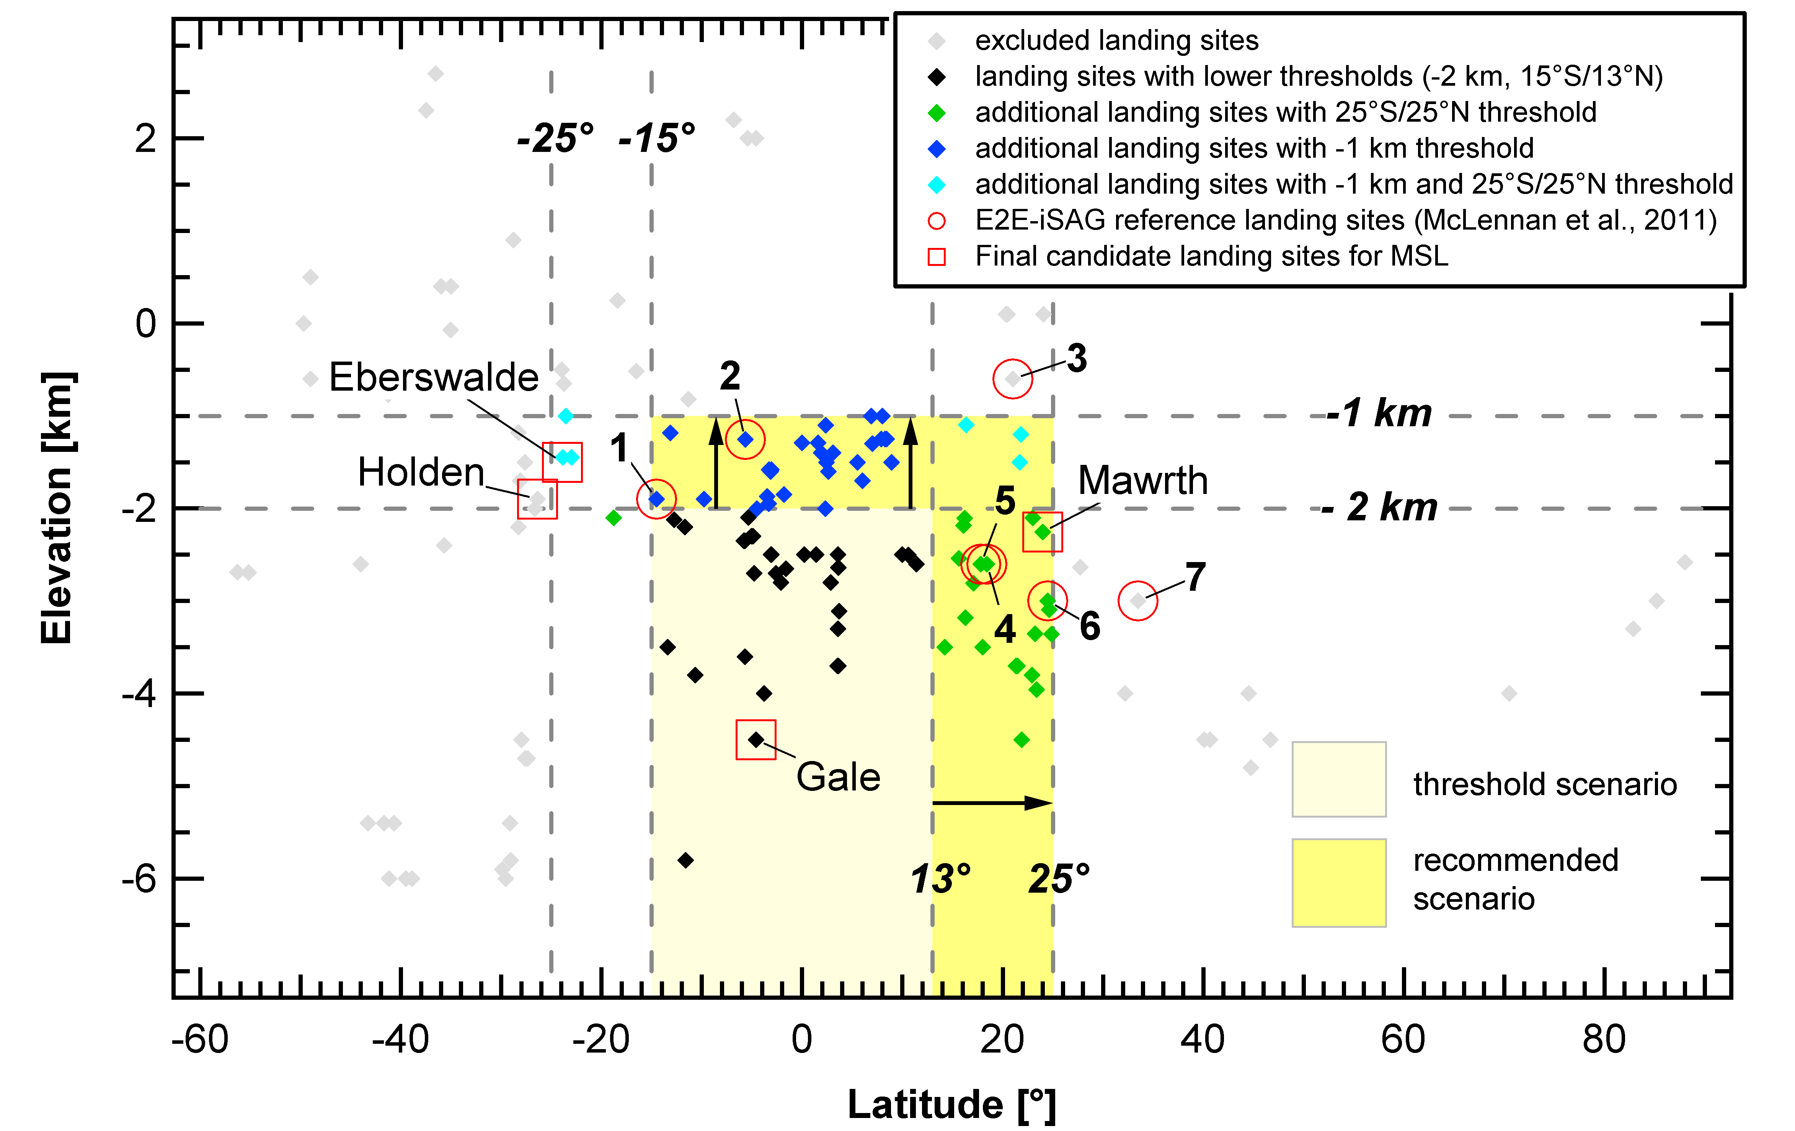

***Figure 8.*** *Elevation vs. Latitude of proposed future landing sites. Thresholds more constraining than the recommended 25°N–15°S latitude band (such as 13°N–15°S), and –2 km maximum site elevation, would result in the elimination of a large number of scientifically promising landing sites, including several E2E-iSAG reference landing sites. For a full listing of the proposed landing sites, see Appendix 2.*

|  |  |
| --- | --- |
| Number of Sites Considered (MSL and Future)* | 145 |
| Baseline 25°N–15°S and –1 km | 92 |
| Threshold 13°N–15° S and –1 km | 65 |
| Threshold 13°N–15°S and –2 km | 38 |

*Number is higher than stated in text because some sites include multiple ellipses

***Table 5.*** *Impact of Landing Site Latitude and Elevation on Number of Potential Sites Considered.*

## The importance of “go-to” landing sites

The scientific return of rover missions depends critically on the ability to access the scientifically most promising targets in the landing site region. The maximum distance from anywhere in landing ellipse to the scientific target(s) of interest would define the requirement for the traverse path that a rover should be able to cover. Another important requirement would be that the drop zone for the sample cache would need to be located within the landing ellipse. For some landing sites, the scientific targets might be entirely located within the perimeter bounding the landing site ellipse (assumed to have a diameter of 20 km for the proposed 2018 joint rover mission), such as is the case for Mawrth Vallis. Such sites are called “land-on” sites. However, many of the scientifically most promising landing sites could be “go-to” sites. That is, sites in which the highest priority targets could be located outside the landing ellipse. In the latter case, the minimum distance a rover would have to cover is characterized by the distance from anywhere in the landing ellipse to a location outside of the landing ellipse (~20 km) and back into the landing ellipse to reach the cache Drop zone (Fig. 9a). Even if only one ROI were visited, the resulting traverse length would necessarily exceed 10 km. In any realistic scenario, this value would be >>10 km, because the traverse path cannot not be perfectly straight (due to the need to avoid natural obstacles or to implement science reconnaissance activities). Additionally, it could be expected that visiting more than one ROI would be necessary to assess the geological diversity of a particular landing site. Hence, a traverse distance mobility requirement capable of supporting “go-to” landing sites is considered very important for ensuring the scientific success of the mission.

Among the ~60 landing sites proposed for the MSL mission (Grant et al. 2011) and the ~25 additional community-proposed landing sites (see Appendix 2), many are “go-to” sites. For example, 4 out of the 6+1 reference landing sites identified in the E2E-iSAG (2011) (Table 4) are “go-to” sites, where the scientific investigation of astrobiologically interesting materials and igneous rocks (both identified as high priority targets) requires traversing beyond the boundaries of the landing ellipse (Fig. 9b). Based on the response from the scientific community to an initial call for orbit-based imaging targeting (e.g. MRO HiRISE) of candidate landing sites for future landed missions, it is clear that ”go-to” sites continue to be very important, and may represent some of the highest priority sites for the proposed 2018 joint rover mission.

A rover traverse length limited to 10 km or less would result in the elimination of all “go-to” sites, considering the assumed landing site footprint of 20 km diameter. The eliminated sites represent many of the most promising landing sites and could compromise the success probability of the mission. Even at landing sites where the targets are located within the ellipse, a traverse distance of less than ~10 km is considered to be insufficient, given the mission’s scientific objectives.

|  |
| --- |
| **DRAFT REQUIREMENT (L1; JSWG REF #R3):** The project system shall include a rover with the capability of a total traverse path length of at least [20] km. |

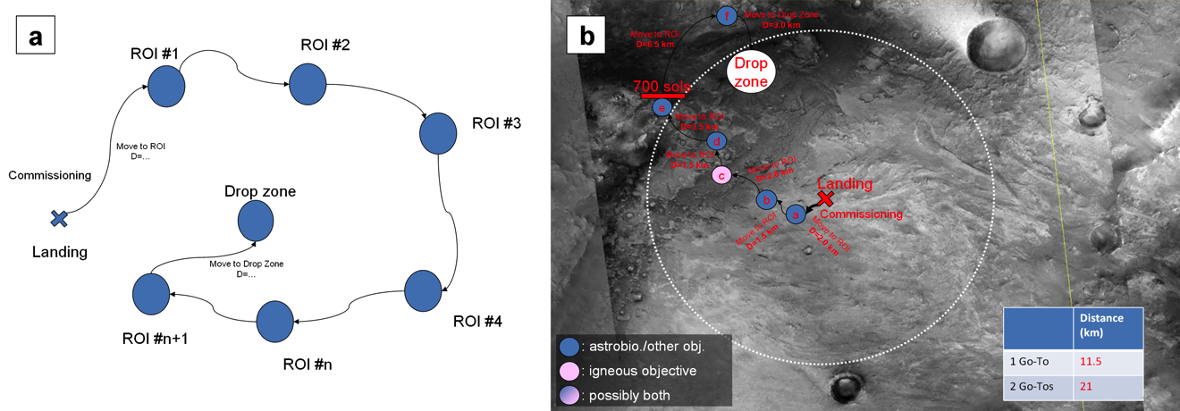

***Figure 9.*** *(a) Sketch of rover traverse for the proposed 2018 joint rover mission. After commissioning, the rover would drive to several regions of interest (ROI) before reaching the cache Drop zone, which is proposed to be located somewhere within the original landing site ellipse (to assure that future components of the Mars Sample Return mission design would be able to retrieve the cached samples). (b) Scenario of rover traverse at Nili Fossae Trough, one of the 2018 reference landing sites identified by McLennan et al. (2011). The required traverse distance to analyze the two “go to” ROIs, assuming landing at the center of the ellipse, would be 21 km. Even the analysis of only one “go to” ROI would require a traverse >10 km (assuming that the diameter of the 2018 landing ellipse would be 20 km).*

The current surface operation scenario described in Section 11 of this report cannot accommodate a traverse of 20 km within the nominal baseline mission duration. Improved landing technology, as described in Appendix 3, would increase the science return of the mission by spending more time at the regions of interest using the considerable science capabilities of the rover system.

## Landing Site Selection Process

A robust community-based landing site selection process would be required. This recommendation is driven by several important considerations. First, engaging the community ensures the full breadth of the community’s expertise is used to ensure the best possible interpretation of the landing site’s setting, which is crucial for ensuring the landing site’s potential for satisfying mission objectives. The requirements necessary to select the best landing site for this missions require input and consensus of the science community beyond that represented by the mission’s science and engineering teams. The samples that would be eventually returned to Earth would constitute a legacy of the science community for many years to come, and their breath and quality would be largely determined by the nature of the landing location. Additionally, community inputs are required to collect site proposals and to help with the evaluation of the various candidate sites. The latter includes the collection and interpretation of orbital data sets of the sites and the iteration with engineering teams to verify the compliance (or otherwise) with engineering requirements. Based on the site selection process employed for the MER and MSL missions, these requirements are best satisfied by a series of community workshops where the science and engineering characteristics of the sites are presented and matured over time. To ensure that the landing site eventually selected receives the benefit of a comprehensive evaluation and possesses a well understood setting including several high-priority science targets for sampling and *in-situ* analysis, the ability to select the landing site as late as six months before launch is strongly recommended.

|  |
| --- |
| **FINDING (JSWG REF #F1):** A robust community landing site process would be required to ensure that the landing site eventually selected would be capable of satisfying all of the mission objectives. |

1. Scientific Instruments

## Introduction

The JSWG assumed that the payload would include all nine Pasteur Payload (PPL) instruments and supporting elements selected by ESA (in 2004 and 2007) for the previously proposed ExoMars mission (see Appendix 1 for the assumption). The JSWG was provided with descriptions and proposed implementation approaches of the PPL instruments (see Appendix 4, and thumbnail descriptions in the Section 6.2). However, JSWG did not reevaluate these instrument selections, their priority, or their proposed placement, configuration or usage. Instead, the JSWG’s charter task was to consider the capabilities of the PPL and determine which, if any, measurements proposed for the former MAX-C mission would need to be included in the proposed 2018 joint rover mission to achieve its science objectives (Section 3 of this report). JSWG was asked to assume that any additional instruments would selected using competitive processes. A key point of focus for team discussions was developing enough definition of these instruments to provide the basis of the competition.

To summarize, the JSWG concluded that four additional instruments (to be described in Section 6.3 of this report) would be necessary: probably one on the mast and probably three on a robotic arm (although it is possible that one or more of the measurement needs nominally assigned to the arm may be achievable on the mast). Several other instruments, beyond the four identified, would also have been desirable, but given that the scientific baseline for the instrument payload and support hardware is already considered very ambitious, they are not discussed in this report.

## Summary of Pasteur Payload (PPL) Instruments

### Externally-mounted instruments

PanCam: Panoramic Camera System

Accommodated on the mast, PanCam has been designed to perform digital terrain mapping. A powerful suite, consisting of a wide-angle, stereoscopic, color camera pair, complemented by a high-resolution, color camera, PanCam would allow characterizing the geological environment at the sites the rover would visit, from panoramic (tens of meters) to mm scale. It would also be used to study outcrops in detail, and to image samples collected by the drill before they are delivered to the analytical laboratory for analysis. PanCam could also be used for atmospheric studies.

The instrument priorities of the ExoMars and MAX-C rover mission concepts overlap in the area of panoramic imaging. The planning for ExoMars has advanced to the point where an instrument has been selected (the PanCam instrument), and its properties could be evaluated. This one instrument (out of the nine that constitute the Pasteur payload) is described in detail in Appendix 5, since a key decision to be made by JSWG was whether to recommend that this instrument slot be re-competed or not. The analysis and decision regarding its ability to satisfy the combined objectives of the proposed 2018 joint rover mission are presented in Section 6.3.1.

|  |
| --- |
| **DRAFT L1 REQUIREMENT (L1; JSWG REF #R4)**: The project system shall accommodate the Pasteur Panoramic Camera System (PanCam). |

WISDOM: Water Ice and Subsurface Deposit Observations on Mars

WISDOM is a shallow ground-penetrating radar capable of characterizing subsurface stratigraphy to a depth of ~3 m, with a vertical resolution in the order of 2 cm (see Appendix 4 for further detail). These capabilities support construction of subsurface maps. Most importantly, WISDOM would help identify layering and help to select interesting buried strata from which to collect Deep Drill samples (~2 meters) for analysis. This capability would be crucial in determining where to drill, since drilling would be a resource-demanding and time-intensive activity. Targets of particular interest to meet mission objectives are well-compacted, sedimentary deposits that could have been associated with past water-rich environments. On the basis of analyses performed on outcrops with other instruments, WISDOM could be used to map how the buried parts of interesting formations are arranged in the subsurface, and determine where best to sample. It is in such buried deposits that the mission may have a good chance to access samples containing organic molecules protected from the surface ionizing radiation and oxidant environment.

|  |
| --- |
| **DRAFT L1 REQUIREMENT (L1; JSWG REF #R5)**: The project system shall accommodate the Pasteur Shallow Ground-Penetrating Radar (WISDOM). |

Ma_MISS: Mars Multispectral Imager for Subsurface Studies

Ma_MISS is a miniaturized IR spectrometer integrated into the drill tool, which would image the borehole wall created as the drill is operated (see Appendix 4 for further detail). Ma_MISS would be used to study subsurface stratigraphy and geochemistry *in situ*. This could be very important, as samples may be altered following extraction from their cold (–75ºC), subsurface conditions. The analysis of unexposed material by Ma_MISS, together with data obtained by the spectrometers located inside the rover, would be crucial for unambiguous interpretation of the pristine character of Martian regolith at the landing site.

|  |
| --- |
| **DRAFT L1 REQUIREMENT (L1; JSWG REF #R6)**: The project system shall accommodate the Pasteur Borehole Infrared Spectrometer (Ma_MISS). |

CLUPI: Close-Up Imager

CLUPI is a high-resolution, microscopic, color imager mounted on the drill box that would be used to perform detailed, structural studies of outcrops and soils with a spatial sampling of 7 µm/pixel (see Appendix 4 for further detail). CLUPI includes a mechanism allowing it to focus from a few cm to infinity, enabling imaging of targets at a range of distances. CLUPI would provide detailed images of samples collected by the 2-m ExoMars Drill (see Section 7.2) before they are delivered to the analytical laboratory for further analysis. A mirror assembly would allow CLUPI also to observe the cuttings produced during drilling operations and the regolith excavated by wheel trenching.

|  |
| --- |
| **DRAFT L1 REQUIREMENT (L1; JSWG REF #R7)**: The project system shall accommodate the Pasteur Close-up Imager (CLUPI) on the 2-meter Drill System. |

### Instruments in the Analytical Laboratory Drawer (ALD)

The 2018 joint rover mission is envisioned to include an on-board laboratory, referred to as the Analytic Laboratory Drawer (ALD), that was previously designed as a part of the ExoMars mission concept. The ALD would contain five instruments, a method of receiving sample material from the ExoMars drill, a sample crushing system, and a system for distributing the crushed material to the instruments. The latter two functions are collectively referred to as the Sample Preparation and Distribution System (SPDS). The ALD would be able to provide a very complete characterization of the samples mineral composition and organic content. The samples would not be recoverable after analysis. A more detailed description of the ALD is presented in Section 7.6 below.

MicrOmega: Micro-Observatoire pour la Minéralogie, l’Eau, les Glaces et l’Activité

MicrOmega is a visible and infrared imaging spectrometer (see Appendix 4 for further detail). Following the crushing of a collected sample, MicrOmega would be the first instrument to observe it within the analytical laboratory. MicrOmega would study mineral grain assemblages to try to unravel their geological origin, structure, and composition. These data would be vital for interpreting past and present geological processes and environments on Mars. Because MicrOmega is an imaging instrument, it could also be used to identify grains that are particularly interesting, e.g. carbonates, sulfates, and clays, and assign their position coordinates (within an individual sample) as targets for subsequent Raman and MOMA-LDMS observations (see Figure 10). This would allow investigation of the same mineral assemblages with complementary techniques, resulting in a very complete characterization.

RLS: Raman Laser Spectrometer

The Raman spectrometer could detect silicate, clay, carbonate, oxide, and sulfate minerals indicative of igneous, metamorphic, sedimentary, and especially water-related processes (e.g. chemical weathering, chemical precipitation from brines, etc.) (see Appendix 4 for further detail). In addition, it would be capable of detecting a wide variety of organic functional groups. These capabilities make it a high-priority instrument for establishing the geological context of samples, for assessing habitability, and for first-order detection of bulk organics and certain key pigments.

MOMA : Mars Organic Molecule Analyzer

MOMA would be able to identify a broad range of organic molecules with high analytical specificity, even if present at very low concentrations, supporting investigation of the possible origin, evolution, and distribution of complex organics and life on Mars (see Appendix 4 for further detail). These studies would be carried out through two main activities: 1) the detection of organic molecules, and 2) the possibility to establish their biotic or abiotic source by identifying the distribution of molecules and their chirality. MOMA has two basic operational modes supported by different sub-systems: 1) Laser Desorption Mass Spectrometry (MOMA-LDMS), to study large macromolecules and inorganic minerals; and 2) Gas-Chromatograph Mass-Spectrometry (MOMA-GCMS), for the analysis of volatile organic molecules such as amino acids. MOMA-LDMS uses a high-power laser to release organics and analyze their molecular fragments in the gas spectrometer. It requires no consumables and could therefore be used many times. In MOMA-GCMS, crushed sample material would be placed in a single-use oven, which would be sealed and heated stepwise to high temperature. The resulting gases are separated by gas chromatography and analyzed by the mass spectrometer (shared with LDMS). There would be 40 single-use ovens within the MOMA-GCMS. Most of the GCMS analyses would be conducted in the presence of a derivatization agent that could render small organic compounds (such as amino acids) volatile.

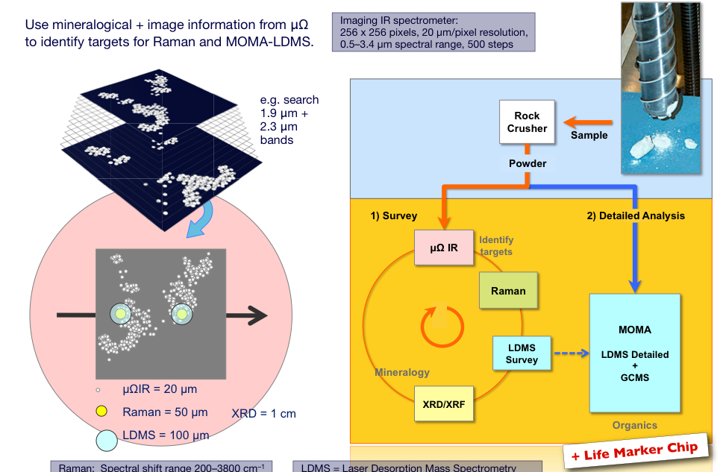

***Figure 10.*** *Illustration of sample analysis procedures in the ALD. Samples are crushed first, then MicrOmega analyzes the crushed particles. Mineralogical and imaging information from MicrOmega would be used to identify targets for Raman and MOMA-LDMS. XRD/XRF completes the mineralogical characterization. MOMA and LMC are used to search for organics.*

MARS-XRD: Mars X-Ray Diffractometer

MARS-XRD is a miniaturized instrument that combines X-ray diffraction and X-ray fluorescence to help determine the complete mineralogical and chemical composition of the crushed samples (see Appendix 4 for further detail). The instrument’s targets include all the silicate minerals such as clays, and sulfates, carbonates, sulfides, or other aqueous minerals that could be indicative of a past Martian hydrothermal system capable of preserving traces of life. The X-ray fluorescence capability could provide elemental composition information.

LMC: Life Marker Chip

LMC performs a liquid extraction of molecules from sample material delivered to the ALD, and simultaneously detects multiple molecular biomarkers and non-biogenic organic molecules using antibodies in a microarray inhibition/competition immunoassay (see Appendix 4 for further detail). The antigenic targets are predefined with antibodies made against them. Each LMC chip would contain a library of antibodies for resolving simultaneously up to 25 target molecules. The present proposal is to use this instrument to provide an independent verification of the outcome of MOMA. As such, LMC would be able to process a reduced number of samples (four).

|  |
| --- |
| **DRAFT REQUIREMENT (L1; JSWG REF #R8):** The project system shall accommodate the Analytical Laboratory Drawer (ALD) containing the following Pasteur instruments:   * MicrOmega IR * Raman Laser Spectrometer (RLS) * Mars XRD * Mars Organic Molecule Analyzer (MOMA) * Life Marker Chip (LMC). |

The main technical characteristics of the Pasteur instruments are summarized in Appendices 4 and 5.

## New instruments to be competed

The recommended four competed instruments would include a mast-mounted mineralogy instrument; to complement PanCam and help analyze geology at larger scales with the objective to select interesting rocks for more detailed studies; as well as a close-up microscopic imager, a mineralogy instrument, and an elemental chemistry analyzer, accommodated on a dexterous robotic arm, to examine surface rocks and soils. These competed mast and arm instruments are needed for three primary reasons:

* **Number of target interrogations needed to understand field geology.** The E2E-iSAG (2011) discussed the need for arm- and mast-mounted measurement capabilities to interpret local geology. This geological understanding would be needed both to select samples and to ensure adequate context for those samples. In the case of the proposed 2018 joint rover mission, these measurement capabilities would be needed in support of the proposed 2018 sample return-related objectives, but also in support of the proposed 2018 *in situ* science objectives. In order to analyze the landing area geology, investigate past habitability and preservation of physical or chemical signs of life (i.e. objectives 1–3), and select and establish context for samples that could be returned to Earth to address the proposed MSR Campaign goals (i.e. objectives 4a-d), it would be a *requirement* to **acquire and integrate numerous small- and large-scale observations of the variations in mineralogy, chemistry, physical structures and textures in surface geological materials** at the landing site. These measurements are essential for establishing the habitability of the past environment in which the rocks formed, and for evaluating whether the original processes of rock formation and subsequent processes of rock alteration were conducive to preservation of biosignatures. Furthermore, the importance of such observations and contextual interpretations for detecting and interpreting biosignatures (*in situ* or in returned samples) cannot be overstated.
* **Time.** The rover’s prime mission is constrained by heritage considerations to be not more than one Mars year, which places severe limits on the amount of mission time that could be devoted to the use of the instruments. Achieving a sufficient number of rock and soil evaluations during the primary mission phase (in order to achieve Objectives #1 and #2) leads to the implication that each measurement or observation be acquired relatively quickly.  Based on experience from prior Mars missions (most importantly MER, but also MPF and PHX), we know that mast and arm instruments are capable of quick rock and soil interrogations.  However, the Pasteur payload does not include any arm-mounted instruments.  Whether Pasteur’s on-board laboratory instruments alone could deliver lithologic and petrologic information quickly enough for the purpose of this mission is subject to question.  Recent experience in this area from the Phoenix mission, which used a different kind of sampling system, was that sampling operations could be more time-consuming than planned. More relevant information will be coming within the next year from MSL.  However, as discussed in Section 11 of this report, the proposed 2018 joint rover mission is judged to need mast- and arm-mounted instruments to be able to generate enough rock and soil data to achieve the science objectives within mission lifetime.

* **Data in spatial context.** Limiting the *in-situ* analysis to subsurface samples only would not allow resolving ambiguities about their context, thus limiting the information they could provide toward the interpretation of geology, habitability, preservation potential, and possible biosignatures. It would be necessary that a sufficient number of surface samples be investigated. For this reason in the previous ExoMars mission concept it was intended that at least some of the ExoMars Drill samples would be collected from surface targets. However, after imaging, surface and subsurface core samples would need to be crushed prior to ALD analysis. This crushing does not allow preserving the spatial relationship of point measurements performed on the crushed sample material. This spatial relationship, on the other hand, could be investigated on point measurements performed on abraded surface targets with robotic arm instruments.
* **Outcrop access.** A further constraint on the Pasteur payload is that the drill would be only able to access surface samples immediately below the rover, therefore limiting the outcrops that may be accessed to low-lying, relatively flat surfaces that the drill could be positioned over. This would almost certainly preclude access to many important outcrops of interest.

It is worth noting that the additional arm and mast instruments listed above were at one time part of the Pasteur Payload. The science community considered those capabilities important in order to achieve the scientific objectives of the ExoMars mission concept —to search for traces of past or present life on Mars. However, because of budgetary constraints some of the payload and payload support equipment of the original ExoMars mission concept had to be de-scoped. This de-scoping exercise was done at project level, in line with recommendations of an independent and international payload confirmation review.

|  |
| --- |
| **FINDING (JSWG REF #F2)**: If the Pasteur Payload is assumed to be included on the rover, then four more measurement capabilities (to be selected competitively in the future) would also be required in order to meet the science objectives of the proposed joint rover mission. Those capabilities include: a mast-mounted (“remote”) mineralogy instrument, a close-up microscopic imager, a close-up mineralogy instrument, and a close-up elemental chemistry analyzer. |

### Mast-mounted imaging instrument

The mast-mounted camera would need to image the terrain at a sufficient level of detail for navigational purposes (enabling the rover to travel at the required minimum distances per day), to characterize the geological context, and to select locations for further in-depth analyses by contact instruments and sampling. The most important capability for navigational purposes would be to acquire stereo images that allow generating DEM of sufficient accuracy and resolution (e.g., for hazard recognition). Although the angular resolution of the Pasteur PanCam is about a factor of 2 worse than that of the MER Pancam (580 μrad vs. 280 μrad), the stereo baseline is significantly better (50 cm vs. 30 cm). Moreover, the field of view of the Pasteur PanCam is wider than that of the MER Pancam (34° vs. 16.8°), resulting in a spatially larger DEM and partially compensating the smaller IFOV when it comes to DEM accuracy. The DEM derived from Pasteur PanCam stereo images would have an extent, resolution and accuracy that enable blind-driving distances of ~50 m (Table 8), deemed sufficient for the proposed 2018 Joint Mars Rover. Note that the Pasteur PanCam was selected on scientific grounds, and that additional navigation cameras would be onboard the proposed 2018 Joint Mars Rover (the technical specifications of these navigation cameras were not yet available at the time of writing). A combined approach based on the use of PanCam and navigation cameras for blind driving, and Autonomous Navigation for distances to ~100 m is considered sufficient to meet the desired driving distances per sol (150 m/sol; Table 8). PanCam is described in more detail in Appendix 5.

The performance speed of PanCam would be sufficient to meet the proposed operational requirements of the proposed 2018 rover mission. Field tests showed that a full, 14-position RGB PanCam WAC panorama, consisting of 126 images (14 positions × 3 tilt positions × 3 colors), could be acquired in 37 min. A one-position (i.e. without pan/tilt movement) multispectral sequence with all color filters and exposure bracketing would require 2.5 min. These times are sufficiently short to fit into the operations scenarios anticipated for the proposed 2018 rover mission (see Section 11), in particular the requirement that such measurements fit within one planning cycle. Similarly, data volumes generated by the Pasteur PanCam also fit into the limits of the proposed 2018 Joint Mars Rover mission. A full panorama generates less data than an equivalent panorama taken by the MER Pancam, due to the larger field of view. For example, an 8-position RRGB color panorama, consisting of 32 measurements/images, produces ~60 Mbit downlink data (100 Mbit data would be available for decisional science).

|  |
| --- |
| **FINDING (JSWG REF #F3):** The Pasteur Pancam instrument capability is judged to be sufficient to meet the mast-mounted scientific imaging needs of the proposed 2018 joint rover mission, and no further competition is recommended. |

### Competed mast-mounted instrument

Mineralogy Instrument

This instrument would be mounted on the rover’s mast and would work in collaboration with the PanCam for target selection, by identifying at distance minerals that Pancam would not be able to detect. Its main objective would be to determine from afar the presence of key mineral phases in Martian surface targets, thus supporting the selection of specific outcrops, rocks, and soils to investigate in detail with other rover instrumentation. To achieve this goal, the instrument would need to be capable of acquiring rock and soil spectra with sufficient resolution to identify, as a minimum, the spectral features of the main igneous rock-forming minerals, as well as minerals indicative of past persistent liquid water including carbonates, phyllosilicates, sulfates, and silica. Key requirements would be to detect occurrences of these classes of minerals 10 cm in size or greater, from a range of up to 10 m. Beyond these minimum capabilities, it is highly desirable to have more capable instrumentation that provides enhanced information on the presence, types, and distribution of key minerals. Detection of smaller occurrences, ~1 cm or less in size, at ranges greater than 10 m is highly desired. It is also desirable to detect mineralogical differences within these mineral groups resulting from differences in crystal structure, cation composition, and/or hydration state, and to detect halide minerals. In order to support rover tactical operations, the solid angle that should be surveyed and analyzed within 1 sol would be at least 10° x 20°; larger surveys approaching panoramic scale are desired, if they could fit within rover resource and downlink limits. See Appendix 6 for further details and explanations.

|  |
| --- |
| **DRAFT REQUIREMENT (L1; JSWG REF #R9):** The project system shall accommodate an instrument capable of determining mineralogy by remote means. |

### Competed close-up instruments

Three instruments would work in concert for close-up characterization on the surface of a potential sample for collection and caching. All three would observe the same location, typically one that has been or would be brushed or abraded by a surface preparation tool that could remove loose coating or more resistant alteration rinds (see Section 7.5, Appendix 6 for more detail). The rover would provide a robotic arm to bring these instruments into contact with rocks and soils of interest. It is desired that the arm would be capable of placing the instruments within ±0.5 cm of a particular location (±1 cm required). Alternatively, accommodation on the mast or elsewhere on the rover (rather than on the arm) is not precluded, provided all science requirements described below and in Appendix 6 could still be met.

Close-up Microscopic Imaging Instrument

The objectives of the microscopic imager are to characterize grain morphology and the textural fabric of rocks and soils at a microscopic scale. The images from this instrument: 1) would contribute to the characterization of the rover site’s geological environment; 2) would illuminate details of local geologic history, such as crystallization of igneous rocks, deposition and diagenesis of sedimentary rocks, and weathering and erosion; and 3) may assist in the search for morphological biosignatures if preserved in the rock record. The microscopic imager would be tasked with obtaining information on shapes and textures of mineral grains or clasts, the nature of rock fabrics, and inter-granular color variations that could help to constrain textural relations among different mineral phases. The minimum requirements for the microscopic imaging instrument would be to acquire in-focus color images at a pixel scale of 40 µm or smaller. The rationale for the instrument’s spectral band(s) is to be justified by the instrument proposer. It is anticipated that, due to the uneven nature of surfaces to be imaged, autofocus or image stacking and processing may be required. Any autofocus capability should be internal to the imager and not require arm articulation. Onboard processing of stacked images would be preferred to minimize downlink requirements, if it could be accomplished with the available rover computational and data storage resources. See Appendix 6 for further details and explanations.

|  |
| --- |
| **DRAFT REQUIREMENT (L1; JSWG REF #R10):** The project system shall accommodate a microscopic imaging instrument able to analyze rocks and granular materials in place. Note “in place” means not collected prior to analysis. |

Close-up Mineralogy Instrument

The objectives of the close-up mineralogy instrument are to detect and to measure the spatial distribution, at sub-millimeter scale, of the signatures of key minerals in outcrops, rocks, and soils. As with the mast-mounted remote mineralogy instrument, the mineral classes of interest are the main igneous rock-forming minerals, as well as minerals indicative of past persistent liquid water including carbonates, phyllosilicates, sulfates, and silica. Key requirements would be to detect occurrences of these classes of minerals 0.5 mm in size or larger. Beyond these minimum capabilities, it would be highly desired to detect occurrences of minerals of interest to ≤0.1 mm in size; to detect mineralogical differences within these minerals groups that result from cation composition and/or hydration state; and to detect halide minerals. See Appendix 6 for further details and explanations.

|  |
| --- |
| **DRAFT REQUIREMENT (L1; JSWG REF #R11):** The project system shall accommodate a close-up mineralogy instrument able to analyze rocks and granular materials in place. Note “in place” means not collected prior to analysis. |

Close-up Elemental Chemistry Instrument

The objective of the close-up elemental chemistry instrument is to measure the abundances of major and selected minor elements with atomic numbers of Na and higher. Among the science goals of these measurements are to discriminate between igneous rock types and silica-rich material; to detect chemical evidence for mobilization of elements by liquid water, for example involving leaching or injection of hydrothermal fluids; and to detect compositional partitioning among phases. Desired requirements would be to detect Si, Al, Fe, Mg, Ca, Na, K, P, S, Cl, Ti, Cr, and Mn if present at >1000 ppm, with an accuracy of ±10%. The spatial resolution of the measurement should be 1.8 cm or smaller; measurement scales as small as 0.1 mm are desired. See Appendix 6 for further details and explanations.

|  |
| --- |
| **DRAFT REQUIREMENT (L1; JSWG REF #R12):** The project system shall accommodate an elemental chemistry instrument able to analyze rocks and granular materials in place. Note “in place” means not collected prior to analysis. |

### Candidate instruments options (“Reference Payload”)

To allow the Joint Rover Engineering working group (JEWG) to develop a rover design that could satisfy a range of potential instrument accommodation needs (mass, power, data rates, etc.) for the four new proposed 2018 joint rover mission instruments (which would not be selected any earlier than fall 2012) the JSWG has prepared a “Reference Payload”. Rather than specify a single instrument for each of the four instrument slots recommended for competition, we found it more useful to identify three apparently viable instruments for each of the slots. This will give the engineering team a better feeling for the range of possible outcomes of the future instrument competition, rather than providing just a single guess on the part of this committee for each slot. Table 6 provides an overview of the Reference Payload; Appendix 7 includes additional details on these instruments and on their accommodation needs. However, the JSWG recognizes that other instrument designs may also be able to meet the proposed science requirements given in Sections 6.3.1, 6.3.2, and Appendix 6 while fitting within the available mission resources of cost, payload mass, power, etc. Actual instrument selections would be made through a competitive AO process, and the reference payload listed here would have no bearing.

|  |
| --- |
|  |

***Table 6.*** *Summary of pre-selection ‘reference payload’ envelopes for engineering planning activities for the proposed 2018 joint rover (note that this table includes only the instruments slots remaining to be competed, not the entire payload). For additional information on these instrument candidates, see Appendix 7. Mass margin included in the figures in the right column include 10% margin for re-builds, 30% margin for new instruments.*

## Scientific Instruments infographics

As a conclusion of this section, Figure 11 illustrates all the scientific instruments to be accommodated on the proposed 2018 joint rover mission.

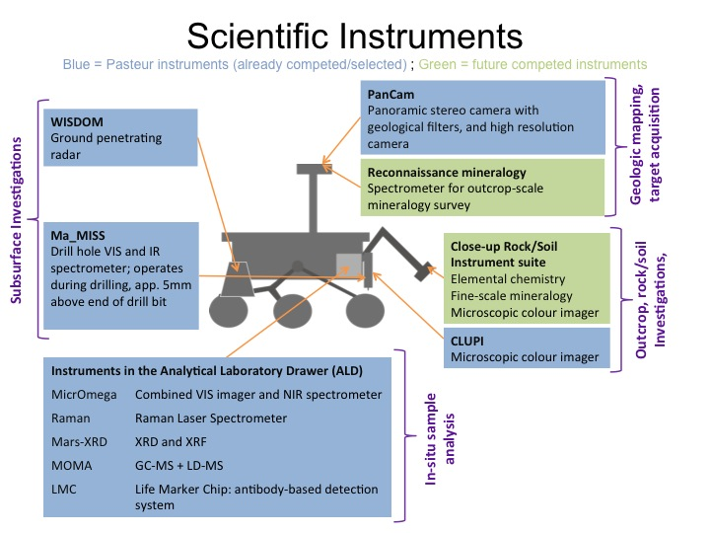

***Figure 11.*** *Summary of scientific instruments for the proposed 2018 joint rover mission.*

1. Science Support Hardware

Critical to the scientific strategy and objectives of the science instrumentation for the proposed 2018 joint rover mission (see Figure 11) are rover system capabilities and infrastructure supporting those objectives. There are key instrument functionality, performance, and mechanical accommodation assumptions and proposed requirements necessary to enable the desired fields of view, instrument pointing, placement of the contact instruments, acquisition of samples, surface preparation, mobility and more; some of which has been discussed in earlier sections. Figure 12 illustrates key science support and enabling hardware envisioned for the proposed rover. Key details of operational need and design characteristics for these systems would expect to be finalized after the competitive science payload selection process is completed.

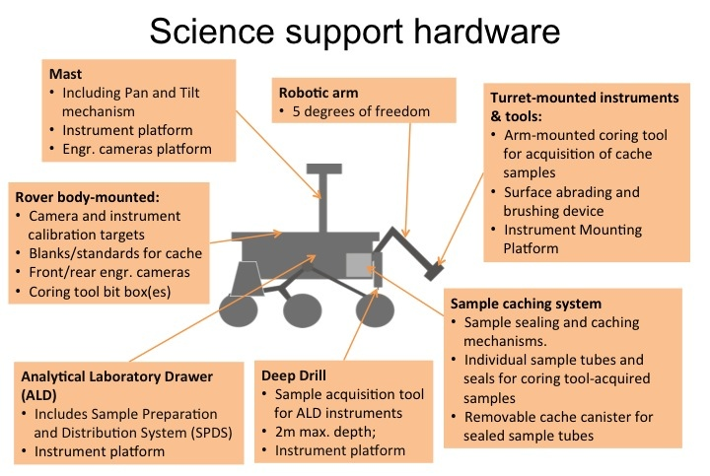

***Figure 12.*** *Summary of Science Support Hardware.*

The Rover hardware elements directly interfacing with the scientific instruments have a key importance for the mission’s scientific performance. In this section these elements are briefly described, and the corresponding high-level requirements are listed.

## Mast

The rover system is envisioned to include a one-time deployable Remote Sensing Mast (RSM). The mast would need to support science instrument mechanical interface(s) and a pointing capability to implement the science and engineering remote sensing needs. The RSM would be expected to provide a panoramic pointing capability in azimuth (360°) and elevation (+90° skyward, and [–90°] towards the rover deck). The mast science instrument platform would be expected to provide pointing accuracy and precision in azimuth and elevation, sufficient to meet the needs of the science instruments and engineering devices mounted on the mast accommodation areas. The current mission concept for the rover system includes space for potential mast instrument components inside the rover’s Warm Electronics Box (WEB), and cabling suitable for power and digital signal transmission between the WEB and the mast-mounted science instruments.

The RSM is intended to support long-range reconnaissance instruments (e.g. Pasteur PanCam and the proposed future competitively selected mast-mounted mineralogy instrument), and stereo engineering cameras for rover mobility and payload support operations. Consistent with engineering constraints, it is considered advantageous for the engineering camera and science instrument apertures to be located as high as possible on the deployed mast, to maximize the field of view of science targets, hazards, and obstacles on the Mars irregular terrain. In addition, it is often considered necessary that the mast-mounted instruments be able to image the robotic arm’s working volume, the ExoMars Drill cuttings and the ALD sample tray. For engineering reasons, it may also be desirable/necessary to be able to image both front wheels for mobility considerations. The mast would need to provide a pan and tilt mechanism to point instruments at targets of interest as described above. Preliminary recommendations for minimum science instrument pointing accuracy could be derived from information summarized in Appendices 6 and 7 of this report. This information may assist pre-decisional engineering efforts to characterize and size support elements to enable the science remote sensing measurements recommended in this report.

The needs and requirements levied on the mast system would ultimately be a superset of the engineering requirements (including those of the engineering cameras, workspace and terrain visibility and other rover system mast accommodation constraints), PanCam requirements and the requirements of the future competed mast mineralogy instrument. Additional accommodation and performance information regarding constraints and requirements would become available prior to the future instrument competitive process assumed in this report (e.g. in a proposed Announcement of Opportunity (AO) and accompanying Proposal Information Package (PIP) for the rover system), and more specifically following such an instrument selection process. For example, questions on whether rastering would be accomplished using the mast pan/tilt mechanism, or mechanisms internal to the future instrumentation is TBD at this point in the joint rover concept development effort. Depending on the competitive process inputs and results, it may be necessary to run a fiber optic cable between the mast instrument platform and the rover body to deliver data to rover body-mounted electronic support elements, the rover compute element or other systems. In a cost-constrained environment, it would be expected that the AO and PIP would provide the science community with further specific guidance on the accommodation factors and considerations factoring in the assessment and selection suitability of proposed future instruments.

|  |
| --- |
| **DRAFT REQUIREMENT (L2 or lower; JSWG REF #R13):** The project system shall accommodate a mast to support the Pasteur PanCam and the future competitively selected mast-mounted mineralogical instrument (see Sections 6.2.1 and 6.3.2). |

## The ExoMars Drill

The proposed rover would be equipped with the ExoMars Drill (see Figure 13), which is devised to acquire samples (the sample reference size is 1 cm in diameter x 3 cm in length), from 0 (surface) down to a maximum depth of 2 meters (subsurface) from a variety of soil types, ranging from well-compacted, hard rock deposits to loose regolith.

The Drill Unit consists of the following elements:

* A Drill Tool: This is the forward-most drill bit segment, approximately 700 mm in length, equipped with the sample acquisition device (including a shutter, movable piston, position and temperature sensors, etc.) and with the Ma_MISS science instrument’s (see Section 6.2.1) tip components (such as optical fiber, IR lamp, window, reflector).
* A set of 3 Drill Tool Extension Rods: Each segment is approximately 500 mm in length. Collectively, they are designed to extend the subsurface penetration depth to 2 m. Each segment is equipped with electrical contacts and dedicated interfaces to enable the transmission of the optical signal to the Ma_MISS spectrometer, located in the upper part of the Drill Unit.
* A Rotation-Translation Group: Including the sliding carriage motors and sensors, the gear mechanisms, and the Ma_MISS optical rotary joint.
* A Drill Box Structure: Including the clamping system for all rods (rod magazine group), and the automatic engage-disengage mechanism. On the drill box structure are installed the Ma_MISS spectrometer and the drill proximity electronics.
* A back-up Drill Tool: A spare forward drill bit segment to be used as a replacement in case the primary Drill Tool becomes unusable (e.g. once it loses its bite, or if it gets stuck and must be abandoned).

The Drill Unit would be supported by a dedicated positioning system, capable of deploying it from its storage position to its operational position, orthogonally to the terrain. The positioning system also allows delivering the acquired sample to the SPDS inlet port. The drill’s positioning system would be equipped with an emergency jettison device, to be used in case the unit would ever remain blocked in the terrain, endangering rover mobility and the continuation of the mission. For more details on the ExoMars Drill please refer to Magnani et al, (2011).

|  |
| --- |
| **DRAFT REQUIREMENT (L1; JSWG REF #R14):** The project system shall accommodate the ExoMars drill. |

|  |  |  |
| --- | --- | --- |
|  | Drilling mode    Coring mode |  |

***Figure 13.*** *The ExoMars Drill. Left: CAD drawing of drill concept. Upper center: drill bit in drilling mode. Lower center: drill bit in coring mode. Right: prototype drill during a 2 m depth functional test.*

## Robotic Arm

The rover is envisioned to include a robotic arm for four primary purposes:

1. Accommodation of some of the science instrumentation (see Section 6.3.3). The robotic arm is envisioned to have the functionality to place tools and science instruments near, against, and normal to science targets within a defined robotic arm workspace.
2. Accommodation of the necessary surface preparation devices (see Section 7.5) supporting such instrumentation.
3. Accommodate the arm-mounted coring tool necessary to acquire the desired rock core and regolith samples (see Section 7.4) and the functionality necessary to deliver such samples to a sample sealing and caching subsystem (see also Section 7.4).
4. Be able to extract the cache container from the rover system, allowing placement of the cache on the surface of Mars at a location suitable for retrieval by a future mission.

As has been the case in some previous landed missions (MER and MSL), the robotic arm is assumed to require five degrees-of-freedom to achieve its science instrument, science surface preparation, sample acquisition, and other interface functions. Absolute placement accuracy of arm-mounted instruments and tools onto science targets, and tool interface points, would be desired to be on the order of ±0.5 cm accuracy (with ± 1 cm accuracy required based on past mission requirements), but would be further detailed and specified in due time to meet the needs as specified in the presumed competitive procurement process. Accuracy and repeatability would need to be sufficient to allow the arm-mounted instruments and core acquisition tools to access surfaces previously prepared by the abrasion and brushing tools.

When operating at the end of this envisioned robotic arm, the coring and surface preparation tools would generate vibration and dust that would need to be considered by the science teams interested in proposing instruments that might be located on this robotic arm. As would be the case for the mast, the science instrument accommodation, environment and performance information for the robotic arm would be expected to become available prior to any future instrument competitive process (e.g. in a proposed Announcement of Opportunity (AO) and accompanying Proposal Information Package (PIP) for the rover system). The presumed AO/PIP would also need to describe whether any actuations necessary to achieve satisfactory, in-focus science performance would be provided by the robotic arm, or would instead need to be integral to the design of the instruments themselves. Following instrument selection, arm placement accuracy and workspace needs would be revisited to integrate instrument and tool needs with robotic arm performance requirements and other constraints.

As in past rover missions, it is assumed that a rover body-mounted flight computer would control placement of arm-mounted instruments for contact science, and operation of arm-mounted sample acquisition and surface preparation devices. Arm-mounted payload support and science instruments would be expected to accommodate possible engineering contact sensors for arm motor control and instrument placement purposes. Current mission concepts for the rover system include some limited space for arm instrument component mounting inside the rover body Warm Electronics Box (WEB; typically a more benign thermally controlled environment within the rover body), and for cabling suitable for power and data signal transmission between the WEB and the arm-mounted science instruments. Cable and possible fiber-optic runs between instruments and tools mounted on the arm would be integral to the arm design and, as has been the case in past rover arm designs, may result in motion capability constraints.

|  |
| --- |
| **DRAFT REQUIREMENT (L2 or lower; JSWG REF #R15):** The project system shall accommodate a robotic arm to support the functionality necessary for close-up science investigations, surface preparation activities, acquisition of cache samples, and tool interface needs supporting sample acquisition, transfer and eventual cache extraction. |

## Sample Acquisition and Caching System

The purpose of a sample acquisition and caching rover subsystem would be to acquire, uniquely identify, protect and store rock and regolith samples in a cache canister, enable placement of the cache canister on the surface of Mars once the cache is full, and do so in a manner suitable for collection and return to Earth of the cache by a possible subsequent mission. Sample acquisition and caching functionality could be accomplished utilizing separate subsystems or mechanisms that would include a coring tool, which would be deployed to the surface by the robotic arm, and a sample handling, sealing and storage system mounted on the rover body, that would interface with the coring tool and prepare the cache.

Arm-mounting of a coring tool is one implementation solution to meet a JSWG vision of sample acquisition from the exact same locations interrogated by the arm-mounted science instrumentation and surface preparation devices. Alternate sample acquisition tool implementations that provide the same terrain access as would be required of the arm-mounted instrumentation may be possible but is not discussed in this report.

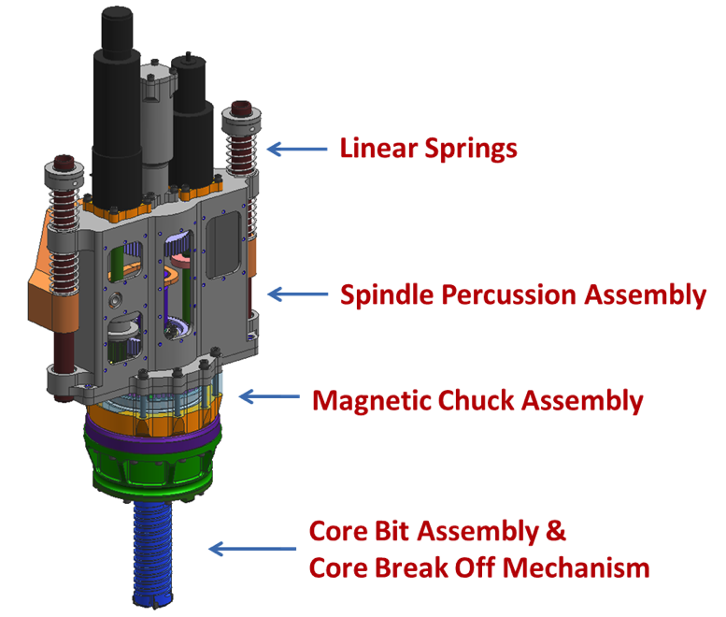

***Figure 14.*** *A pre-decisional example coring tool (SAT; for Sample Acquisition Tool) design concept [Klein, 2012].*

The envisioned coring tool function would need to include a capability for acquisition of rock cores and loose regolith to meet the sample acquisition needs proposed for this mission. The arm-mounted coring tool would need to provide the following functionality: coring, core break-off, and core retention during subsequent transport/arm motions. Similar functionality for the acquisition and retention of regolith samples would also be required. These are the minimum engineering functionality requirements that result from a science functional need to acquire cored samples for analysis in Earth-based laboratories (ND-SAG, MRR-SAG, E2E-iSAG and this JSWG). Bit capture and release would be necessary engineering functions to enable bit substitution for bit wear, or bit release in rover contingency scenarios (e.g. rover slip, or an un-removable/stuck bit). A pre-decisional example design concept of a coring tool is shown in Figure 14 and is further described in [Klein 2012].

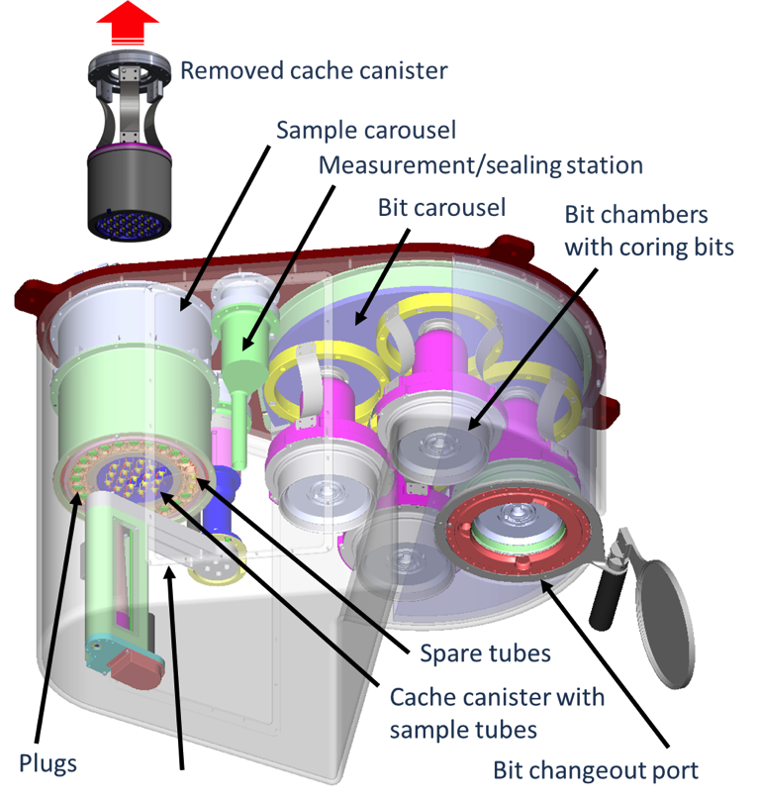

***Figure 15.*** *A pre-decisional sample sealing and caching system (SHEC; for Sample Handling, Encapsulation and Containerization) design concept [Younse, 2010]*

The rover body-mounted sample sealing and caching system would need to have the functionality to preserving the identity and scientific integrity of the acquired samples, and have an engineering design compatible with retrieval and transport interfaces with possible subsequent missions. A cache of individually cored and encapsulated samples, with some level of sealing, would be a fundamental JSWG science requirement endorsed and carried forward from past science analysis groups (MRR-SAG 2009, E2E-iSAG 2011, NRC 2011). As discussed in [ND-SAG 2008], the scientific usefulness of the returned samples would depend critically on keeping them from commingling, on being able to uniquely identify them for linkage back to documented field context, and on keeping rock samples mechanically intact. A sample sealing and caching implementation concept would include the following science functional requirements to meet these needs:

1. The cored samples acquired from the arm-mounted coring tool would be individually identifiable, encapsulated and sealed.
2. Individually encapsulated/sealed coring tool samples would be stored in a cache for later transport and return to Earth by a possible future mission.
3. There would be means to measure some indication of the amount of material (e.g. mass or volume) in a sample tube (TBD measurement precision) prior to placement of the cache on the surface of Mars.
4. There would be a means to carry additional tubes and tube sealing devices within the sealing and caching system to enable collection of at least 25% more samples than could be ultimately cached and returned (carried forward from E2E-iSAG recommendations and endorsed by this JSWG).
5. There would be a means to substitute later collected samples for earlier collected samples in the cache that would be deposited on the surface of Mars (see discussion under Strategy S4 in Section 4 of this report; E2E-iSAG, 2011). [Additional rationale note for items #4 and #5: This is a consequence of the assumed serial nature of the science sample collection concept of operations, a desire to preserve the ability to use real-time scientific judgment and measurements to prefer one acquired sample vs. another (e.g. volume of material acquired may be different), and the presumed engineering consequences to the overall campaign for bringing back all 38 collected samples recommended in this report].
6. The sample collection and caching system would comply with Planetary Protection and Contamination control requirements (TBD at this time)
7. The cache would need to be capable of being extracted from the rover and placed on the surface of Mars for retrieval and transport by a possible subsequent mission.

A pre-decisional sample sealing and caching example conceptual design is shown in Figure 15, and further described in [Younse 2010]. The desired end product of sample acquisition and caching would be a filled cache canister containing individually sealed core and regolith samples, to be placed on the surface of Mars. It would be anticipated that a subsequent mission would have a similar cache interface and cache extraction capability to support nominal and contingency cache retrieval scenarios.

## Surface Preparation Tool

The surfaces of naturally exposed rocks and outcrops are commonly covered with dust and/or weathering products that can mask the parts of the rock needed to interpret its genesis. This is true on Earth and especially on Mars where a layer of dust accumulates to varying thickness in the absence of rainfall. Although rock alteration is interesting in its own right, given that water often is involved, it is important to be able to investigate the primary or original composition and texture of rocks with the rover’s robotic arm instruments. Experience from the MER rovers routinely demonstrated the scientific value of clearing away surface dust and alteration coatings to expose “fresh” surfaces for interrogation [e.g., Squyres et al., 2004]. Without this capability, our understanding of the mineralogy, chemistry, and textures of Martian rocks would be compromised.

On Earth geologists typically break open rocks to expose a fresh surface. Although simple to implement on Earth, breaking open rocks on Mars would be extremely challenging. Instead, the use of a surface abrasion technique offers a reasonable alternative, as aptly demonstrated by the Rock Abrasion Tool (RAT) used by the MER rovers (Gorevan et al 2003). The RAT provided both the ability to brush off a loose dust layer and to grind a circular hole (45 mm diameter) of varying depth on both outcrops and large rocks. The ability to both brush and grind a surface has such scientific merit that the MER team frequently employed both in a protocol designed to understand the nature and depth of rock alteration on Mars [e.g., Squyres et al., 2004]. Although MSL will use a rotating brush to clear surface dust (Jandura, 2010), it has no grinding capability to expose rock interiors as a result of a cost cutting de-scope of the payload. This loss of capability may create an additional challenge in interpreting observations from the other instruments, which should be avoided on the proposed 2018 rover. The MER RAT relied on brushing and grinding to expose fresh surfaces; nevertheless, other methods may also be possible. However implemented, the clearing of dust and exposing of rock interiors would be important to the scientific success of the mission.

|  |
| --- |
| **DRAFT REQUIREMENT (L1; JSWG REF #R16):** The project system shall accommodate a device to clear dust and expose fresh rock, with lifetime sufficient to support the in-situ science instruments and sample cache collection objectives. |

## Analytical Laboratory Drawer (ALD) and Sample Preparation and Distribution System (SPDS)

The Pasteur instruments described in Section 6.2.2 are accommodated inside the Analytical Laboratory Drawer (ALD). The October 2010 configuration of the ALD is shown in Figure 16.

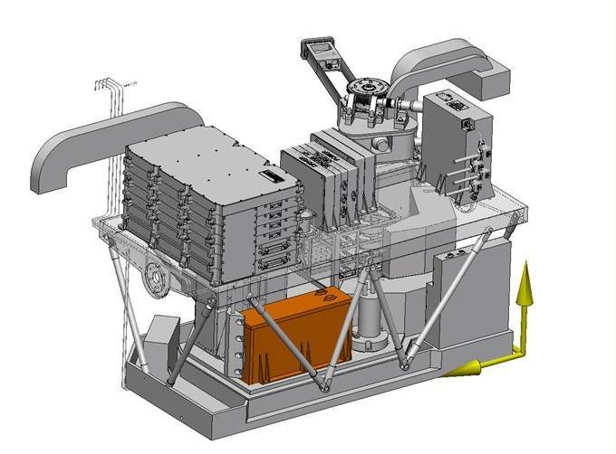

***Figure 16.*** *The Analytical Laboratory Drawer (as of October 2010) and a close-up of the Sample Preparation and Distribution System.*

The ALD provides the analytical instruments with structural support, thermal control, and an Ultra-Clean Zone (UCZ) around the sample path. It also includes the Sample Preparation and Distribution System (SPDS), composed of:

* The sample receiving mechanism/container (interfacing with the ExoMars drill)
* The Core Sample Transport System (CSTM), from inlet port to crushing station
* The Crushing Station
* The Dosing Station
* The sample distribution carousel, equipped with both re-usable sample containers and a finite number of ovens for gas chromatography with MOMA-GCMS
* A sample flattening device (to render the particulate matter resulting from crushing the sample flat for observation by instruments)
* A scientific blanks/standards sample dispenser

The Drill deposits a core sample (approx. 3 cm x 1 cm diameter) in the sample tray that would be then retracted inside the ALD by the CSTM. There, the sample would be dropped between the jaws of the crushing station and crushed to an average grain size of 0.15 mm in a 0.05 and 0.5 mm Gaussian distribution (90% of the samples). After that, the powdered samples are poured down and stored inside the dosing station. From there, the dosing station would be used to feed:

* A refillable container located on a carousel. The samples inside this refillable container would be smoothed to a planarity within 0.1 mm in order to be examined and analyzed MicrOmega, RLS, MARS-XRD and MOMA-LDMS. After analysis, the samples are discarded and the refillable container could be filled with new samples.
* One of the 20 ovens also located on the carousel, to analyze the samples after pyrolysis by MOMA-GCMS. Each oven could be used only once.
* One of the 4 funnels of the LMC (Life Marker Chip).

The carousel includes also the calibration targets needed by the instruments.

This configuration offers a very large flexibility of examination so that the best synergies could be chosen between instruments, completing or comparing their results in order to help their interpretation.

## Science Support Environment

### Contamination control

A prerequisite to properly address the search for martian organic chemistry and signs of extraterrestrial life (i.e. science objectives 3 and 4a) is the understanding of the nature and quantity of terrestrial organic contamination on the elements of the flight system that could potentially contaminate the sample or the sample pathway. The sample pathway includes all the elements of the sample acquisition, transport, preparation, and analysis systems.

The general approach proposed to manage contamination on a flight system in order to control contamination of sensitive elements is to:

* Avoid contamination sources to the maximum extent possible
* Isolate contamination sources from the contamination sensitive elements
* Condition contamination sources to reduce the level of contamination they could produce (e.g., precision cleaning, bake-outs)
* Characterize the residual contamination that could potentially end up on contamination sensitive elements (e.g., pre-flight tests, analysis of contamination transport, use of blanks during operations)

Essential inputs to manage the contamination levels of contamination sensitive elements are:

* Identification of the nature and quantity of terrestrial organic contamination that would jeopardize the particular scientific investigation, i.e. search for martian organic chemistry and life
* Identification of contamination sensitive elements on the flight system
* Allocating contamination budgets for different project phases (i.e. before launch and after launch) starting from the acceptable contamination level at End-of-Mission

The terrestrial organic contamination sources include:

* Particulates from cleanroom fall-out or flight system elements (engineering sources before and after launch)
* Microorganisms from cleanrooms or flight system elements
* Organic molecules from cleanrooms or flight system elements (engineering sources before and after launch)

Contamination control constraints affect the selection of materials (e.g., outgassing characteristics), the flight system design, assembly and testing, as well as surface operations.

SCIENCE STRATEGY (JSWG REF #S6): Address contamination control from the earliest stages of flight hardware design, including material selection, planning for flight hardware assembly and testing, and surface operations.

DRAFT REQUIREMENT (L1; JSWG REF #R17): The project shall characterize the nature and quantity of terrestrial organic contamination that could contaminate the sample or the sample pathways until end-of-mission.

The contamination sensitive elements (i.e. sample pathway), for sample *in-situ* analysis and for caching, that are directly affected by stringent contamination control constraints are:

* ExoMars drill, Sample Preparation and Distribution System (SPDS), Ultra Clean Zone (UCZ), and analytical equipment in the UCZ
* Robotic arm mounted surface preparation device, sample acquisition tool, and the rover body mounted sample-caching mechanism

Other elements of the flight system (e.g., descent stage, exterior of the rover, robotic arm, robotic arm payload) might be indirectly affected by more stringent contamination control constraints due to their potential to re-contaminate contamination sensitive elements.

### Blanks

It is recognized that the terrestrial organic contamination of a flight system cannot be zero and that any level of terrestrial organic contamination that may have been established before launch would change in nature and quantity over the course of the mission. What would be important for the in-situ and cache scientific investigations targeting martian organic chemistry and life would be the actual terrestrial organic contamination level that could be transferred to a sample when it is processed, analyzed, or cached on Mars. The most practical way to measure the nature and abundance of transferable contamination is through the use of carefully designed blank samples that could be processed through the sample pathway on Mars.

|  |
| --- |
| **FINDING (JSWG REF #F4):** Blanks should be used to monitor the terrestrial organic contamination during acquisition and transport of samples for in-situ analysis and for caching. |

Many of the instruments in the proposed payload would need calibration targets, and planning for these is left to successor planning teams. The need for organic blanks/standards is called out in this report because a). It is fundamental to the mission concept, and b). It could have significant implementation implications. Since the mission concept involves sensitive organic measurements to be made both on Mars (MOMA and LMC instruments) and on Earth (at the eventual culmination of the Mars Sample Return campaign, both would need planning attention.

In the case of the ALD, ESA had previously defined a set of implementation requirements that would respond to the high-level drivers of Requirement #R17 and Strategy #S7 (above). This specific implementation was not reviewed by this committee (as per our charter, we did not consider any of the internal design aspects of the ALD), and any needed further refinements are left to the project team.

In the case of the samples that would be cached for potential later return to Earth, it is assumed that a set of blanks would need to be stored with the cached samples and available for analysis in terrestrial laboratories once the cache would be returned to Earth. However, there remain open questions about the number of blank standards, their size, the character of the standard material(s), and the position the standards would be fit within the sequence of natural samples. These questions could not be addressed within the scope of the JSWG study, and are deferred to a successor planning team.

**RECOMMENDATION: A future planning team should evaluate the number and character of the blanks needed to be incorporated in the sample caching system. This group should propose project requirements in this area.**

### Cross-contamination

Cross-contamination between samples (i.e. contribution of Mars-sourced material from one sample to another) could have an effect on the project’s ability to achieve the proposed scientific objectives. Strategies to minimize this have been considered as part of the design of the ALD. For example, a sample may be crushed and discarded before powder would be produced for the dosing station, cleaning the crushing station in this process. Martian surface material (e.g., aeolian dust) could be processed through the sample acquisition, transport and preparation elements to remove organic contamination from previous samples considering the expected low level of organic material in the mobile surface material. However, this topic could not be discussed within the scope of the JSWG—setting requirements in this area is deferred to future planning teams.

1. Quantitative aspects of the mission implementation—how many?

In order to have a credible chance of achieving the scientific objectives of the proposed 2018 joint rover mission, the following implementation considerations are judged by JSWG to be essential, and are presented as proposed Level 2 requirements.

|  |  |
| --- | --- |
| **Capability** | **Values** |
| **From Former ExoMars Concept** | |
| # of Surface Measurements (SM)  (ExoMars Drill sample + subsequent analysis with ALD) | 6 |
| # of Vertical Surveys (VS) | 2 |
| Depth of drill hole | 200 cm |
| Sampling rate within drill hole | every 50 cm |
| # of Deep Measurements (DM)  (subsurface ExoMars Drill sample + subsequent analysis with ALD) | 6 |
| Depth of drill hole | 150 cm |
| Sampling rate within drill hole | Sample at base |
| **From E2E-iSAG, 2011 (derived implementation values)** | |
| # of rock + granular materials samples able to select, acquire, and encapsulate | 38 |
| # of samples to be stored in the cache | 31 |
| Total # of rock + soil samples | 28 |
| Additional samples for over-selection and sample change-out | 7 [25% of 28] |
| # of blanks/standards | 3 (TBR) |
| Mass per sample of rock | 15-16 g |
| Length of time cache must maintain scientific integrity on the rover or the surface of Mars | 3350 sols (TBR)  ~5 Martian years  ~10 Earth years |

***Table 7.*** *Some quantitative aspects of mission implementation*

DRAFT REQUIREMENT (L1; JSWG REF #R18): The project system shall have the capability to perform [6] Surface Measurements (SM), each consisting of acquiring 1 sample with the ExoMars drill from a surface target, and subsequent analysis with the ALD instruments.

Source: ExoMars Science Management Plan, 2010.

DRAFT REQUIREMENT (L1; JSWG REF #R19): The project system shall have the capability to perform [2] Vertical Surveys (VS), each consisting of acquiring 5 samples with the ExoMars drill, from the same drill hole, in 50 cm increments, between 0–200 cm, and subsequent analysis with the ALD instruments.

Source: ExoMars Science Management Plan, 2010.

DRAFT REQUIREMENT (L1; JSWG REF #R20): The project system shall have the capability to perform [6] Deep Measurements (DM), each consisting of acquiring 1 sample with the ExoMars drill from a depth of 150 cm, and subsequent analysis with the ALD instruments.

Source: ExoMars Science Management Plan, 2010.

DRAFT REQUIREMENT (L1; JSWG REF #R21):  In order to fill a 31-slot cache (Requirement #R22), and to have the ability to reject 25% of the samples collected, the project system shall have the capability to scientifically-select, acquire, and encapsulate at least 38 individual samples of rock and granular materials.

Rationale: This is related to two factors: 1) the serial scientific assessment of sample value (see discussion under Strategy S4 in Section 4 of this report; E2E-iSAG, 2011), and 2) the need to be able to detect and reject inadequately filled sample tubes (note: what constitutes “inadequate” needs to be defined). The system capability should be sized to assure 38 "good" samples to be judged on scientific merit; the 7 "changeout" samples should not include incomplete or failed samples.

DRAFT REQUIREMENT (L1; JSWG REF #R22): The project system shall have the capability to cache at least 31 encapsulated samples. Note this includes any cache blanks/standards.

Rationale: The number of samples required to address the scientific goals of the proposed 2018 joint rover mission were determined by E2E-iSAG (2011) based on the experience and lessons learned by the MER Spirit rover. The need for blanks/standards is addressed in Section 7.7.2 of this report as well as in E2E-iSAG (2011).

DRAFT REQUIREMENT (L1; JSWG REF #R23): The project system shall have the capability to place any selected set of encapsulated samples in the cache.

Rationale: See discussion above under Draft Requirement #R21. JSWG suggests the implementation choice should be left to the future engineering team.

DRAFT REQUIREMENT (L1; JSWG REF #R24): The project system shall have the capability to select, acquire, and encapsulate samples of rock and granular materials. Rock samples should comprise approximately 15-16 grams of material, and regolith samples should be about 8 g (because of differences in density, rock and regolith samples would both have a volume of about 6 cm3).

Rationale: Samples of rock and regolith are both required (E2E-iSAG, 2011). Recommended sizing is based on the number of analyses expected to be carried out, the desire to repeat high-priority analyses, margin for follow-up studies, and the desire to retain a portion of every sample for future research as laboratory techniques are developed and refined (E2E-iSAG, 2011).

DRAFT REQUIREMENT (L1; JSWG REF #R25): The project system shall have the capability to maintain the scientific integrity of the cached samples during a period of time no less than [3350] sols (~[5] Martian years or ~[10] Earth years) while cached on the rover or the surface of Mars.

Rationale: The minimum time that the cache would be required to remain intact on the surface of Mars is a function of programmatic balance within both NASA and ESA (NRC, 2011).

1. The scientific importance of using organic geochemistry information in selecting samples for the sample cache

With the highest priority science objectives for Mars *in-situ* investigations and sample return directly linked to the identification of organic compounds, the ability to recognize organic matter-bearing materials has obvious merit. Instrumentation necessary to make organic measurements *in-situ* has been advocated in a number of different precursor studies of Mars sample return (ESA 1999, ND-SAG 2008, MMR-SAG 2009).

Existing orbital and *in-situ* observations clearly demonstrate that water-related minerals and geologic settings are present on Mars. These settings are interpreted to correspond to past environments that could have been habitable. If the environments did host life, its organic remains may have been preserved in rocks. Potential organic matter-bearing materials could be identified using morphological and textural features, as is most often the case during field collection campaigns on Earth. The risk of a negative result, however, could be reduced by *in-situ* measurements. *In situ* mineralogical analyses could confirm assertions of past environment habitability and organic matter preservation potential initially based on visual data.

Maximizing the probability that cached samples provide the best information possible on past habitability and perhaps life on Mars would require development and careful implementation of a context-dependent measurement protocol that takes advantage of the rich array of instrumentation on-board the proposed 2018 rover. This would typically include determination of morphology at various spatial scales, elemental abundances, mineralogy, and identification of organic compounds. *In-situ* mineralogical analyses are easily achievable and could provide valuable data suggestive of an environment in which organic matter may have been produced and preserved. But only *in-situ* organic analyses could provide evidence of the real presence of organic matter. Mineralogical and organic analytical steps could be combined in a powerful sample triage process to determine the best sample for caching. Hence, it would be required that some samples, those that are considered the most likely to contain organic matter, are subjected to the complete triage process (observation, mineralogical analysis, organic analysis) to demonstrate adherence to our highest priority in-situ and sample return science objective. Flexibility in application of the measurement protocol is recommended to be able to adapt to particular situations. For example, one could imagine that the first samples would be chosen after a full array of measurements are accomplished and analyzed. On the other hand a more limited set may be implemented once the science team becomes familiar with the key sites and strata and could recognize important sampling locations without the full measurement array.

As currently envisioned for the proposed 2018 Joint Mars Rover, it would be possible to conduct organic measurements, using the MOMA instruments in the ALD, on samples delivered via the ExoMars drill either from surface outcrops or the subsurface. Providing these measurements on samples acquired with the arm-mounted corer would require a transfer capability to the ALD that has not yet been developed. Although this implementation is potentially challenging, key scientific objectives of the mission could be better addressed with this capability. It also offers greater efficiency and flexibility of delivering candidate cache samples to the ALD compared to the ExoMars drill.

|  |
| --- |
| **SCIENCE STRATEGY (JSWG REF # S8)**: Use the organic geochemistry capability of the ALD (using sample delivered to it by the deep drill) as an input to selecting samples for the cache. |

|  |
| --- |
| **FINDING (JSWG REF #F5)**: The ability to screen for organics on samples acquired by the robotic arm would be beneficial for the science return of the mission. Such capability should be investigated early in the design process and implemented if resources allow. |

1. The scientific importance of including a sample from the deep subsurface in the sample cache

The capability to return samples from the martian subsurface is considered as extremely valuable (E2E-iSAG, 2011; see also Science Strategy S3 in Section 4 of this report).

The ExoMars drill (described in Section 7.2) could acquire samples from 0 down to 2 m. During the drilling process, Ma_MISS (see Section 6.1.1) would characterize the outside wall of the borehole by performing IR reflectance measurements. In addition mechanical properties of the drilled material would be obtained from the monitoring of drilling parameters. In nominal operation a core of 2.5 to 3 cm in length and 1 cm diameter would be delivered to the SPDS of the ALD. If a core analyzed by the ALD instruments were found to have organic content (not contaminants), it would be extremely valuable to be able to place a sample of that material in the cache for return to Earth. Unfortunately, the samples analyzed by the ALD are crushed, but there would be two options for acquiring an alternative sample. The first option would be to acquire a second (sister) core from immediately below the first in the same borehole, or perhaps to create an adjacent borehole and collect a core at the same depth as the one containing the organic signature. The second option would be to acquire a sample of the cuttings produced during acquisition of the core. Cuttings are produced during the process of drilling and accumulate at the top of the borehole in a small mound. There is no assumption that acquisition of bulk cuttings would preserve depth-related stratigraphy, however, any discovery of reduced chemistry would be significant. It may be possible to use regolith collection bit on the arm-mounted coring tool to collect some of those cuttings, although if this occurs on regolith, potential mixing of cuttings with regolith material cannot be eliminated.

Either cuttings or a subsurface core would constitute valuable samples for addressing Sample Return Science objectives, although their value would not be equal. Core samples would be more valuable for addressing the higher priority science objectives, because they retain contextual information (e.g. orientation, relative position of mineralogical or sedimentological features). However, the science value of both cuttings and core also depends critically on whether they are encapsulated to prevent the loss of volatile organic compounds.

A core that is encapsulated to prevent loss of volatile organic compounds would have the highest value (Figure 17). The second most valuable sample would be a sample of encapsulated cuttings. This would be more valuable than a non-encapsulated core, as the preservation of volatiles is deemed more important in this scenario than preservation of spatial context alone, in the case of no encapsulation. The reason that encapsulation is deemed more important than spatial context in this scenario is because the main motivation for acquiring deep samples is their potential to preserve volatiles, organic molecules, and other species liable to oxidation and radiation degradation (see ESE-iSAG Science Arguments above). The third choice would be a non-encapsulated core, and fourth a non-encapsulated sample of cuttings.

While the proposed 2018 rover would be likely to include a device to collect soil and regolith, and presumably could sample drill cuttings, hand-over of cores from the ExoMars drill to the sample sealing and caching system (see Section 7.4) would require additional hardware. This is likely to be a cost and design driver.

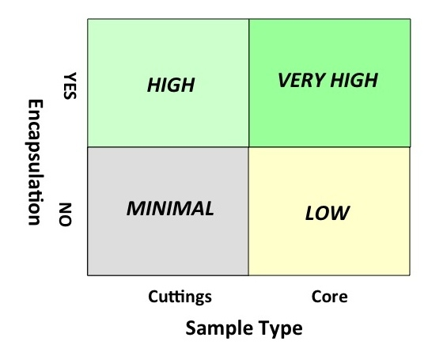

***Figure 17.*** *The scientific value of deep drill samples for return to Earth. Encapsulation would be extremely important for both sample types. As discussed in the text, collecting, encapsulating, and caching a cuttings sample is thought to be far easier than for a core sample, and this approach is recommended.*

|  |
| --- |
| **DRAFT REQUIREMENT (L2 or lower; JSWG REF #26):** The system shall have the capability to acquire and encapsulate a sample of drill cuttings produced by the ExoMars drill from a 0.5 to 2.0 meter deep hole. |

|  |
| --- |
| **FINDING (JSWG REF #F6):** The capability to encapsulate and cache a deep drill core is highly desired. Such capability should be investigated early in the design process and implemented if resources allow. |

1. Reference Surface Mission Operations Scenario, and Implications for Minimum Mission Lifetime

In order to establish the rover surface mission lifetime necessary to fulfill the science objectives described in Section 3, the team developed a high-level reference surface mission operations scenario. In order to characterize the landing site’s geology (Objective 1) the vehicle would need to be able to move and to interrogate numerous rock/soil targets. The results of Objectives 1–2 would become essential inputs to select locations for subsurface surveys (Objective 3) and for sample caching/documentation operations (Objective 4). To complete Objective 3 (subsurface surveys) and Objective 4 (caching), the rover would have to carry out certain very specific operations, included in the sampling/caching type of work considered below.

Since the objective of this scenario tool is to determine mission lifetime needs, the primary focus of the work was on the number of sols needed to carry out each of the various types of activities, as well as the number of instances required of each activity type within the reference surface mission. (See Appendix 8 for more detail, as well as Figure 19.) After summing the number of sols contained in a reference mission, an operations multiplier is applied in order to account for losses caused by the phasing of communication sessions. Finally, a margin is applied to ensure some capacity to absorb risk. The resulting number is the recommended requirement for the surface mission lifetime.

## Maximizing science return within 1 Martian year (669 sols)

To fulfill the scientific objectives, the scenario had to trade between three fundamental areas: 1) fieldwork, 2) driving, and 3) sampling within an overall constraint of 669 sols, as defined by the qualification status of the MSL subsystems, intended to be reused for this mission (Figure 18).

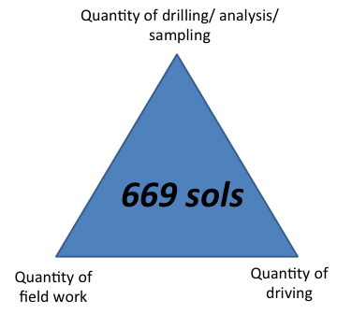

***Figure 18.*** *Trade between fieldwork, sampling and driving.*

The final scenario is described in detail in Appendix 8. At a high level, Figure 19 shows the number of sols allocated to each type of activity such that the mission lifetime could fit within the 669 sol constraint.

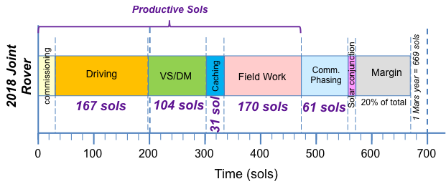

***Figure 19.*** *Compilation of numbers of sols required for each type of activity. Note that the description is not representative of the sequence of events in the scenario, but simply a method to add up the different sol types. VS/DM refers to Vertical Surveys and Deep Measurements. Surface Measurements with ALD are accounted into the Field Work.*

Starting from the various objectives, assumptions, and constraints, and with due consideration for the experience acquired during the MER and MSL missions, as well as ExoMars rover mission concept development, the JSWG has concluded that it would be possible to perform the proposed 2018 joint rover mission as a 669-sol mission if various assumptions are respected (See Appendix 8).

|  |
| --- |
| **DRAFT REQUIREMENT (L**1**; JSWG REF #R27):** The project system shall conduct scientific operations on the surface of Mars for at least [669] sols ([687] Earth days). |

## Two Operational Centers

Based on the ESA/NASA partnership and the desire of both agencies to contribute equally to ground operations for the rover surface mission, ground operations could use two control centers (CCs) separated by nine time zones, working while the rover “sleeps” on Mars. An implication from the use of two control centers is that this configuration would significantly recoup the loss of productivity resulting from using an X-band fixed local mean solar time commanding window (from Earth to Rover) and a non-sun-synchronous UHF return relay (from Rover to Earth via a relay satellite) whose overflights of the rover position “walk earlier” each sol relative to the rover’s local mean solar time. This orbiter overflight “walk” means that there are periods where the duration between the return relay and the next commanding window would be shortened, such that it would sometimes prove impossible to have enough time for the ground to interpret the rover’s actions prior to the window becoming again available for daily commanding. Using two control centers separated by nine time zones could “make up” for some of the surface operations time lost by the phasing of the “walking” return relay and fixed commanding windows, relative to a ground control configuration with a single control center, assuming a sustainable work schedule in each configuration.

The two control centers would enable a higher fraction of sols that include ground interpretation of rover actions. This is what is colloquially known as “ground in the loop” sols or “productive” sols. However, achieving this gain in “ground in the loop” sols implies frequent control handoffs between centers (approx. every 1-2 weeks), effective on-Earth communications mechanisms (hardware, software) and associated training, and significant command error rate management, to a degree greater than previously considered for other missions’ ground operations. The timing appears to lend itself to shift work, so that many individuals involved in rover operations may not need to be synchronized to the Martian clock for long periods and without significant rest (the latter is known to be unsustainable).

Other implications of this configuration are that control center handoff times would change week-to-week and month-to-month. One way to mitigate this additional complexity would be to consider cross training to facilitate Earth time, 24/7 operations rather than phasing staff to support only the martian night. However, the above implies a higher staffing level and significantly increased training than is presently planned for MSL operations (which is not executed on Mars time during the primary mission phase), with higher associated cost. Another final, but crucial implication of the sharing of ground operations over two control centers would be the development of a management system spanning both operation centers to coordinate overall planning and to maintain flow of authority and responsibility.

|  |
| --- |
| **FINDING (JSWG REF #F7):** The potential to use two control centers for rover control is an exciting possibility to amplify productivity, and is an assumed part of the scenario to manage the orbiter overflight path and communications phasing. |

|  |
| --- |
| **FINDING (JSWG REF #F8):** The stated scientific objectives could be achieved within 669 sols (one Mars year) with the following assumptions:   1. Efficient use of two operations centers. 2. Shorter commissioning time compared to MSL. 3. Less operational margin compared to MSL. 4. Higher number of productive sols compared to MER and MSL. 5. Improved driving per sol compared to MSL. |

**RECOMMENDATION: A follow-up study should be performed to understand the issues related to two control centers to refine the operations concept and to develop initial planning for management, scheduling, and cost.**

## Looking at a Three-season rover

Though the results of the 1 Martian year mission analysis indicated that 669 sols were barely sufficient to achieve the science objectives from Section 3, the scenario team was asked to determine whether the science objectives could be met in less than a Martian year. Due to the perceived benefits to rover design and cost, the scenario team considered what additional assumptions would need to be made in order to meet the science objectives within 500 sols. The 500-sol surface duration is significant, in that it represents a “three season” rover —such as a solar rover— that would not need to survive the major dust storm season and Martian winter. The analysis performed to fit within 500 sols meant that there would be additional reductions to the key traded components of fieldwork, driving, and sampling (Figure 20).

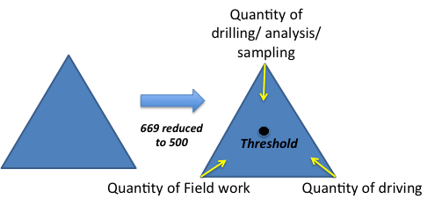

***Figure 20.*** *Additional reduction of key components to fit within 500 sols.*

To fit within 500 sols, the JSWG thought it might be useful to identify the number of sols necessary to accomplish the proposed 2018 joint rover mission objectives at a previously visited site. As a proof of concept, then, the team used Spirit’s Gusev Crater landing site for the scenario development.

This assumption-driven concept is dependent upon the following:

* A favorable landing could be achieved close to the Columbia Hills (to reduce amount of time required for driving),
* Significantly reduced amounts of drilling/analysis/caching,
* The time allocated for fieldwork is judged to be barely sufficient; actually, the field geologists within JSWG feel the time would be insufficient for proper fieldwork,
* Any site not previously visited by a rover would require much more time to characterize.

The ability to reduce the number of sols hinges heavily on significant technology developments becoming available for this mission, in particular for the autonomous operation of the rover. The amount of scientific productivity also depends on where within the landing ellipse the rover touches down. In the most favorable scenarios, the amount of drilling/caching lies above the baseline requirements, but the inverse is true in the least favorable scenarios. The proposed 2018 rover is envisioned to include powerful new instruments, particularly in the area of mineralogy, geochemistry, and organic detection, which were not available to Spirit and Opportunity. 500 sols appear insufficient to achieve the mission’s objectives.

**RECOMMENDATION: The JSWG recommends investing in improved autonomy for rover and payload operations.**

|  |
| --- |
| **FINDING (JSWG REF #F9):** JSWG concludes that a 500-sol lifetime is below the mission’s science threshold given current assumptions. |

The JSWG concluded that other lifetime options may become possible with technology development. Some combination of modifications to the inputs defined for the scenario could make a mission between 500 and 669 sols credible as shown in Tables 8 and 9.

|  |  |  |
| --- | --- | --- |
| **Driving Option** | **Impact** | **Acceptable to JSWG?** |
| Eliminate “Go To” landing sites | • Shortens driving distances, therefore time available for science analysis  • Drastic consequences for landing site selection – may constrain mission to sites that are not scientifically relevant | No |
| Land precisely | • Requires technology development: precision landing (reduces ellipse size)  • Shortens driving distances, therefore time | Yes |
| Add TRN/HDA  (see Appendix 3) | • Requires technology development: TRN/HDA  • Shortens driving distances, therefore time  • More sites with internal science targets | Yes |
| Increase drive time/sol | • More driving distance per sol  • System power/energy  • Heating and cooling issues for actuators (TBR) | Yes |
| Increase driving speed | • More driving distance per sol  Note on traverse rate: current scenario assumes 150m/sol combining 50m “blind” drive @ 100 m/hr + 100m @ 44 m/hr “autonomous” drive using ESA GNC. *This is already an improvement from MSL (100m/sol) and assumed in 669 sol* | Yes |

***Table 8.*** *Possible technology development options to decrease the time required for driving. (See Appendix 3 for landing technologies).*

|  |  |  |
| --- | --- | --- |
| **Field Work Option** | **Impact** | **Acceptable to JSWG?** |
| Revisit previously characterized site | • Would no longer be a stand-alone exploration mission (caching-only not credible to OMB, DS)  • Eliminates landing site competition (Gale, Gusev only possibilities)  – major science disadvantage | No |
| Reduce number of rock and soil contacts (currently 84) | • Major science disadvantage to select and interpret samples for caching (84 contacts considered barely adequate to interpret geology) | No |
| Cache some drill samples | • Requires technology development and system impact: Drill to Cache capability  • Actual number of sols gained to be assessed further | Yes |
| Disallow sites with complex geology | • Would reduce time needed to select samples and document context  • Major consequences to selecting a scientifically relevant site. | No |
| Increase autonomy for arm placement | *•* Technology development for target approach and robotic arm deployment (Assumes 2 sols/target with MSL, MER capabilities)  • With improved automation there is potential to improve this to 1 sol per target  • Note that this implies that the arm-mounted instruments must be able to complete their measurements in time/energy remaining after drive, arm placement, and other associated observations to see any benefit, and would need to gather data required for decision-making during the middle of the day before the UHF downlink feeding into the ground planning cycle  • It also implies that distance for target selection for arm placement could be increased. | Yes |

***Table 9.*** *Possible options to reduce the amount of time required for fieldwork.*

1. Conclusions and Recommendations

## Conclusions

This report has described a mission concept for a NASA-ESA joint rover that would be launched to Mars in the 2018 launch opportunity. This concept is defined by 4 science objectives, a set of implementation strategies, a set of draft science-related requirements, and a reference surface operations scenario. Justifications and explanations for each of these are contained in the above report. Note that this report does not summarize all of the mission’s requirements— in addition to those originating from science considerations, there would be an additional set that would originate from engineering considerations, and these would need to be combined to make up a full requirement set.

It is the intent of the JSWG that this report has enough definition of the mission’s science and implementation strategies to guide the development of a mission PIP (Proposal Information Package) and AO (Announcement of Opportunity).

In addition, the JSWG reached nine significant conclusions, on different kinds of topics that it discussed that are marked as “findings”—those are summarized below.

1. **FINDING (JSWG REF #F1):** A robust community landing site process would be required to ensure that the landing site eventually selected would be capable of satisfying all of the mission science objectives.
2. **FINDING (JSWG REF #F2):** If the Pasteur Payload is assumed to be included on the Rover, then four more measurement capabilities (to be selected competitively in the future) would also be required in order to meet the science objectives of the proposed joint rover mission. Those capabilities include: a mast-mounted (“remote”) mineralogy instrument, a close-up microscopic imager, a close-up mineralogy instrument, and a close-up elemental chemistry analyzer.
3. **FINDING (JSWG REF #F3):** The Pasteur Pancam instrument capability is judged to be sufficient to meet the mast-mounted scientific imaging needs of the proposed 2018 joint rover mission, and no further competition is recommended.
4. **FINDING (JSWG REF #F4):** Blanks should be used to monitor the terrestrial organic contamination during acquisition, transport and caching of samples for return to Earth.
5. **FINDING (JSWG REF #F5)**: The ability to screen for organics on samples acquired by the robotic arm would be beneficial for the science return of the mission. Such capability should be investigated early in the design process and implemented if resources allow.
6. **FINDING (JSWG REF #F6):** The capability to encapsulate and cache a deep drill core is highly desired. Such a capability should be investigated early in the design process and implemented if resources allow.
7. **FINDING (JSWG REF #F7):** The potential to use two control centers for rover control is an exciting possibility to amplify productivity, and is an integral part of the scenario to manage the orbiter overflight path and communications phasing.
8. **FINDING (JSWG REF #F8):** The stated scientific objectives could be achieved within 669 sols (one Mars year) with the following assumptions:

1. Efficient use of two operations centers.

2. Shorter commissioning time compared to MSL.

3. Less operational margin compared to MSL.

4. Higher number of productive sols compared to MER and MSL.

5. Improved driving per sol (including blind drive) compared to MSL.

1. **FINDING (JSWG REF #F9):** The JSWG concludes that a 500-sol lifetime is below the mission’s science threshold given current assumptions.

## Recommendations

1. JSWG recommends a **follow-up study** to understand the issues related to two control centers to refine the operations concept and to develop initial planning for management, scheduling, and cost.
2. JSWG recommends a **follow-up study** on the number, character, and strategy for use of blanks/standards to achieve the eventual scientific objectives related to the proposed MSR Campaign.
3. **Technology Development:** The JSWG recommends investing in improved technology in the following areas:
   * **Increased autonomy and autonomous performance for rover and payload operations.** Includes **Fast Traverse** technologies to achieve increased mobility on the surface;
   * **Advanced EDL technologies (Terrain-Relative Navigation, Hazard Detection and Avoidance, and Precision Landing) to greatly inc**rease the diversity of sites that could be targeted by the mission, and to increase the possibility of science targets internal to the landing ellipse—which may significantly reduce driving distances;
   * **Sample Acquisition and Caching** technologies needed to acquire, encapsulate, and cache selected samples for subsequent retrieval and return to Earth;
   * **Planetary Protection, Contamination Control, and Sample Integrity** technologies to achieve the stringent requirements on the levels of terrestrial contaminants in collected samples, both for *in situ* analysis and for the cached samples.

The rover and its payload as described in this document would be one of the most capable spacecraft developed for Mars surface exploration. of this study look forward to the concepts and strategies outlined here becoming reality in the near future.

1. Acknowledgements

Information related to the mast was contributed by Peter Waydo (JPL). Information related to the sample caching system was provided by Paul Backes (JPL). Andrew Johnson (JPL), Aron Wolf (JPL), David Way (NASA Langley) contributed to the science support hardware section. Charles Whetsel contributed in many ways. Franceschetti Paola (Thales Alenia Space), Joel Hurowitz (JPL), Damien Loizeau (ESA), and Ben Boyes (Astrium-EADS) contributed to the reference surface mission scenario. Christine Simurda (undergraduate, Washington University in Saint Louis) contributed to the development of the traceability matrix.

The JSWG activity described in this report was supported by the Jet Propulsion Laboratory, California Institute of Technology, under a contract with the National Aeronautics and Space Administration.

1. References Cited

The following references are directly cited within this report, but the JSWG has drawn extensively upon the knowledge summarized in the MEPAG E2E-iSAG report (2011) and the NRC Vision and Voyages for Planetary Science in the Decade 2013-2022 (2011), which both have very extensive references to the recent work and thinking of the international Mars science community. We acknowledge the community’s broad contributions, and refer the interested reader to the reference lists of those two documents.

 Allwood, A.C., Walter, M.R., Burch, I.W., Kamber, B.S., 2007: 3.43 billion-year-old stromatolite reef from the Pilbara Craton of Western Australia: Ecosystem-scale insights to early life on Earth. Precambrian Research, v. 158, p. 198-227.

Anderson, R. C. , L. Jandura, A.B. Okon, D. Sunshine, C. Roumeliotis, L. Beegle, J. Hurowitz, B. Kennedy, D. Limonadi, S. McCloskey, M. Robinson. C. Seybold, K. Brown, J. Crisp (in press), Collecting Powdered Samples in Gale Crater, Mars; An Overview of the Mars Science Laboratory Sample Acquisition, Sample Processing and Handling System.  Submitted December 2011 to *Space Science Reviews*.

Coates, A.J., Griffiths, A.D., Leff, C.E., Cousins, C.R., Jaumann, R., Schmitz, N., Josset, J.L., Paar, G., Barnes, D.P. (2011) The PanCam instrument for the ExoMars 2018 rover: science objectives and instrument characteristics. EPSC Abstracts, 6, Abstract # EPSC-DPS2011-248.

Cousins, C.R., Griffiths, A.D., Crawford, I.A., Prosser, B.J., Storrie-Lombardi, M.C., Davis, L.E., Gunn, M., Coates, A.J., Jones, A.P., and Ward, J.M. (2010) Astrobiological Considerations for the Selection of the Geological Filters on the ExoMars PanCam Instrument. Astrobiology, 10, 933-951, doi: 10.1089/ast.2010.0517.

E2E-iSAG (2011) Planning for Mars Returned Sample Science: Final report of the MSR End-to-End International Science Analysis Group (E2E-iSAG), 101 pp., posted December, 2011, by the Mars Exploration Program Analysis Group (MEPAG) at <http://mepag.jpl.nasa.gov/reports/>. Also currently in press (Astrobiology).

ESA Exobiology team study, Exobiology in the solar system & the search for life on Mars, Report from the ESA Exobiology Team Study, ESA SP-1231, 1999.

ExoMars Science Management Plan, EXM-MS-PL-ESA-00002, Issue 5, Rev. 4, 12 February 2010.

Gary, M., et al. (Eds.) (1972), Glossary of Geology, 805 pp., American Geological Institute, Washington, D.C.

Grant, J. A., Golombek, M. P., Grotzinger, J. P., Wilson, S. A., Watkins, M. M., Vasavada, A. R., Griffes, J. L., and Parker, T. J., 2011, The science process for selecting the landing site for the 2011 Mars Science Laboratory, Planet. Space Sci., 59, 1114-1127, doi:10.1016/j.pss.2010.06.016.

Gorevan, S. P., et al., Rock Abrasion Tool: Mars Exploration Rover Mission, J. Geophys. Res., 108(E12), 8068,

doi:10.1029/2003JE002061, 2003.

Hoehler, T. and Westall, F. 2010. The search for life on Mars. Astrobiology, 10, 859-867

House, C.H, Schopf, J.W., McKeegan,K.D., Coath, CD, Harrison, TM, Stetter, KO, 2000. Carbon isotopic composition of individual Precambrian microfossils. Geology 28: 707-710

iMars Working Group (2008), Preliminary Planning for an International Mars Sample Return Mission, Report of the iMARS (International Mars Architecture for the Return of Samples) Working Group, Mars Exploration Program Analysis Group, accessed at mepag. jpl. nasa. gov, Available online at: http://mepag.jpl.nasa.gov/reports/iMars_FinalReport.pdf.

Jandura, L. (2010) Mars Science Laboratory Sample Acquisition, Sample Processing and Handling: Subsystem Design and Test Challenges. Proceedings of the 40th Aerospace Mechanisms Symposium, NASA Kennedy Space Center, May 12-14, 2010

Johnson, A. Ansar, L. Matthies, N. Trawny, A.I. Mourikis, and S.I. Roumeliotis, "A General Approach to Terrain Relative Navigation for Planetary Landing", Proc. 2007 AIAA Infotech at Aerospace Conference, Rohnert Park, CA, May 7-10,2007.

Johnson, A., A. Huertas, R. Werner and J. Montgomery, “Analysis of On-Board Hazard Detection and Avoidance for Safe Lunar Landing,” Proc. IEEE Aerospace Conference (Aerospace08), Big Sky, MT, March 2008.

Klein, K., M. Badescu, N. Haddad, L. Shiraishi, and P. Walkemeyer, 2012, “Development and Testing of a Rotary Percussive Sample Acquisition Tool,” IEEE Aerospace Conference, March 2012.

Knoll, AH, 1982, Microfossils from the late Precambrian Draken conglomerate, NY Friesland, Svalbard. Journal of Paleontology. 55:755-790

Magnani, P., et al, (2011), EXOMARS EM Drill Tool Performance in Mars-like Environmental Conditions, IAC-11-A3.3B.4 presented at the 62nd International Astronautical Congress, Cape Town, SA.

Mattingly, R., and L. May (2011), Mars Sample Return as a campaign, IEEEAC Paper #1805, Version 1, updated October 12, 2010.

Mars Mid-Range Rover Science Analysis Group (MRR-SAG) (2009), The Mars Astrobiology

Explorer-Cacher (MAX-C): A Potential Rover Mission for 2018, Astrobiology, Volume 10, Number 2, 2010, 127-163.

MEPAG Next Decade Science Analysis Group (ND-SAG) (2008), Science priorities for Mars sample

return, Astrobiology, 8, 489-535

MSL Landing Site Selection/User’s Guide to Engineering Constraints (2007), available online at:

webgis.wr.usgs.gov/msl/docs/MSL_Eng_User_Guide_v4.pdf

Noffke, N., Eriksson, KA, Hazenm RM, Simpson, EL, 2006, A new window into Early Archean life: Microbial mats in Earth's oldest siliciclastic tidal deposits (3.2 Ga Moodies Group, South Africa). Geology, 34:253-256

NRC (National Research Council) (2011), Vision and Voyages for Planetary Science in the Decade 2013-2022, The National Academies Press, Washington DC.

# NRC, 2007. An Astrobiology Strategy for the Exploration of Mars. National Research Council,

# Washington, 130 pp.

Núñez, Jorge I., Jack D. Farmer, R. Glenn Sellar, Gregg A. Swayze, and Diana Blaney. 2012.

Development and Science Applications of a Multispectral Microscopic Imager (MMI) for the Robotic Exploration of Mars. *Astrobiology* (In review).

Sellar, R.G., Farmer, J. D., and Nuñes, J. I., 2011, Multispectral microimaging as a tool for in situ

petrographic analysis and selection of samples for potential return to Earth, in The importance of Solar System Sample Return Missions to the Future of Planetary Sciences, Abstract 5020.

Southam, G. L. Rothschilde, F. Westall, 2007. The geology and habitability of terrestrial planets: Fundamental requirements for life. Geology and habitability of terrestrial planets, Space Science Reviews, 129, 7-34.

Squyres, S. W., R. E. Arvidson, J. F. Bell, III, J. Bruckner, N. A. Cabrol, W. Calvin, M. H. Carr, P. R. Christensen, B. C. Clark, L. S. Crumpler, et al. (2004), The Spirit Rover's Athena science investigation at Gusev Crater, Mars, Science, 305(5685), 794-799.

Steltzner, A., et al. (2006), Mars Science Laboratory entry, descent, and landing system, paper presented at Aerospace Conference, 2006 IEEE, Big Sky, MT.

Summons, RE., Amend, JP., Bish, D., Buick, R., Cody, G.D., Des Marais, D.J., Dromart, G.,

Eigenbrode, J.L., Knoll, A.H., and Sumner, D.Y., 2011. Preservation of Martian Organic and Environmental Records: Final Report of the Mars Biosignature Working Group. Astrobiology, 11, 157-181.

Way, D., "On the Use of a Range Trigger for the Mars Science Laboratory Entry, Descent, and Landing", IEEEAC Paper #1142, Final Version 2, Updated January 11, 2011, Proc. IEEE Aerospace Conference (Aerospace11), Big Sky, MT, March 2011.

Westall, F., Cavalazzi, B., 2010. Biosignatures in rocks. Encyclopedia of Geobiology (Eds.) V. Thiel, J. Reitner, Springer, Berlin, 189-201.

Wilson, M. G., Salvo, C. G., et. al., “Development of a NASA 2018 Mars Landed Mission Concept”, ASCE Conf. Proc. doi:10.1061/41096(366)98, Earth and Space 2010: Engineering, Science, Construction, and Operations in Challenging Environments, Proceedings of the 12th International Conference on Engineering, Science, Construction, and Operations in Challenging Environments, ISBN: 978-0-7844-1096-7, March 2010.

http://cedb.asce.org/cgi/WWWdisplay.cgi?261394

Wolf, A., Casoliva, J., Manrique, J., Acikmese, B., Ploen, S., "Improving the Landing Precision of an MSL-Class Vehicle", IEEEAC Paper #1789, Proc. IEEE Aerospace Conference (Aerospace12), Big Sky, MT, March 2012 [to be published].

Younse, P., C. Collins, and P. Backes, 2010, “A Sample Handling, Encapsulation, and Containerization Subsystem Concept for Mars Sample Caching Missions,” International Planetary Probe Workshop 7, Barcelona, Spain, Jun. 13-19, 2010.

Appendices

## Appendix 1: Charter

**Charter**

**Joint Science Working Group (JSWG),**

**2018 joint rover mission (name TBD)**

Introduction

NASA and ESA have entered into discussions aiming to define a joint program for Mars exploration, having as long-term goal the return to Earth of carefully selected samples from a well-characterized site on Mars. The 2016 ExoMars Trace Gas Orbiter, with its ability to detect atmospheric trace gases of geological or biological origin, and its telecommunications relay capability, would be the first mission in the Joint Mars Exploration Program (JMEP). The next step in the JMEP would be the launch of a single, joint rover to Mars in the 2018 opportunity. The joint rover would pursue in-situ science objectives and would also cache samples, constituting the first element of a Mars Sample Return (MSR) campaign. The current MSR concept includes two flight missions after 2018: (1) a landed mission to retrieve the cache from the surface of Mars and launch it into orbit using a Mars Ascent Vehicle, and (2) an orbiter to rendezvous and capture the orbiting cache. That orbiter in turn would conclude the flight segment of the “MSR Campaign” by releasing an Earth Return Vehicle that would bring the sample cache to the Earth’s surface.

To support definition of the 2018 mission concept, a Joint Science Working Group (JSWG) is hereby formed for this rover mission, referred to for the purpose of this work as the joint rover mission (jrm).

The general scientific purpose of the jrm, which integrates elements of the ExoMars Rover mission, currently in development by ESA, and the 2018 Mars caching rover concept endorsed by the U.S. Planetary Decadal Survey, is threefold:

1. Characterize the geology of the landing site, a major purpose of which is to provide context for the following two objectives.
2. Explore the surface and subsurface down to 2 meters, including the acquisition and detailed analysis of samples to search for organic matter, pre-biotic chemistry and biosignatures.
3. Prepare a cache of scientifically selected and properly packaged samples that could be returned to Earth for analysis to address the scientific objectives of MSR.

Assumptions

1. The joint rover is tightly cost-constrained, and the mission concept must take this into consideration.
2. Scientific objectives and requirements will be derived from:
   1. Existing scientific planning related to the ESA ExoMars Rover;
   2. The planning documents prepared by the Mars Exploration Program Analysis Group’s (MEPAG) End-to-End international Science Analysis Group (E2E-iSAG), which in turn builds on finding s and recommendations from the Visions and Voyages report of the NRC (2011), and the MEPAG ND-SAG (2008) report.
   3. Preliminary work done by the interim Joint Science Working group (IJSWG).
3. Assume that the Pasteur payload is incorporated into the mission concept in the form it presently exists in ExoMars, including the 2-meter sub-surface drill.
4. The JSWG will serve the role of a traditional Science Definition Team (SDT).

Statement of task

The JSWG is asked to work with the Joint Engineering Working Group (JEWG) to formulate a detailed mission concept that will be presented to the Joint Mars Executive Board (JMEB) for approval. This concept will be defined by three primary deliverables:

1. A statement of scientific objectives for the jrm.
2. A listing of proposed requirements, to as low a level as needed to define the mission concept, such that major science objectives are enabled by implementing the engineering requirements in the design:
   1. Develop a straw man instrument payload and options that would be required by the recommended mission concept. The instrument-related discussion shall cover the following areas:
      1. Summarize capabilities of the existing Pasteur payload to contribute to geological context characterization and to the search for organic molecules and structural and chemical biosignatures on the surface and in the subsurface.
      2. Identify how the capabilities of the existing Pasteur payload could contribute to the selection and documentation of samples for the cache;
      3. Define the requirements of additional instruments (whether mounted on mast, deck or robotic arm) to be acquired through a future competitive joint Announcement of Opportunity (AO).
   2. Provide recommendations for hardware (cache, arm-mounted corer, sample transfer chain) related to the sample return functionality that will support potential future returned sample science.
      1. Summarize existing thinking on requirements relating to protecting the samples from contamination. There is no expectation that JSWG will generate new information in this area.
   3. This analysis should include preliminary evaluation of the “opportunities” previously identified by the iJSWG, and a recommendation as to whether each should be incorporated into further planning.
   4. Prepare first draft of 2018 Rover MLRA (Mission Level Requirements Appendix (level 1 & 2)), by 9 Aug 2011. This action is joint between the JSWG and JEWG for delivery to JMEB (Meyer and Vago).
3. A Reference Surface Mission operations scenario consistent with the engineering requirements that would support the scientific objectives proposed.
4. Deliver a report that will serve as input to a competitive joint AO and associated Proposal Information Package (PIP).

Methods and Schedule

1. To keep time and cost demands to a minimum, the JSWG is asked to conduct its business primarily via telecons, e-mail, and/or web-based processes.
2. The JSWG will deliver an interim report by October a) and a final report by January 31, 2012 (need to look at the mission timeline) to the convening authorities.
3. The JSWG shall disband at least 30 days before the AO (or draft AO) release is announced.

Dr. Michael Meyer, NASA Senior Scientist for Mars Exploration, NASA HQ

Dr. Jorge Vago, ExoMars Project Scientist, ESA

June 23, 2011

## Appendix 2: Candidate Landing Sites

The landing sites in the table present those proposed for MSL (Grant et al. 2011), plus those added in response to multiple calls for future mission landing sites that include many relevant to the proposed 2018 mission. The rows colored red indicate sites above ±25°, whereas the pink identifies sites between ±15 and 25°, and the purple highlight sites above –2 km elevation. When color-coded in this manner, it becomes clear that restricting candidate landing sites for the proposed 2018 mission to ±15° and below –2 km really limits the number of sites that can be considered (and eliminates almost all of the E2E reference sites.

|  |  |  |  |  |
| --- | --- | --- | --- | --- |
| **Site Number** | **Site Name** | **Center of Proposed Ellipse** | | |
| **Lat (°N)** | **Lon (°E)** | **Elev (km)** |
| 65 | North Pole A | 88.0 | 275.6 | -2.58 |
| 72 | North Pole B (the saddle) | 85.2 | 34.6 | -3 |
| 70 | North Pole C (Gemini Lingula) | 82.9 | 354.5 | -3.3 |
| 52 | Vastitas Borealis | 70.5 | 103.0 | -4.0 |
| 68 | Acidalia Mensa | 46.7 | 331.1 | -4.5 |
| 68 | Acidalia Mensa | 44.7 | 331.7 | -4.8 |
| 69 | Acidalia Planitia | 44.5 | 317.3 | -4 |
| 69 | Acidalia Planitia | 40.7 | 332.3 | -4.5 |
| 69 | Acidalia Planitia | 40.1 | 333.3 | -4.5 |
| 71 | Ismenius Cavus | 33.5 | 17.0 | -~3 |
| 67 | Northern Chryse | 32.2 | 322.7 | -4 |
| 85 | Chryse Region Seismic Network Station North | 27.7 | 347.0 | -2.634 |
| 22 | Marwth Vallis site 4 | 24.9 | 339.4 | -3.4 |
| 22 | Marwth Vallis site 1 | 24.7 | 340.1 | -3.1 |
| 22 | Marwth Vallis site 0 | 24.5 | 338.9 | -3.0 |
| 73 | Antoniadi crater | 24.1 | 63.1 | +0.1 |
| 22 | Marwth Vallis site 2 | 24.0 | 341.0 | -2.3 |
| 83 | Utopia Region Seismic Network North | 23.4 | 127.7 | -3.956 |
| 22 | Marwth Vallis site 3 | 23.2 | 342.2 | -3.4 |
| 45 | Nilo Syrtis | 23.0 | 76.0 | <-2.0 |
| 17 | Tiu Valles | 22.9 | 327.8 | -3.8 |
| 49 | Nili Fossae carbonate plains | 21.9 | 78.9 | -4.5 |
| 47 | East Nili Fossae | 21.8 | 78.6 | -1.2 |
| 48 | Nili Fossae carbonate | 21.7 | 78.8 | -1.5 |
| 25 | Becquerel crater | 21.5 | 351.4 | -3.6 to -3.8 |
| 25 | Becquerel crater | 21.3 | 352.5 | -3.6 to -3.8 |
| 43 | Nili Fossae Trough | 21.0 | 74.5 | -0.6 |
| 73 | Antoniadi crater | 20.5 | 62.8 | +0.1 |
| 73 | Antoniadi crater | 20.3 | 62.9 | +0.1 |
| 46 | Nili Fossae crater (Jezero) | 18.4 | 77.6 | -2.6 |
| 50 | Western Isidis | 18.0 | 79.6 | -3.5 |
| 44 | Northeast Syrtis Major | 17.8 | 77.1 | -2.6 |
| 44 | Northeast Syrtis Major | 17.1 | 75.4 | -1.1 |
| 44 | Northeast Syrtis Major | 16.4 | 77.4 | -2.8 |
| 44 | Northeast Syrtis Major | 16.3 | 78.0 | -3.2 |
| 44 | Northeast Syrtis Major | 16.2 | 76.6 | -2.1 |
| 44 | Northeast Syrtis Major | 16.1 | 76.7 | -2.2 |
| 83 | Utopia Region Seismic Network West | 15.6 | 105.7 | -2.539 |
| 50 | Western Isidis | 14.2 | 79.5 | -3.5 |
| 7 | Northern Xanthe | 11.4 | 314.7 | -2.6 |
| 85 | Chryse Region Seismic Network Station West | 10.6 | 316.8 | -2.504 |
| 57 | Athabasca Vallis | 10.0 | 157.0 | -2.5 |
| 34 | West Arabia Terra | 8.9 | 358.8 | -1.5 |
| 29 | Meridiani Planum bench | 8.4 | 354.5 | ~-1 to –1.5 |
| 29 | Meridiani Planum bench | 8.3 | 354.0 | ~-1 to –1.5 |
| 7 | Northern Xanthe | 8.0 | 312.7 | -1.0 |
| 29 | Meridiani Planum bench | 7.9 | 354.0 | ~-1 to –1.5 |
| 8 | ShalbatanaVallis | 7.0 | 317.0 | -1.3 |
| 7 | Northern Xanthe | 6.9 | 312.8 | -1.0 |
| 31 | Vernal crater (Southwest Arabia Terra) | 6.0 | 355.4 | -1.7 |
| 33 | Northern Sinus Meridiani crater lake | 5.5 | 358.1 | -1.5 |
| 74 | Libya Montes | 3.7 | 85.6 | -3.11 |
| 83 | Utopia Region Seismic Network South | 3.6 | 136.4 | -2.638 |
| 82 | Libya Montes Layered Coastal Cliffs (shoreline) | 3.6 | 85.9 | -3.7 |
| 74 | Libya Montes | 3.6 | 84.1 | -3.3 |
| 74 | Libya Montes | 3.6 | 84.4 | -2.5 |
| 82 | Libya Montes Layered Coastal Cliffs (shoreline) | 3.5 | 86.0 | -3.7 |
| 36 | Northern Sinus Meridiani | 3.1 | 3.3 | -1.4 |
| 81 | Libya Montes Layered Deposits | 2.8 | 85.7 | -2.8 |
| 35 | Northern Sinus Meridiani | 2.6 | 358.9 | -1.6 |
| 36 | Northern Sinus Meridiani | 2.4 | 3.5 | -1.5 |
| 39 | Northern Sinus Meridiani | 2.4 | 6.7 | -1.1 |
| 6 | Xanthe Terra | 2.3 | 309.0 | -2.0 |
| 36 | Northern Sinus Meridiani | 1.9 | 0.4 | -1.4 |
| 32 | Northern Sinus Meridiani | 1.6 | 357.5 | -1.3 |
| 58 | Elysium (Avernus Colles) | 1.4 | 168.7 | -2.5 |
| 58 | Elysium (Avernus Colles) | 0.2 | 172.5 | -2.5 |
| 37 | East Meridiani | 0.0 | 3.7 | -1.3 |
| 23 | Iani Chaos | -1.6 | 341.8 | -2.5 to -2.8 |
| 27 | Miyamoto crater, Southwestern Meridiani (formerly Runcorn) | -1.8 | 352.4 | -2 to -1.7 |
| 23 | Iani Chaos | -2.1 | 342.3 | -2.8 |
| 23 | Iani Chaos | -2.6 | 342.2 | -2.7 |
| 58 | Elysium (Avernus Colles) | -3.1 | 170.6 | -2.5 |
| 30 | South Meridiani Planum | -3.1 | 354.6 | -1.6 |
| 58 | Elysium (Avernus Colles) | -3.1 | 170.7 | -2.5 |
| 26 | Chloride west of Miyamoto crater (site 17) | -3.2 | 351.6 | -1.6 |
| 30 | South Meridiani Planum | -3.3 | 354.4 | -1.6 |
| 27 | Miyamoto crater, Southwestern Meridiani (formerly Runcorn) | -3.4 | 352.6 | -2.0 |
| 27 | Miyamoto crater, Southwestern Meridiani (formerly Runcorn) | -3.5 | 352.3 | -1.9 |
| 14 | Valles Marineris | -3.8 | 324.6 | -4.0 |
| 4 | Juventae Chasma | -4.5 | 297.5 | -2.0 |
| 54 | Gale crateri | -4.6 | 137.4 | -4.5 |
| 66 | Juventae Plateau | -4.6 | 296.4 | +2.0 |
| 4 | Juventae Chasma | -4.8 | 296.8 | -2.7 |
| 55 | Northwestern slope valleys | -4.9 | 146.5 | -2.3 |
| 53 | Aeolis Region | -5.1 | 132.9 | -2.3 |
| 85 | Chryse Region Seismic Network Station South | -5.4 | 345.6 | -2.097 |
| 2 | Western Candor Chasma | -5.5 | 284.5 | 2.0 |
| 2 | Western Candor Chasma | -5.5 | 284.5 | 2.0 |
| 28 | East Margaritifer Terra | -5.6 | 353.8 | -1.3 |
| 54 | Gale crateri | -5.7 | 137.6 | -3.6 |
| 84 | Aeolis Meanders | -5.7 | 153.5 | -2.35 |
| 84 | Aeolis Meanders | -5.8 | 153.7 | -2.35 |
| 64 | Noctis Labyrinthus | -6.8 | 261.0 | +2.2 |
| 64 | Noctis Labyrinthus | -6.8 | 261.2 | +2.2 |
| 64 | Noctis Labyrinthus | -6.9 | 261.1 | +2.2 |
| 1 | Melas Chasma | -9.8 | 283.6 | -1.9 |
| 12 | Eos Chasma | -10.7 | 322.0 | -3.8 |
| 83 | Utopia Region Seismic Network Antipode | -11.3 | 329.6 | -0.82 |
| 3 | Eastern Melas Chasma | -11.6 | 290.5 | -5.8 |
| 20 | Margaritifer basin | -11.7 | 337.3 | -2.2 |
| 20 | Margaritifer basin | -12.8 | 338.1 | -2.1 |
| 24 | Margaritifer Terra Chloride Site 10 | -13.1 | 345.3 | -1.2 |
| 9 | Eos Chasma Alluvial | -13.4 | 317.5 | -3.5 |
| 85 | Chryse Region Seismic Network Station Antipode | -16.5 | 162.8 | -0.517 |
| 38 | Chloride Site 15 | -18.4 | 4.5 | 0.2 |
| 18 | Ladon basin | -18.8 | 332.5 | -2.1 |
| 16 | Eberswalde crater | -23.0 | 327.0 | -1.5 |
| 21 | Samara Vallis | -23.6 | 339.8 | -1.0 |
| 16 | Eberswalde crater | -23.8 | 327.0 | -0.7 to -0.6 |
| 16 | Eberswalde crater | -23.9 | 326.7 | -1.5 |
| 16 | Eberswalde crater | -24.0 | 325.6 | -0.6 to -0.4 |
| 15 | Holden crater | -26.4 | 325.1 | -1.9 |
| 15 | Holden crater | -26.4 | 325.1 | -1.9 |
| 15 | Holden crater | -26.7 | 325.0 | -2.0 |
| 42 | Terby crater | -27.4 | 73.4 | -4.7 |
| 42 | Terby crater | -27.6 | 74.0 | -4.7 |
| 76 | Neisten crater | -27.6 | 57.8 | -1.5 |
| 42 | Terby crater | -28.0 | 74.1 | -4.5 |
| 76 | Neisten crater | -28.1 | 58.1 | -1.7 |
| 5 | Ritchey crater | -28.3 | 308.9 | -1.2 |
| 75 | SW Neisten crater | -28.3 | 56.8 | -2.2 |
| 60 | Columbus crater | -28.8 | 194.0 | 0.9 |
| 78 | N. Hellas Rim | -29.1 | 67.6 | -5.8 |
| 77 | N. Hellas Rim | -29.1 | 66.7 | -5.4 |
| 79 | Layers on Northern rim of Hellas (west of Terby) | -29.5 | 70.8 | -6 |
| 80 | Layers on plains west of Terby | -29.9 | 71.8 | -5.9 |
| 56 | South Terra Cimmeria | -35.0 | 156.0 | 0.4 |
| 59 | Ariadnes Colles | -35.0 | 174.2 | -0.1 |
| 13 | Hale crater | -35.7 | 323.4 | –2.4 |
| 56 | South Terra Cimmeria | -36.0 | 156.0 | 0.4 |
| 62 | Naruko crater | -36.6 | 198.2 | +2.7 |
| 61 | Kamnik crater | -37.5 | 198.1 | +2.3 |
| 51 | Dao Vallis | -38.9 | 81.2 | -6.0 |
| 51 | Dao Vallis | -39.5 | 82.7 | -6.0 |
| 51 | Dao Vallis | -40.7 | 85.6 | -5.4 |
| 51 | Dao Vallis | -41.2 | 84.4 | -6.0 |
| 63 | Avire crater | -41.3 | 200.1 | -0.77 |
| 51 | Dao Vallis | -41.7 | 85.8 | -5.4 |
| 51 | Dao Vallis | -43.3 | 86.8 | -5.4 |
| 41 | Hellas | -44.0 | 46.0 | -2.6 |
| 40 | Southern mid-latitude (SML) craters | -49.0 | 14.0 | 0.5 |
| 19 | Wirtz crater | -49.0 | 334.0 | -0.6 |
| 10 | Argyre | -49.7 | 316.0 | -- |
| 11 | Argyre | -55.2 | 322.4 | -2.7 |
| 11 | Argyre | -56.3 | 318.0 | -2.7 |

## Appendix 3: Additional Detail Regarding Entry, Descent, and Landing (EDL)

**Explanation of Engineering Factors that Influence Landing Site Elevation and Latitude**

Pure science considerations in an unconstrained programmatic environment would advocate for the widest range of possible latitudes from which to select the ultimate 2018 landing site: global access would be the ideal JSWG recommendation in this report. However, there are additional factors to be considered: demonstrated engineering capabilities of high heritage subsystems under consideration by NASA and ESA, the ability to return to the landing site a decade later to retrieve the cached samples, and the lifetime length required to meet the scientific objectives. These factors all constrain the elevation and latitude range of viable potential landing sites.

As indicated in the Charter for the development of this report, the proposed 2018 joint rover mission is tightly cost-constrained and integrates elements of the previous ExoMars Rover mission in development by ESA, and elements of a proposed NASA 2018 Mars caching rover concept endorsed by the U.S. Planetary Decadal Survey. The single 2018 joint rover concept would merge engineering capabilities and systems contributed by NASA and ESA, and would include strong consideration for use of high heritage systems developed, or under development, by the respective agencies. These considerations supplement science considerations for development of the requirements and implementation options of the joint rover.

Landing site elevation engineering constraints are a key manifestation of entry, descent, and landing (EDL) system performance limitations for a given arrival mission design (e.g. Mars-relative arrival speed) and the expected Mars arrival time environment characteristics (e.g. atmospheric density, pressure and dust loading over the proposed landing site). A proposed baseline EDL system for the proposed 2018 mission would utilize a 2011 Mars Science Laboratory (MSL)-style system (Steltzner et. al. 2006) to land a rover of sufficient mass compatible with 2018 joint development contributions and joint scientific objectives. At the time of writing of this report, MSL is enroute towards Mars for a planned arrival and EDL in August 2012. For such a system, safe touchdown speeds for landing are achieved through sequential phases of deceleration during a hypersonic entry phase, a parachute phase and a final chemical propulsion phase. Furthermore, for the 2018 mission arrival entry speeds and atmospheric conditions, as well as the time and distance over which it would be necessary to complete these deceleration activities and reach a safe touchdown speed, results in a maximum landing site elevation of approximately -0.5 km relative to the MOLA areoid.

Part of the rationale for selecting the Mars 2018 landing site includes a Mars program-level consideration of being able to return to this same landing site later in the following decade, for a second landed element in the overall proposed joint MSR Campaign (e.g. a fetch rover/Mars Ascent Vehicle (MAV) mission element that would need to land at the same site to retrieve the cached samples and subsequently place them in low Mars orbit) (Mattingly and May, 2010). Although it would not be a strict programmatic constraint that a possible subsequent landed mission element would also use an EDL system that would be as close to MSL as is envisioned for the proposed 2018 joint rover mission; at this point, for engineering planning purposes, the performance in those mission opportunities are considered and informed by this assumption.  Based on the preliminary work to date (subject to further revision in the future), the EDL engineering estimates are that an MSL-based landing system operated by a mission launching in the 2024 or 2026 opportunity would lose delivery performance capability as compared with the proposed 2018 mission levels. This performance degradation would be consistent with landing at a lower site elevation, of -1.0 km or lower with respect to the MOLA areoid, while preserving the landed mass performance capabilities (~900-950 kg) deemed necessary for those later mission opportunities and landed payload.  Maintaining a higher landing site elevation constraint (e.g. -0.5 km) at this time in the development of the MSR Campaign concept either implies committing to developing a more capable EDL system by the 2024 or 2026 timeframe, or committing at this time to a plan that would implement the remaining elements of the proposed MSR Campaign with a landed element that delivers less mass to the surface than 2011 MSL or the proposed 2018 joint rover mission. Both of these scenarios carry potential programmatic and engineering risk. The JSWG recognizes this characteristic of a multi-element MSR Campaign, and provides a scientific assessment for limiting landing site elevation requirements (i.e. sites could be required to be at -1.0 km or less with respect to MOLA areoid) to be consistent with this MSR Campaign-level consideration (with discussion of the associated implications to the pool of available 2018 landing sites). Conclusions and findings are consistent with E2E-iSAG (2011) assessments.

Rover system design limitations and constraints that would enable operation and survival of the proposed joint rover in the Mars environment over the desired surface mission lifetime are also reflected in landing site latitude engineering constraints. For example, the previous ExoMars solar-powered rover concept had a planned mission operating lifetime of approximately 200 sols. The NASA solar-powered MAX-C caching mission concept had a proposed lifetime of approximately 500 sols. However, the merging of the scientific objectives of these two previous mission concepts into a single joint rover mission concept pushes the concept of operations to require a rover surface lifetime on the order of a full martian year, spanning all seasons on Mars (see Section 11 of this report).

A solar-powered mission enjoys high heritage with both ESA and NASA systems. However, depending upon many rover system implementation scenarios, it could introduce very significant additional landing site latitude constraints. The feasibility of the solar-powered rover design is very strongly dependent on the assumptions made for the power and thermal energy production necessary for survival, as well as the extremes in variance of local Mars environment to be assumed for the design (e.g. dust accumulation or atmospheric dust loading). Survival and operation of solar-powered rover systems that span a full martian year surface lifetime could further restrict the band of possible landing site latitudes that could be considered. As an example, persistent cold temperatures in winter may reduce the energy available to operate the science instruments or the engineering thermal control elements of key rover subsystems (e.g. mobility system actuator heaters).

A NASA solar-powered MAX-C caching mission concept had landing site latitude limits of 25°N to 15°S while the previous ExoMars solar-powered rover concept had planned latitude limits of 30°N to 5°S. A simple overlap of these constraints for independent rovers operating within their individual mission lifetimes might result in landing sites restricted to a 25°N to 5°S latitude band. These narrow latitude limits generated a significant analysis effort on the part of E2E-iSAG (2011) to understand the implications to the science objectives of the proposed MSR Campaign if the more restrictive solar rover designs were to drive the landing site latitude capability of the caching mission.

High heritage NASA systems would introduce the possibility of radioisotope power systems (RPS) to enable meeting mission science objectives, thus introducing the possibility of rover systems capable of surviving and operating at various levels of efficiency over a very wide range of latitudes and seasons. In the case of MSL, survival and operation of this RPS-powered rover over a Martian year would be possible over a broad range of latitudes, ±45 deg with respect to the Mars equator, with varying degrees of operational efficiency (noting that there could be a significant degradation in operational capability as potential landing sites move poleward towards these latitude extremes) (MSL Landing Site Selection User’s Guide to Engineering Constraints, 2007).

The JSWG is cognizant of these open programmatic and engineering trades and decisions for key rover systems, and in Section 5 of this report discusses the scientific merit and implications of narrower bands of landing site latitude restrictions, all of which are assumed consistent with desired levels of scientific operational performance over the necessary lifetime. It is noted that the science value of higher latitude sites, in directions poleward from the equator, would need to be great enough to outweigh the expected operational efficiency reduction in these more energy limited implementation scenarios. However, at the time of writing of this report, the engineering implementation concept and latitude constraints for survival, and a resulting quantification of the overall operational efficiency of a solar-powered version of a joint rover, was still open: Definitive JSWG findings and statements about the merit or appropriateness of such systems could not be provided during the period of performance of this joint working group.

**Potential Beneficial Improvements in Landing Technology**

Three potential improvements in landing technology would have obvious benefits for the scientific return of the mission:

* **Improved targeting accuracy** (Way, 2011; Wolf, 2012): The Entry, Descent and Landing (EDL) architecture for the proposed 2018 joint rover mission assumes an implementation methodology, heritage, and landing accuracy essentially equal to that of Mars Science Laboratory (MSL), now en route towards Mars for a scheduled touchdown in August 2012.  As part of the EDL phase of the MSL entry vehicle, a 21.5 m Viking-heritage, Disk-Gap-Band, supersonic parachute would be deployed at approximately Mach 2. The baseline algorithm for commanding this parachute deployment is a navigated Mars planet-relative velocity trigger, deploying the parachute at a particular desired velocity, regardless of the vehicle’s position relative to the desired landing site target. This parachute deployment algorithm contributes to an MSL landing ellipse footprint size of approximately 20 km diameter (with 99% probability, a pre-launch planning estimate). An alternative parachute deployment algorithm is under study whereby the parachute deployment trigger would be based on 'range-to-go' to the desired target (incorporating velocity constraints to avoid violating Mach limits at parachute deployment), rather than on planet-relative velocity. This velocity-constrained range trigger is sometimes referred to as "smart chute". Initial studies and analyses indicate that a range trigger for parachute deployment has the potential to significantly reduce the landing accuracy footprint size, by approximately 50% with respect to the MSL-heritage velocity trigger implementation, with no change in the flight hardware.
* **Terrain Relative Navigation (TRN)** (Johnson et al, 2007): During a possible TRN phase of EDL, the position of the expected touchdown point for the lander could be estimated relative to an on-board map pre-generated from orbital reconnaissance data. The lander uses on-board landing position knowledge updates to localize itself relative to known hazards embedded in the pre-generated on-board map, and to command a divert to the nearest safe site in the landing ellipse in case this is required. TRN would be used to avoid large hazard regions (<1 km wide) that are identified prior to launch using orbital reconnaissance information (e.g. MRO HiRISE imagery). TRN enables considering candidate landing sites containing a number of large hazardous regions within the predicted landing ellipse. TRN would require additional flight hardware (e.g. an optical camera) to enable acquiring onboard position knowledge updates during the TRN phase.
* **Hazard Detection and Avoidance (HDA)** (Johnson et al, 2008): During a possible HDA phase of EDL, sensor data would be collected during terminal descent to build a high resolution terrain map of the region around the expected touchdown point of the lander. This local terrain map would then be processed on-board to identify local hazards in the expected touchdown region, enabling a divert maneuver to a safe landing site that would be free from steep slopes and excessive surface roughness (e.g., rocks). HDA could be used to avoid small hazard regions (< 6m) as identified on-board during landing. HDA enables consideration of candidate landing sites containing numerous, small hazard regions, and could provide a divert capability for hazards that may not have been identified or be visible from orbital reconnaissance. The presence of an HDA capability on the lander could be used in concert with TRN to reduce the size of large hazardous regions. HDA would require additional flight hardware (e.g. an active terrain sensor, such as an imaging LIDAR) to enable onboard high-resolution hazard identification during the HDA phase.

## Appendix 4: Pasteur Payload Summary Table

|  |  |
| --- | --- |
| **Pasteur Instrument** | **Key Parameters** |
| **Mast-Mounted instruments** | |
| **PanCam** | Panoramic Camera system:   * Two Wide Angle Cameras (WACs): 34° FOV, IFOV 580 μrad/pixel, fixed focus, both “eyes” equipped with a 12-position filter wheel (for filters 400-1000 nm), stereo baseline separation of 50 cm; * High Resolution Camera (HRC): RGB on-chip filter for color imaging, 5° FOV, IFOV 83 μrad/pixel, autofocus mechanism (976 mm to infinity); * Calibration target and RIM (Rover Inspection Mirror). |
| **Other externally-mounted instruments** | |
| **WISDOM (Water Ice and Subsurface Deposit Observations on Mars)** | Continuous-wave ground-penetrating radar covering the frequency range from 0.5–3.0 GHz; vertical resolution of a few centimeters, and penetration depth ~3 m, depending on soil dielectric properties. |
| **Ma_MISS (Mars Multispectral Imager for Sub-surface Science)** | Visible and infrared spectrometer (0.4-2.2 µm) imbedded in the ExoMars Drill; 20 nm spectral resolution; able to target a 0.1 mm diameter area of the drill borehole during drilling. |
| **CLUPI (Close-Up Imager)** | Microscopic colour imager (2652 x 1768); resolution of 7 μm/pixel at 10 cm working distance; able to focus between 10 cm and infinity. |
| **Analytical Laboratory Drawer (ALD) instruments** | |
| **MicrOmega (Micro-Observatoire pour la minéralogie, l’Eau, les Glaces et l’Activité)** | Micro-imaging system able to analyze 5 x 5 mm2 areas, divided into 2 functions:   * Near-infrared reflectance hyperspectral imaging spectrometer (0.9–3.4 µm), high spectral sampling (2–14 nm), resolution of 20 x 20 µm per pixel, providing hyperspectral cubes; * Visible monochromatic imager (using a few wavelengths between 0.5 and 0.9 µm), 20 µm/pixel resolution. |
| **RLS (Raman Laser Spectrometer)** | Raman spectrometer covering a spectral shift range of 200–3800 cm–1; spectral resolution of 6 cm–1.  The Raman spectrometer uses a green laser with spot beam diameter of around 50 µm. |
| **MOMA (Mars Organic Molecules Analyser)** | 4-column Gas Chromatograph (GC) capable of chiral analysis and Ion Trap Mass Spectrometer (ITMS), 50–2000 AMU range, capable of MS-MS analysis, having two complementary operational modes:   * GC-MS for detecting volatilized organic molecules, with 3 different derivatization agents; sensitivity goal 1 ppb; * Laser Desorption-MS (LD-MS), UV laser 266 nm, targeting refractory materials, sensitivity goal 10 ppb. |
| **MARS-XRD** | Combined X-ray diffraction and fluorescence, using a 55Fe source and CCDs in fixed arc-circle geometry; covering 2-theta angles from 6 to 70°, with a resolution of 0.5°; XRF resolution of 200 eV. |
| **LMC (Life Marker Chip)** | Lateral-flow immunodiagnostic device to detect biomarkers (complex hydrocarbons, proteins, bacterial contaminants) by CCD-monitored fluorescence-reduction at the level of parts per million to parts per billion. Contains four modules for separate analysis of 4 different samples. |

## Appendix 5: Description of the Pasteur PanCam Instrument

PanCam: Panoramic Camera System

The Panoramic Camera System (PanCam) (Coates et al., 2011), a mast-mounted camera, is an essential part of the science payload, as it constitutes the starting point for all scientific and operational tasks to be performed by the 2018 rover. It would be based on the images generated by this instrument that the navigational targets would be defined. PanCam would also be fundamental to identify scientific targets, to determine the most promising spots to collect samples from, and to position the Deep Drill with sufficient precision to collect the right sample. PanCam has been designed to perform digital terrain mapping. It would characterize morphology and visible-wavelength color variations at the sites the rover would visit, from panoramic (tens of meters) to millimeter scales. It would also be used for atmospheric studies.

PanCam is an imaging suite of three camera heads to be mounted on the rover's mast, with the boresight about 1.8 m above the bottom of the wheels when the rover is on a flat surface. The PanCam consists of two identical Wide Angle Cameras (WAC) having fixed focal length lenses, and a High-Resolution Camera (HRC) with an automatic focusing mechanism, placed adjacent to the right WAC (. 21). The wide angle stereo pair provides identical focal length binocular vision for stereoscopic studies, as well as 12 filter positions (per camera) for stereoscopic color imaging and scientific multispectral studies (Cousins et al., 2010). The stereo baseline of the pair is 500 mm.

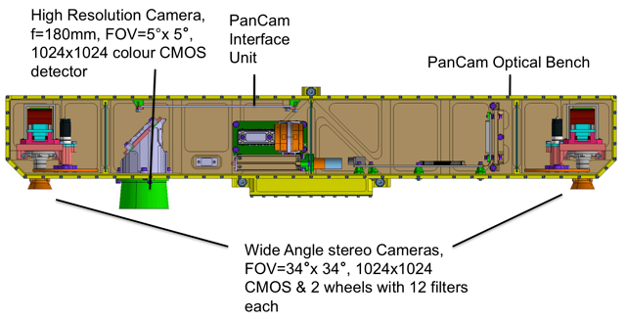

***Figure 21.*** *Schematic drawing of the ExoMars Pancam instrument. The proposed instrument capability of Pancam has been judged to be sufficient to meet the imaging needs of the proposed 2018 joint rover mission, and no further competition is recommended.*

The two WACs have a 22-mm focal length, f/10 lens that illuminates a 34° square field-of-view (FOV), 1024 x 1024 pixels. The HRC has a ~180mm focal length, f/16 lens that illuminates a 5° square FOV, 1024 x 1024 pixels. The WACs have fixed focus lenses, with an optimal focus set to 4 m and a focus range between 1.2 m (nearest view to the calibration target on the rover deck) and infinity. A strict definition of "in focus" is used for the cameras, wherein the optical blur circle is equal to or less than 2 pixels across. The HRC could focus between ~0.9 m (nearest view to a drill core on the rover’s sample tray) and infinity. Due to the wide distance range over which sharp HRC images of the surface shall be taken, refocusing of the HRC optics with an autofocus mechanism is required in order to achieve optimum pixel resolution.

PanCam has an IFOV of 580 μrad for the WACs and 83 μrad for HRC, respectively. This translates into a resolution of 8.3 mm/pixel at 100 m distance with the HRC, sufficient to resolve sub-centimeter-sized particles at a distance of tens of meters and thus being able to pre-select targets for *in situ* sampling. The 12 PanCam filters (440-1000 nm; Cousins et al., 2010) are selected to provide information on charge transfer and electronic transition bands associated with iron and other transition metals. This multispectral capability provides information on the presence of iron oxides, oxhydroxides, sulfates, carbonates, and both ferrous and ferric silicates. Further, it may be possible to map other hydrated phases using an expected spectral downturn at 1 μm wavelength. Integrated over the HRC detector is an RPB (red, panchromatic, blue) stripe interference filter (the red and blue filter cover the left and right 512 x 1024 pixels, respectively, and the panchromatic filter covers the central 768 x 1024 pixels).

## Appendix 6: Competed Instruments Level 2 Requirements and Justifications

**Draft Requirements for Enhanced Mast- and Arm-mounted Instrument Capabilities, proposed 2018 Joint Rover Mission**

**Proposed General requirements**

1. The instruments shall provide datasets compatible with tactical planning of rover operations within one planning cycle.

Rationale: The baseline operations scenario involves two kinds of activities, each within one sol: 1) Driving sols: in which the rover needs to travel AND in which the mast instruments may carry out reconnaissance observations to support the acquisition and/or prioritization of targets for potential contact observations; and 2) Contact science sols: in which investigations are performed on rock or soil targets by arm-mounted instruments. It is assumed that these contact targets have been previously identified by mast-mounted reconnaissance instruments. It is further assumed that a rock surface could be brushed, all of the arm-mounted instruments used, and enough data transmitted to support decisions about subsequent operations, within one sol.

1. Instruments that require data compression are preferred to use compression algorithms already available from the Rover CPU (Pasteur on-board computer). Alternate approaches that use internal instrument resource allocations are allowable, but only if it could be demonstrated that they provide scientific or tactical advantages.

Rationale: The rover CPU already contains compression algorithms that are used for this purpose by the Pasteur payload. Avoiding duplication of functionalities and the existence of power constraints would need to be taken into account if instrument-based data editing or compression is proposed.

1. The instruments shall meet performance specifications after exposure to dust generated by the surface preparation tool and occurring in the ambient Mars environment.

Rationale: The arm instruments and the surface preparation tool would be located together at the end of the arm. The mast instruments would be exposed to the ambient environment.

1. Instruments that could perform measurement operations during the martian daytime are preferred over those that require night-time observations.

Rationale: Day-time measurements are preferred due to the lower demand for heater power. Nighttime instrument operations would be permitted only if they are scientifically justifiable compared with day-time observations, and could be achieved within the available energy profile. Additionally, use of the rover CPU during nighttime should be minimized or avoided to conserve energy resources.

1. The instruments shall have power usage requirements compatible with the expected power resources of the rover. A final choice between solar power and RTGs has not yet been made.
2. The instruments shall generate datasets that are compatible with the assumed available data rate of 40 Mbits per sol for planning purposes, 20 Mbits engineering, and 20 Mbits for decisional science. The total data return per sol is assumed to be 250 Mbits.

**Note:** Themast-mounted imager is assumed to be the Pasteur Pancam. JSWG has concluded that Pancam meets the scientific needs of the mission for color panoramic imaging.

**Proposed Mast-mounted Mineralogy Instrument**

1. The mast-mounted mineralogy instrument shall assess the composition of an outcrop, rock, or soil in the vicinity of the rover out to a minimum distance of 10 m. Ability to assess composition at greater distances (to >20 m) is highly desired.

Rationale: The science function of this instrument (reconnaissance of potential targets for contact measurement, establishment of geologic context of the contact measurements) would be enhanced by increasing the range at which useful information could be gathered. The range needs to extend well beyond that obtainable using arm-mounted instruments and short rover traverses (“bumps”).

1. The mast-mounted mineralogy instrument shall detect and provide mineralogical assessments for features 10 cm in size, that could be correlated with images from the PanCam and navigation cameras. Higher spatial resolution (resolving features as small as ≤1 cm from 10 m distance) is highly desired.

Rationale: 10 cm is considered to be the maximum resolvable feature size that satisfies the combined requirements for spatial coverage, resolution, and operational constraints imposed by available data volume and/or operation time. Instruments with better resolution are highly desired and may be proposed; they could resolve smaller compositional variations at similar distances, possibly leading to new types of compositional information. However it would be required that adequate spatial coverage (currently assumed to be to at least 10° x 20° in a single observing session) be obtained within operational time and data volume consistent with requirements #10 through #12.

1. The mast-mounted mineralogy instrument shall be capable of detecting / identifying and assessing the spatial distribution of the following classes of minerals: primary rock-forming silicates; OH- and H2O-bearing secondary silicates; and silica, sulfates, carbonates, and oxides. Additional capability to discriminate among phases within these broad classes is also desired, as is the capability to detect halides.

Rationale: All four science objectives require knowledge of the mineralogy of geologic materials beyond the reach of arm-mounted instruments. Detecting and determining the spatial relations of these classes of minerals would provide key constraints on the processes and environments of formation of potential samples. In order to achieve these objectives with the greatest efficiency, the mast-mounted mineralogy instrument would need to, as a minimum, be able to recognize the major primary and secondary mineral classes listed above. Discrimination of closely related mineralogies (e.g., Fe vs. Mg sulfates, Fe vs. Mg clays, different hydration states of sulfates) would add additional scientific capability, and provide improved context for contact measurement targets.

1. The mast-mounted mineralogy instrument shall conduct a contiguous survey of lithological/mineralogical variations of the geological materials within a field of view of at least 10° x 20° within a single measurement cycle.

Rationale: The reconnaissance mineralogy measurements would need to afford sufficient coverage of the surrounding geology to provide context and guide placement of higher resolution measurements, using a data volume not exceeding that expected for a typical downlink. Coverage of a larger field of view is highly desired. However, adequate sampling would need to be preserved; it would not be sufficient to have a few individual point measurements that randomly sample the geological features present. At least two measurement strategies are acceptable: (1) the field of view could be sampled continuously at a density consistent with detection requirements described in requirement #8 (e.g., "imaging" or "raster scanning"), or (2) a smaller number of point measurements sampling each of the visible geological components in the scene could be targeted autonomously (e.g., "onboard autonomous targeting"). In the latter case adequate contextual measurements of the remainder of the scene are required. It would be up to the proposer to demonstrate that a chosen measurement approach is consistent with requirements #7, #8, and #9.

1. Time and Data Volume requirements specific to the mast-mounted mineralogy instrument would be negotiated after instrument selection consistent with requirement 6.

Rationale: Requirements on the duration allowable for each instrument and also the data volume budget for each instrument still need to be addressed.

1. Operation of the mast-mounted mineralogy instrument shall be compatible with pointing control (pan/tilt) provided by the mast assembly as documented in the PIP. That value is presently unknown but is expected to be comparable to that of MER, approximately 0.1 degrees. Operation shall also be compatible with pointing stability to be specified in the PIP. That value is presently unknown but is expected to be comparable to that of MER, not worse than 0.3 mrad RMS (3 sigma) in 1 sec.

Rationale: The mast has independently defined requirements for pointing stability ("jitter", "drift") and for ability to point at a designated target ("pointing control"). Proposers who have requirements relevant to either area cannot meet those requirements by specifying improved performance of the mast; they would need to accomplish their objectives using appropriate instrument design and observing strategies.

**Proposed General: Close-up instrument suite**

1. High spatial resolution measurements of morphology, mineralogy and elemental chemistry may be provided by arm-mounted instruments. Alternatively, acquisition of these measurements from the mast would be permissible if all of the measurement requirements could be met through such an implementation. In the requirements below, the term "arm-mounted" should therefore not be construed to prohibit mounting on the mast.

Rationale: The value of arm-mounted contact sensors for collecting data at a small enough spatial scale to interpret rock origin and subsequent modification has been demonstrated by Mars Pathfinder, MER, and Phoenix. Sensors with similar performance are also on MSL, and would be required for the proposed 2018 joint rover mission. However, if the performance of mast-mounted instruments has advanced to the point that sufficient resolution could be obtained from the mast rather than by arm-mounted contact or proximity instrumentation, then mast-mounted instrument solutions would be acceptable.

1. Arm-mounted instruments shall operate on a robotic arm that would be capable of placing instruments at a standoff distance of [0–10] cm from a rock surface, with control of pointing to within [2] mm relative to a desired placement.

Rationale: The arm's standoff performance would be derived from engineering capability. The pointing control depends on two considerations: 1) knowledge of position relative to the rover, and 2) knowledge of position relative to the circular area prepared (with brushing and/or abrading) by a surface preparation tool.

1. If an arm-mounted instrument requires scanning to obtain a series of measurements across the surface of a target, then the instrument shall provide its own scanning mechanism.

Rationale: The robot arm is not required to have the precision, or desired to execute the complexity of operations, needed to relocate the instrument through an array of points that meets small-scale measurement requirements.

1. An arm-mounted instrument that requires confirmed contact with a target during its measurements shall provide its own contact design including a contact sensor, plus a well-defined preload requirement.
2. Time and Data Volume requirements specific to the collective arm-mounted instruments would be negotiated after instrument selection consistent with requirement 6.

Rationale:: Requirements on the duration allowable for each instrument and also the data volume budget for each instrument still need to be addressed.

1. Operation of the arm-mounted instruments shall be compatible with stability provided by the arm assembly. This value is not presently known. Proposers should define minimum requirements for successful function of their instruments.

**Proposed Arm-Mounted Imaging Instrument**

1. The arm-mounted imaging instrument shall resolve features with a diameter of 80 microns, leading to a pixel size requirement of ≤40 microns.

Rationale: Determination of rock type and robust interpretations of the petrogenetic processes responsible for the formation geological materials requires close-up imaging at a scale adequate to resolve the sizes and shapes of individual mineral grains and other microtextural (fabric) elements in rocks, including both primary and secondary mineralogical and textural features. Micro-imaging of rocks during previous Mars missions, as well as petrographic studies of a variety of terrestrial analog materials, suggests that the resolution indicated is the minimum needed to adequately characterize the microtextures of fine-grained volcanic and sedimentary materials likely to be encountered on Mars.

1. The arm-mounted imager shall autonomously collect data required for in-focus images without relying on rover arm adjustments.

Rationale: For the arm-mounted implementation of this investigation, the depth of field is likely to be smaller than the scale of relief on the rock or soil surfaces being imaged, necessitating "stacking" images with different depths of field to synthesize an in-focus image. If the capability for autofocusing is necessary, it would need to be accomplished internal to the instrument and should not require additional arm motion. Onboard stacking and automated processing are highly desirable in order to reduce stored and transmitted data volumes.

1. The arm-mounted imager shall be capable of acquiring color images. However, the choice of spectral bands, and the scientific justification for these bands, is left to individual proposers.

Rationale: Color greatly enhances the discrimination of mineral phases and identification microtextural features of rocks and soils. Depending upon the wavelengths and spectral bandpasses, color imaging may also provide direct evidence for mineral composition. Where several phases are present, they may be distiguishable (though not identifiable directly) by their color. The distributions of minerals within rock textures may help to constrain the paragenesis (timing of emplacement) of mineral phases in a rock and their post-depositional (diagenetic) history.

1. The arm-mounted imager shall perform measurements on abraded, brushed and natural rock surfaces.

Rationale: The objective of characterizing the texture of rocks requires measurements of abraded, brushed surfaces to penetrate any coating or rind that has a different texture. However textural differences between bulk rock and a coating removed by brushing or a rind removed by brushing and abrasion may provide insight into processes that modified the rock's surface, such as accumulation of dust, alteration by thin films of water, or abrasion by eolian sediment.

1. The arm-mounted imager shall perform measurements on the surfaces of rocks and outcrops at the same places that are accessible by the arm-mounted mineralogy instrument, surface elemental chemistry instrument, and surface preparation tool.

Rationale: Morphology, mineralogy and elemental composition are complementary types of information that are needed to constrain the formation and modification of igneous and sedimentary rocks. Acquiring all three types of data at the same location provides more constraints than one measurement type alone. See discussions of the arm-mounted mineralogy and elemental chemistry instruments for examples of the complementary nature of the data.

**Proposed Arm-Mounted Mineralogy Instrument.**

1. The arm-mounted mineralogy instrument shall detect, identify, and assess the spatial distributions of the following classes of minerals: primary rock-forming silicates; OH- and H2O-bearing secondary silicates; and silica, sulfates, carbonates, and oxides.  Additional capability to discriminate among or identify specific minerals within these broad classes is also desired, as is the capability to detect halides.

Rationale: All four mission science objectives are supported by knowledge of the mineralogy of geologic materials at the very small spatial scales that could be investigated by arm-mounted instruments. These classes of minerals provide key constraints on the processes and environments of formation of geologic materials. In order to achieve these objectives, the arm-mounted mineralogy instrument would need to, at a minimum, be able to recognize the major primary and secondary mineral classes listed above. Additional capabilities to distinguish cation composition and/or hydration state between minerals within each of these classes would significantly enhance the science return from the instrument.

1. The arm-mounted mineralogy instrument shall determine mineral composition at spatial scales of ≤ 0.5 mm. The ability to determine the mineralogy of grains at scales of ≤ 0.1 mm is highly desired.

Rationale: Mineralogical differences between grains or compositional domains within a rock provide information on the time sequence of formation and modification processes. The minimum required resolution would be adequate to detect phenocrysts within a finer-grained groundmass in an igneous rock, grains of different composition in a coarse-grained sedimentary rock, or secondary growths having the size scale of coarse sand or larger. The desired higher resolution would detect mineral grains in typical basaltic igneous rocks or clasts the size of fine sand or larger in sedimentary rocks.

1. The arm-mounted mineralogy instrument shall provide data that in post-processing support location of any point within the rock surface analyzed to within ≤ 0.5 mm in close-up images.

Rationale: The morphology of mineral grains and the textural relations of different minerals are both diagnostic of processes that formed and modified igneous and sedimentary rocks. This positional knowledge would facilitate registration of data from the arm-mounted imager and mineralogy instruments, improving determination of the morphological expression of mineral occurrences at microscopic scale.

1. The arm-mounted mineralogy instrument shall perform measurements on the surfaces of rocks and outcrops at the same places that are accessible by the arm-mounted imager, surface preparation tool, and surface elemental chemistry instrument.

Rationale: Morphology, mineralogy and elemental composition are complementary types of information that are needed to constrain the formation and modification of igneous and sedimentary rocks. Acquiring all three types of data at the same location provides more constraints than one measurement type alone. The pervasiveness of dust coatings and rinds requires that, in many cases, an outer layer be removed before representative measurements of a bulk rock could be obtained.

1. The arm-mounted mineralogy instrument shall perform measurements on abraded, brushed and natural rock surfaces.

Rationale: The objective of characterizing the mineralogic composition of rocks requires measurements of abraded, brushed surfaces to penetrate a thin dust coating or weathering rind. However differences in mineralogy between bulk rock and unabraded rind may carry a signature of processes that have modified a rock surface, such as leaching, hydrolysis by transient surface moisture, deposition of efflorescences, or cementation of airfall dust.

**Proposed Surface Elemental Chemistry Instrument.**

1. The surface elemental chemistry instrument shall be capable of detecting Si, Al, Fe, Mg, Ca, and Na at concentrations down to approximately 1000 ppm with +/- 10% accuracy over the instrument's footprint at an ideal deployment geometry, and K, P, S, Cl, Ti, Cr, Mn at concentrations down to approximately 1000 ppm.

Rationale: The major elements discriminate between igneous rock types and some types of deposits formed by liquid water, such as silica-rich sinter or weathering residue. The minor elements are proven in landed studies by MER or Phoenix, or in laboratory studies of terrestrial analogs, to provide evidence for additional processes such as leaching, chemical precipitation, injection of hydrothermal fluids, etc.

1. The surface elemental chemistry instrument shall perform measurements on the surfaces of rocks and outcrops on the same targets that are accessible by the arm-mounted imager, mineralogy instrument and surface preparation tool.

Rationale: The required spatial sampling by the elemental chemistry instrument would be much coarser than typical igneous mineral grains or clasts within a sedimentary rock. The higher resolutions afforded by the morphology and mineralogy instruments would help to resolve ambiguity in interpreting the results of elemental chemistry measurements - for example, providing textural measurements that indicate whether a basaltic elemental composition corresponds with a primary igneous lithology or with a weakly altered sedimentary lithology. Co-location with the footprint of the surface preparation tool would be required to access bulk elemental chemistry below a thin dust coating or weathering rind.

1. The surface elemental chemistry instrument shall perform measurements on abraded, brushed and natural rock surfaces.

Rationale: The objective of characterizing the bulk elemental composition of rocks requires measurements of abraded, brushed surfaces to penetrate a thin dust coating or weathering rind. However differences in elemental chemistry between bulk rock and unabraded rind may carry a signature of processes that have modified a rock surface, such as leaching or hydrolysis by transient surface moisture.

1. The surface elemental chemistry instrument shall acquire measurements at a spatial scale of no larger than 1.8 cm. Measurements at a smaller scale of ≤ 0.1 mm are highly desired.

Rationale: Ideally elemental composition measurements would be acquired at a resolution approaching that of mineralogic measurements, or <0.1 mm, for the same scientific reasons. The minimum requirement of a spatial scale 1.8 cm or smaller in size would be a balance of size and required integration time given the capabilities of probably technologies that could attain the required measurement accuracy.

**Proposed Surface Preparation Tool.**

1. The surface preparation tool (SPT) shall create an exposed rock surface that is flat to within 0.5 mm over a circular area with a diameter of 3 cm.

Rationale: This requirement is based on plausible instrument footprints and depths of field of the other arm-mounted instruments, particularly the elemental chemistry and mineralogy instruments.

1. The surface preparation tool shall provide independent brushing and abrading capabilities.

Rationale: Bulk rock may be thinly covered by either of at least two types of materials. Airfall that samples average mobile sediment typically would be removed by brushing that preserves underlying, more indurated material. Either a loose coating that has been cemented by soluble phases, or a chemically altered outer rind of the underlying rock, may survive brushing and record processes that involved small amounts of transient liquid water. Insights into these processes may be attained by measurement of the brushed surface. Abrasion would be expected to remove both types of covering to expose bulk rock for measurement.

1. The SPT shall abrade approximately three times as many targets as there are sample spaces in the canister, and brush approximately six times as many targets.

Rationale: This is based on estimates of the relative number of targets that would require brushing to observe beneath loose cover, and the number of measurements of "clean" surfaces that would be required to select samples for caching.

1. The SPT shall conduct operation in no greater than TBD minutes, and generate no more than TBD Mbits of data.

Rationale: Requirements on the duration allowable and also the data volume budget still need to be addressed.

## Appendix 7: Candidate Instrument Options (“Reference Payload” for new competed instruments)







## Appendix 8: Baseline Operations Scenario—Analysis notes

***Assumptions***

Various assumptions were incorporated into the reference surface mission scenario study as directives to the team about the capabilities of the system and the environment in which the rover would be operated. This type of assumption includes:

* The surface mission lifetime should not exceed 1 Martian year (669 sols); however, if the science objectives could be achieved in less time, a shorter duration would be preferred.
* The rover should use the 2016 Trace Gas Orbiter (TGO) as its primary data relay. The scenario team did not consider the data volume requirements for achieving the science objectives, but did take into account the effect of TGO’s planned orbit. This orbit optimizes the collection of TGO science, but would result in an overflight pattern for the 2018 rover that “walks” through the Martian day (roughly 13 Mars-minutes earlier each succeeding sol).
* The “commissioning” phase, during which the various rover subsystems would be checked out and science instruments would be commissioned, was assumed to take 30 sols. By way of comparison, MSL’s commissioning phase is expected to last 60–90 sols, with about 20 sols of rover subsystem checkouts before the rover would be ready to initiate contact science.
* The margin policy is that a 20% mission duration margin should be considered based on improvements in operations and spacecraft fidelity. For comparison, MSL held 25% lifetime margin at launch, intended to cover:
  + Communication problems (e.g., outages in the deep space network, relay asset safing);
  + Non-determinism of in-situ operations (including repeating operations that failed);
  + Increases in activity time or energy needs during operations.

In addition to these items, for the 2018 Joint Rover Mission the 20% margin is also intended to cover:

* + Periods of reduced or no operations due to hibernation, dust storms, and/or overheat prevention;
  + Increases in the time required for activities due to energy, thermal, and/or data volume constraints (which have not been looked at yet);
  + Increases in time or energy required for activities due to better understanding of rover and instrument design during development;
  + Sample exchange (estimated to be 25% of cached samples);
  + Flight software uploads during surface operations.

Additional assumptions were given to the scenario team by the JSWG concerning the scientific content of the reference surface mission, including the distance that the rover would be required to cover in order to meet the objectives:

* The surface mission should execute at least 10 km of traverse, in order to capture the notion that while a rover would almost certainly land in an ellipse including some rocky outcrops of interest, there would also be outcrops of interest outside the ellipse. So, although the reference surface mission should not consider a "go to" scenario *per se* (one requiring a lengthy drive with no initial science) there would probably be a need for traversing outside the landing ellipse (assumed to have a 20 km diameter).
* ExoMars derived objectives:
  + 6 surface sample acquisition with deep drill and measurements with ALD
  + 6 deep sample acquisition with deep drill and measurements with ALD
  + 2 vertical surveys, analyzing with ALD subsurface samples every 50cm till 2m down.

Finally, the scenario team made assumptions to account for the known stand-down period for solar conjunction, and in order to optimize the scenario as much as possible at this early stage in mission formulation:

* No operations for the period subtending <2 degrees Sun-Earth-Mars angle (e.g., solar conjunction, which spans 12 sols for the 2018 opportunity).
* No separate sol type for remote sensing acquisition. Instead, all remote sensing is assumed to be acquired during other sol types.
* 1 sol is allocated for driving away after dropping off the cache.
* Fixed local mean solar time X-band windows in the Martian morning for commanding (uplink) communications.
* 10 hour ground planning cycle, which includes analysis of received telemetry; determination of plans for the next sol; generation, validation, and review of command products to implement the next sol’s plan; and delivery of command products for radiation. For comparison, MSL’s current planning cycle duration is 16 hours. Although the use of two control centers for 2018 increases complexity of operations, the assumption for 2018 folds in expected lessons learned and increases in efficiency over MSL.
* “Mars Time” operations--which assumes that scheduling of the ground planning cycle follows the procession of the receipt of telemetry (downlink) and the deadline for commanding (uplink) as they “walk” around the Earth clock due to the phasing of Earth time and Mars time--for the entire duration of the surface mission, using 2 control centers separated by 9 time zones. This scheduling strategy yields the highest number of productive sols. Strategies for scheduling the ground planning cycle, other than “Mars Time”, necessarily introduce additional non-productive sols due to the phasing of Earth-time-based work shifts against Mars-time-based downlinks and uplinks. Note that with the “Mars Time” assumption, 8% of sols cannot have “ground in the loop” due to the phasing of the fixed uplink window and the “walking” downlink relay overflight (see Section 11.2).

***Free Parameters***

Given the assumptions described above, the scenario team had some flexibility in adjusting the following aspects of the scenario in order to meet the science objectives outlined in Section 3.

* The JSWG recommendation would be to cache 31 samples. This number would include 26 rock samples, 2 regolith samples and 3 “blank” standard samples. The absolute minimum number of samples would be [24], including 1 regolith and 3 blanks. See Section 8, this report, for rationale.
* A key component of the operations scenario would be the amount of so-called fieldwork. Fieldwork involves reconnaissance imaging of the workspace in which the arm would operate, as well as targeted investigation of surrounding rocks that might be sampled further. A substantial amount of fieldwork would be necessary to understand the geologic context of any samples acquired by the rover (see Sections 3, 8). The fieldwork would be defined as a ratio of simple contacts to samples, and abraded contacts to samples, based on fieldwork that was executed on by the Mars Exploration Rover Spirit at Gusev Crater. The E2E-iSAG report recommended that the ratio of imaged to “simple contacts” would be 6:3 and the ratio of simple contacts to abraded and cached contacts is 3:1. However, to fit into the lifetime constraints imposed by JMEB, the fieldwork ratios were significantly altered 3:0.75:1 and are considered only marginally adequate by JSWG science team members. See Section 4, this report for rationale.
* Another parameter that could be tuned in the scenario is the distance that could be travelled. Two speeds of driving were used in the scenario: so-called “long traverse”, a rapid velocity averaging 150 m per sol, and “short traverse”, where 50 m/sol was assumed. The “short traverse” sol type combines three sub-sol types: 1) “target-limited”, where the distance traversed is limited by the distance at which a target could be identified using remote sensing and have the rover traverse complete with the target in the instrument workspace; 2) “time-limited”, where the time available for traversal is limited by the time required for necessary remote sensing observations; and 3) “terrain-limited”, where the distance that could be traversed is limited by the difficulty of the terrain. Although each of these sub-sol types may have different distance limitations (see additional discussion below), on average the three sub-types of “short traverse” sols together are assumed to cover 50 m/sol.

Given the science objectives defined in Table 3, the JSWG worked to establish an operational scenario that would incorporate the number of vertical surveys and surface and deep measurements planned by the ESA ExoMars mission concept, as well as the number of samples to cache planned by the NASA MAX-C mission concept. The team endeavored to establish the maximum amount of scientific productivity that could be reasonably achieved within one Martian year (669 sols), and also within three seasons (equivalent to 500 sols). A family of scenarios sufficient to derive the major mission lifetime requirements, and no preference or interpretation of which objective might be “more important” was included in the analysis. Rather, each objective was treated as equally valuable to the overall mission design.

However, simply adding up the number of Martian days for the vertical cycles and the days needed to cache samples would introduce an inefficiency, because both sets of measurements incorporate, independently, activities related to surveying the site, which could be considered common. A careful analysis of these details was necessary to proceed most efficiently. Additionally, a report from the Mars Exploration Program Analysis Group (MEPAG) End-to-End international Science Analysis Group (E2E-iSAG) (E2E-iSAG, 2011) established a series of reference landing sites that bounded the amount of driving and fieldwork that would need to be incorporated into the operations scenario.

Another key assumption regarding Mars surface operations rests in the choice of communication means used for relaying rover data back to Earth. The JOSWG assumed the availability of X-band direct from Earth for command upload (from ground to rover) and for troubleshooting, while the TGO spacecraft would provide the primary data relay (from rover, via TGO, to ground). A significant advantage of the partnership between NASA and ESA on the 2018 mission would be the addition of a second control center tasked with generating command upload sequences for the rover. Two control centers separated by nine time zones were found to significantly increase the level of efficiency of the ground operations process by mitigating much of the inefficiencies generated from the elliptical orbit of the TGO spacecraft. This dual center concept allows synchronizing ground process operations with the Mars local time in a potentially more sustainable way. The Pathfinder, MER and Phoenix Mission experiences demonstrated that “following Mars Time” is not sustainable beyond a relatively short number of weeks (only used for the relatively short-duration prime missions). The two control center concept potentially offers resting time to operators by alternating some responsibilities.

Baseline 669 sols scenario description:

This scenario aims at establishing the feasibility of the mission within the assumed maximum surface duration, starting from the various objectives, assumptions and constraints, keeping in mind the experience acquired during the past missions (MER) and on-going MSL as well as for ExoMars rover mission preparations.

At a high level, the mission concept can be described using blocks of activities, some of which would be repeated as necessary, such as, driving and imaging, sampling, and drilling.

**TRAVERSE**

The reference landing sites defined by E2E-iSAG contributed to the scenario in that they provided locations that had both astrobiologically-intriguing sedimentary deposits and also igneous rocks.

|  |  |  |  |
| --- | --- | --- | --- |
|  |  |  |  |
|  |  |  |  |

Reference sites with landing ellipse

|  |  |  |  |
| --- | --- | --- | --- |
|  |  |  |  |
|  |  |  |  |

***Figure 22.*** *Reference sites with potential regions of interest for both astrobiology & igneous rocks objectives.*

Regions of interest, or ROIs, were identified for each reference landing site, and the approximate distances between the ROIs were calculated. Available HiRISE images were the basis of this analysis rather than a detailed, landing site selection process. The results are given in Figures 22 and 23.

The sites were characterized as either “easy” or “difficult” depending upon the roughness of the terrain. A drop zone, where the rover would deposit the sample canister on the ground was defined inside the landing ellipse. Landing was assumed to occur in the center of the landing ellipse.

From the analysis, it appears that some sites are “land-on,” others are “go-to,” and still others could be even considered both, with very different requirements on rover traverse.

|  |  |  |  |  |  |  |  |  |
| --- | --- | --- | --- | --- | --- | --- | --- | --- |
|  | **Mawrth vallis site 0** | | **Nili Fossae through** | | **Gusev - Colombia Hills** | | **NE Syrtis Major** | |
|  | Easy | Difficult | Easy | Difficult | Easy | Difficult | Easy | Difficult |
| **non-go to** | 0.0 | 6.5 | 0.0 | 11.5 | 12.5 | 1.5 | 0.0 | 6.0 |
| **go to** | 0.0 | 61.5 | 0.0 | 21.0 | 0.0 | 0.0 | 0.0 | 19.0 |
|  | **Jezero Crater** | | **Ismenius Cavus** | | **East Margaritifer** | | **TOTAL of 7 sites** | |
|  | Easy | Difficult | Easy | Difficult | Easy | Difficult | Easy | Difficult |
| **non-go to** | 10.0 | 3.0 | 13.0 | 2.5 | 0.0 | 5.9 | 35.5 | 36.9 |
| **go to** | 0.0 | 0.0 | 2.5 | 29.0 | 0.0 | 0.0 | 2.5 | 69.0 |
|  | All in km |  |  |  |  |  |  |  |

|  |  |  |  |
| --- | --- | --- | --- |
|  | **Mean** | | **SUM** |
|  | Easy | Difficult | **km** |
| **non-go to** | 5.1 | 5.3 | **10.3** |
| **go to** | 0.8 | 23.0 | **23.8** |

***Figure 23.*** *Candidate landing site traverse difficulty estimates. Terrain types are defined as “easy or difficult” and values are in kilometers.*

Analysis shows that the rover would need to traverse between 10 and 24 km at the candidate reference landing sites. This excludes the Mawrth Vallis site 0 “go-to” site, which requires a 61 km traverse. The mean traverse distance is 17 km. Note that the computations have assumed landing in the center of the ellipse.

For “easy” terrain, 150 m/sol daily traverse distance has been assumed (50 m blind drive + 100 m autonomous within 2.67 hr drive time); for “difficult” terrain, 50 m/sol was assumed. For easy/normal terrain, the ESA Guidance Navigation and Control (GNC) system could allow traveling up to 115 m/sol in full autonomy during 2.67 hr. Shorter drives per sol (50 m/sol) includes one sol type defined by shorter duration available for driving due to the need to characterize the environment with mast-mounted instruments at the end of a sol’s drive. The 17 km distance has been split into 13 km in easy/normal terrain and 4 km in “difficult” terrain. This was based on the experience of the NASA MER Spirit rover, which traveled relatively rapidly across the plains of the Gusev Crater to reach Columbia Hills, where the speed was necessarily reduced due to increased hazards and targets of interest.

**FIELDWORK**

The concept of Region of Interest (ROI) was used initially to define a reference scenario, where activities would be repeated for each such site. The focus has been on determining the rover activities necessary to characterize the geology to an extent that it would be possible to select a good place to cache samples and drill into the subsurface. These activities are combined into the so-called “fieldwork” section of the mission duration breakdown, and can be defined as the activities necessary to understand the geology of a site.

The initial work, similar to that performed by a geologist on the field, would be to survey the site with the PanCam and mast-mounted mineralogy instrument. Once an area of interest would be identified, e.g. from some distance away, a more specific area could be scouted to investigate at closer range with the robotic arm. It is assumed that this operational sequence —that is, the acquisition of images that would allow ground control to identify a suitable target for further exploration— would be performed at the end of a driving sol, so there is no specific sol allocated for this activity. Moreover, the use of APIC (Automatic Pointing and Image Capture) is assumed, allowing the return to ground a set of HRC images (and mast-mounted mineralogy measurements, TBC) targeted automatically on board from a WAC set of images. This would be crucial to achieve the necessary operational efficiency to accomplish the mission objectives within the allotted mission duration.

Arm mounted instruments would placed on ground-defined targets to execute detailed close up imaging and characterize the rock mineralogy using simple contact measurements. Rocks could be brushed and abraded as required. At each step the scientists could decide whether to proceed with further analyses or move the rover to investigate a different rock or another site. Should the analysis be sufficiently promising, investigators would use the arm-mounted corer to collect and cache a sample in the sample sealing and caching system. The number of sols to be used for each of these activities is calculated by using ratios: 3 simple contacts and 0.75 abraded contacts per cached sample have been assumed. These ratios are lower than recommended by the E2E-iSAG, but this was found acceptable by JSWG, recognizing it was on the very low side. From a science perspective, any increase in efficiency should contribute to increasing this fieldwork allocation. The current scenario assumes it would be possible to approach a target from 50 m distance. The feasibility of target selection at this distance is somewhat debatable. Nonetheless even reducing this value to 20 m approach for target selection does not invalidate the scenario lifetime conclusions.

At least six times during the mission, the scientists would be able to acquire a surface sample with the drill and analyze it in the ALD, which would crush and distribute the sample to the full suite of Pasteur Payload instruments. This is called a Surface Measurement (SM) and is also considered part of the fieldwork. Surface Measurement acquisition would require the rover to remain still for four sols and would complement the geological understanding of a site that has high potential for exobiology.

Depending on the geological complexity and scientific richness of a site, this process would be iterated a number of times. Overall, the 669 sols scenario accounts for 78 single arm placements, where extended analysis could be decided by ground, and 6 surface sample analysis sequences with the ALD.

**IN-SITU ANALYTICAL MEASUREMENTS**

When a site has been properly characterized, and possible caching targets have been documented, the terrain would be examined, for a suitable place to acquire a deep subsurface sample using the drill. During the prior fieldwork, the use of the ground penetrating radar during short distance travelling should have already provided hints about the subsurface morphology and stratigraphic complexity. Assuming that the surface geology is understood at this point, the operations team would then choose a site that is navigable and on which the ground penetrating radar would acquire the detailed data necessary to construct a dense 3-D subsurface map (every 10 cm on a pattern of about 5 m by 5 m). Based on the knowledge of the subsurface, a drill location and depth would then be defined for sample acquisition. The drilling velocity would depend on the density of the subsurface and should be considered in the drill location definition. The drill location should be chosen based on a complete WISDOM set of measurements in order to avoid buried outcrops and ensure that the drilling process would complete in a timely manner.

Though the drilling itself would proceed rather quickly —at speeds of several millimeters per minute, a conservative average daily penetration of 50 cm per sol has been assumed. This considers any uncertainties and takes into account the fact that the entire drill rig would need to be stowed at the end of each sol. An average of 150 cm depth has been used as reference for a Deep Measurements (DM). Each DM lasts 8 sols (including the WISDOM pattern, drilling time, and sample analysis by all ALD instruments (see figure below). The baseline scenario accounts for a minimum of 6 DMs.

Two so-called vertical surveys (VS) are also included. On VS, samples are acquired at 50-cm depth intervals and analyzed, beginning at the surface and proceeding to 2 m depth. This would likely be performed when any exobiology discoveries might require an understanding of the variations in depth. The vertical surveys would be performed on an already characterized site, so no additional WISDOM subsurface mapping has been accounted for this instance.

Finally, the following “ad-hoc measurements” are accounted for in the 669 sol scenario:

* 4 sols for the Life Marker Chip instrument function. One sol for each measurement for a total of 4 possible measurements
* Processing of 1 blank as part of Drill-ALD commissioning and 2 additional blanks for cross contamination analysis

**CACHING**

All of the contact instrument measurements needed to understand geological context and to select targets for sampling have been accounted for in the “field work” section, and the contextual remote sensing observations are accounted for in the traverse (and other) sol types. Thus the only impact on the mission duration of collecting samples for caching is the number of sols needed for the caching operation itself. For the baseline 669-sol scenario, the following sample types are cached, filling the 31-sample canister:

* 26 scientifically-selected rock/outcrop samples, collected using the arm-mounted corer
* 2 regolith samples
* 3 standards of known composition, or “blanks”, cached for contamination analysis in conjunction with analysis of the returned samples

Of note, the scenario includes no additional samples, as would be expected to be collected for sample changeout.

Each of these three sample types take 1 sol in order to collect and cache each sample.

**OTHER ACTIVITIES**

Within the baseline 669 sol scenario, various activities have been accounted in addition:

* 30 sols commissioning accounting for lessons learned from MSL (for comparison, MSL is planning a 60 sol commissioning phase)
* 12 sols for solar conjunction
* 8% non-productive sols resulting from communication phasing (due to the fixed uplink windows and “walking” UHF TGO downlink windows, but mitigated by the use of two control centers separated by 9 time zones) (see Section 11.2)
* 20% margin (see the “Assumptions” section in this Appendix.)

All the above considerations have been incorporated in the mission scenario tool. All the various campaigns and sol-types described above have been defined and power resources have been checked as part of the JEWG work.

***Studying ways to reduce the scenario toward a 500- sol target:***

The 669-sol scenario is driven by the qualification status of the MSL reused parts. The need for studying a 500-sol scenario was requested in view of the potential difficulties that a solar rover would have operating at each latitude within the desired range for a complete Martian year (See Figure 24.)

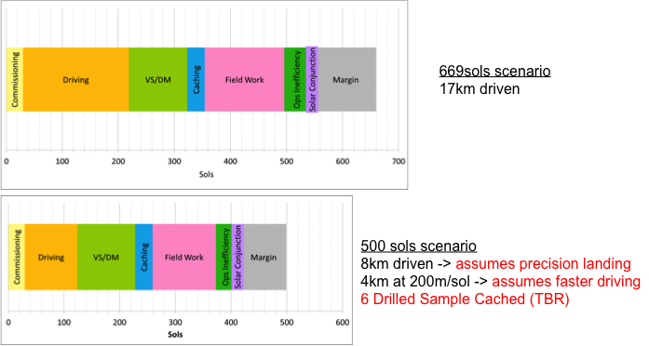

***Figure 24. Summary of number of sols possible showing 669 and 500 sol missions. Comments under 500 sol scenario indicate modifications to scenario that make the scenario possible.***

The JSWG was directed to consider reducing the mission lifetime through technological improvements, since JSWG deemed that achieving lifetime reduction by curtailing the amount of science was not acceptable.

An initial condition was to preserve the amount of science acquired (6 deep measurements, 2 vertical surveys, 31 cached samples with associated field work), reducing the number of sols was left to increasing driving efficiency and driving distance.

This could be achieved by driving a longer time on any given sol, although there would be some risk to the system. For example, for the solar rover configuration, excess power might be available in the first ~150 sols of the mission. This could be particularly useful if the need for long driving were potentially significant based on landing location relative to prospective science targets. More efficient processing for autonomous driving would certainly enable driving longer distances. Increasing the blind drive distance initially traversed might require improvements in camera performance specifications. Alternatively, longer driving might possible through using so-called “autonomous driving”, depending on conditions. However, given the current GNC functionalities, this is less promising since it is considered very dependent on the visibility of the target and therefore on the roughness of the terrain.

Another way to reduce the mission allocation for driving is to actually reduce the driving distance by landing closer to the desired sites, using precision landing technologies to be added to the MSL system baseline for the 2018 mission (See Appendix 3).

In addition, a potential reduction in the mission duration might be achieved by caching deep subsurface samples acquired with the drill. The scientific interest of this capability is discussed in another chapter of this report, but it also has a “logistical” interest: if 6 subsurface samples were cached, the number of samples to be cached with the arm corer might be reduced to 22 in place of 28. As the number of fieldwork sols is directly calculated from the number of samples to be acquired with the arm (see explanation about the ratios above), this might lead to a reduction in the overall number of fieldwork sols. The JSWG opinion was split regarding the feasibility of this option. On one hand, the number of sols dedicated to fieldwork might be reduced but is already exceptionally low. On the other hand, the quality of the cached samples might be ensured, since: 1) the drill samples would have been submitted for analysis with the ALD instruments before being cached; and 2) subsurface samples have more potential for the preservation of organics.

Further reduction could only be achieved by reduction of the scientific objectives.